**ELECTROSTATIC ENERGY  
 AND CAPACITORS**

**Exercises**

**Section 23.1 Electrostatic Energy**

**13.** **Interpret** We are to find the work required to assemble a linear sequence of charges.

**Develop** We use the technique described for assembling the three charges in Figure 23.1. For this problem, we have 4 charges, to be arranged as shown in the figure below. Number the charges 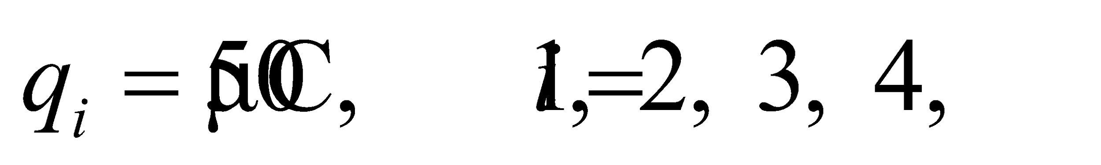 as they are spaced along the line at *a* = 2 cm intervals. There are six pairs, so

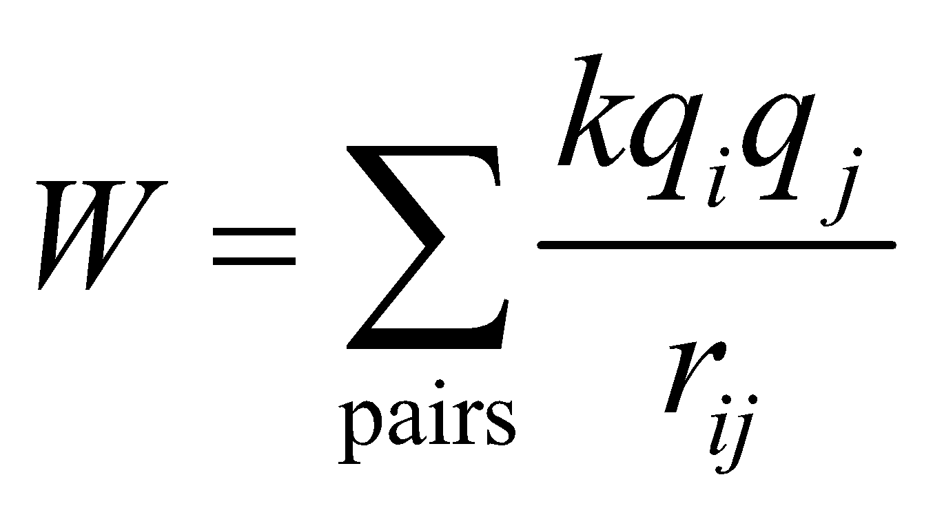

which we can evaluate to find the work *W*.



**Evaluate** Evaluating the expression above gives

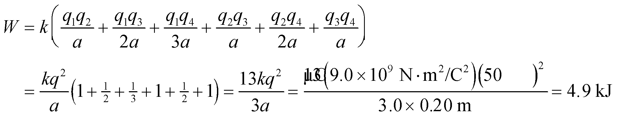

**Assess** The work required does not depend on how the charge configuration is assembled, only on its final state.

**14. Interpret** This problem is similar to the preceding problem, except that the final geometry of the assembled point charges is different (and the point charges do not all have the same charge). We can thus apply the same strategy as in Problem 23.13 to find the electrostatic energy for this collection of point charges.

**Develop** We again use the strategy outlined in the discussion accompanying Figure 23.1. The point charges are arranged on the corners of a square of side length *a*. Three of them have charge 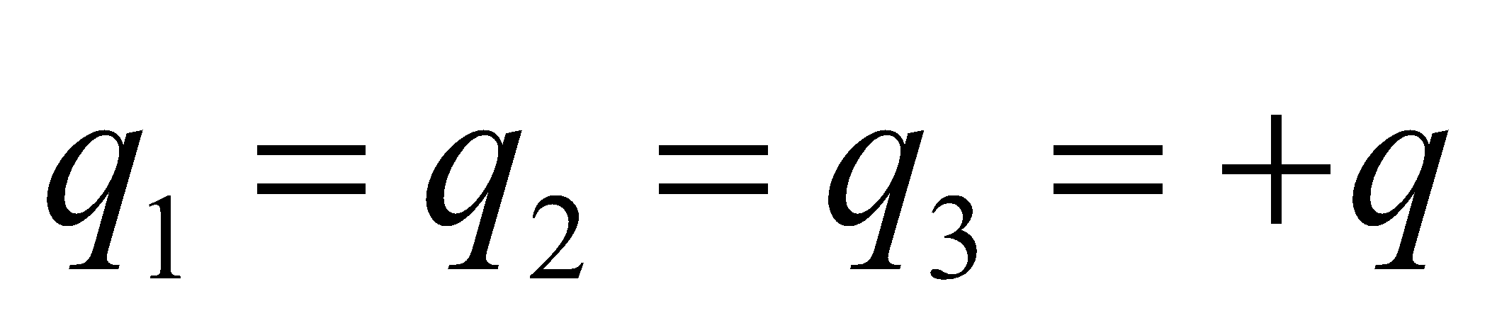, and the fourth has charge 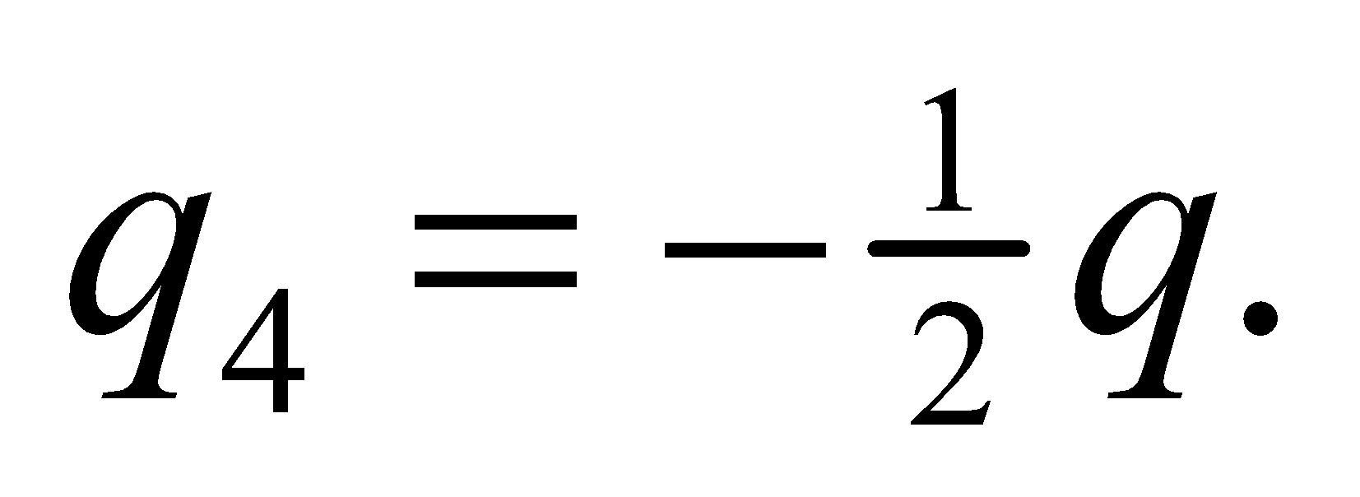 Make a sketch of the final charge distribution and label the charges (see figure below). Again there are six pairs of charges, so the work *W* required to assemble them is



which we can evaluate.



**Evaluate** Evaluating the expression for work gives

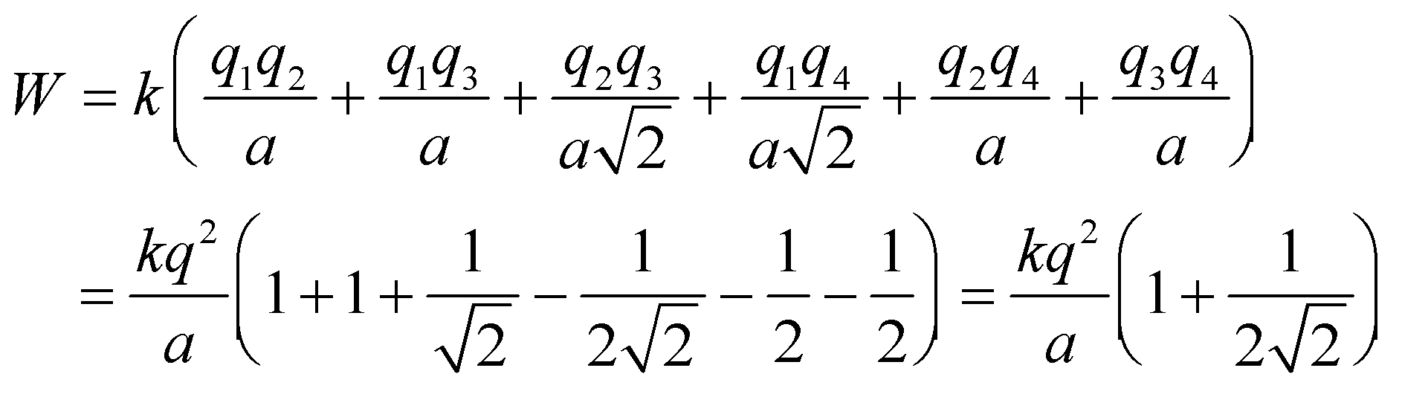

**Assess** This is not a particularly convenient method of calculating energies. Fortunately, the charge on a single electron is small enough that we can usually approximate real charge distributions as continuous and integrate.

**15. Interpret** We are to repeat the preceding problem, with the final charge changed from *q*4 = *q*/2 to *q*4 = −*q*.

**Develop** Use the same strategy as for Problem 23.14, but with *q*4 = −*q*

**Evaluate** Evaluating the expression for work required to assemble a collection of point charges gives

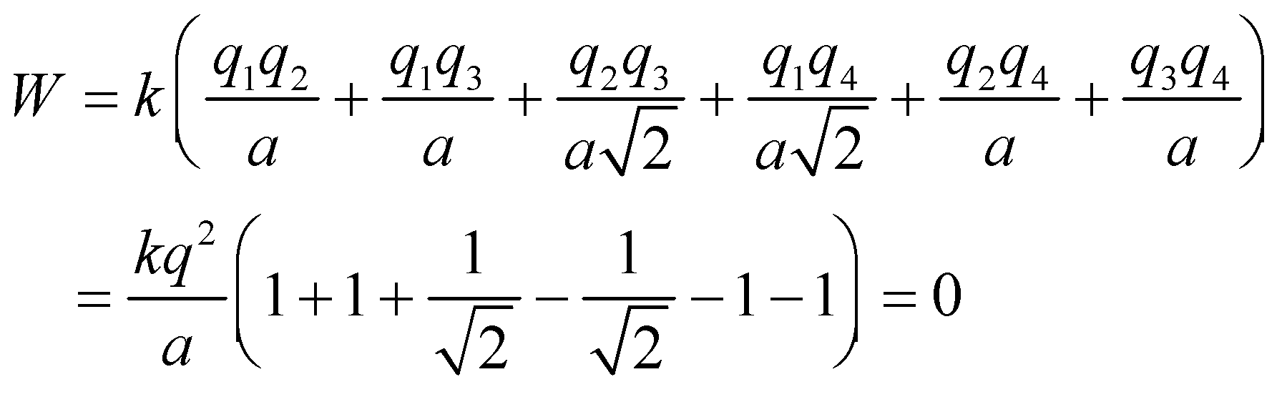

**Assess** Although it takes work to bring the second and third charges into place, that energy is regained by the negative work done in bringing in the fourth charge.

**16. Interpret** We are to find the speed of the charges in an “electrostatic explosion” and can use conservation of energy to address this problem.

**Develop** The three charges *q* are initially in a symmetric arrangement, as shown in Figure 23.1. The work done to assemble the configuration is given:

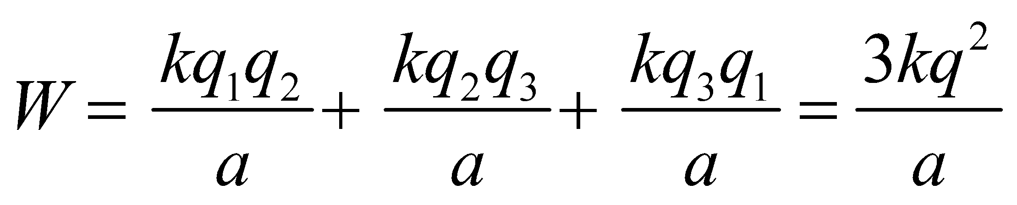

This is the initial energy of the configuration. From the symmetry of the initial configuration, we can argue

that they will each gain 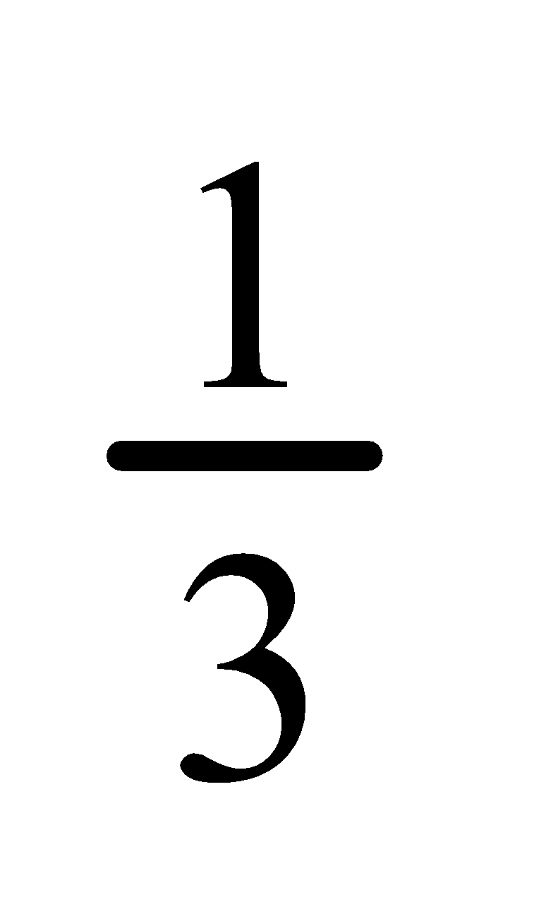 of this energy when they fly apart, so we can find the speed *v* from their kinetic energy.

**Evaluate** The initial energy is 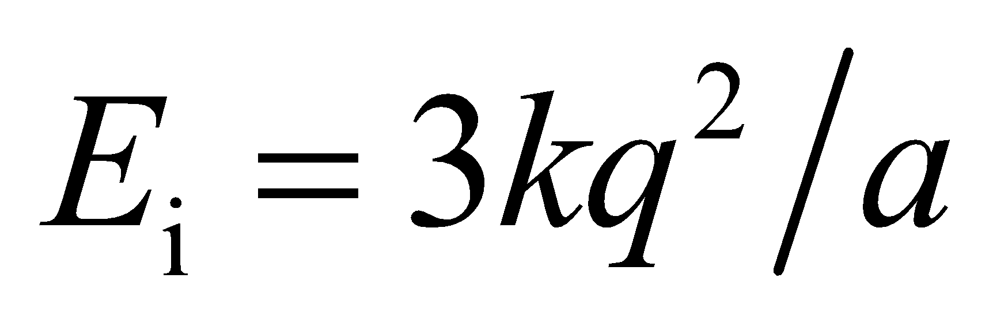 and the final energy is 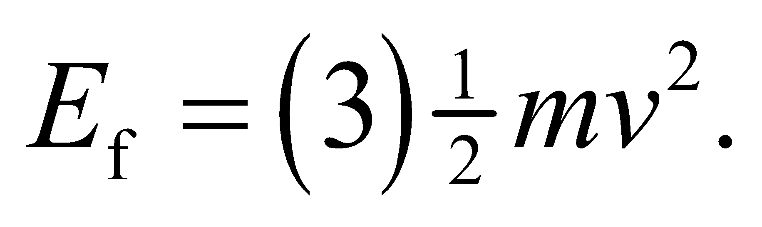 By conservation of energy, these energies must be equal, so

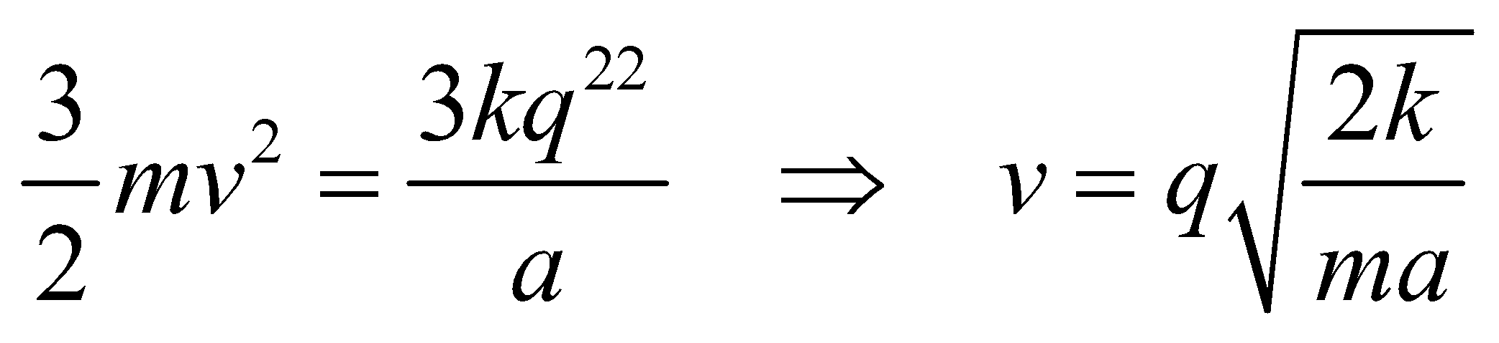

**Assess** Conservation of energy applies to more than just mechanical systems. This technique is used throughout all areas of physics and is fundamentally related to time symmetry.

**17.** **Interpret** For this problem, we are to find the work required to assemble a crude model of a water molecule. Note that if the work is negative, then energy is released in forming the molecule.

**Develop** In this approximation, electrostatic potential energy of the water molecule (i.e., the work required to assemble the molecule) is

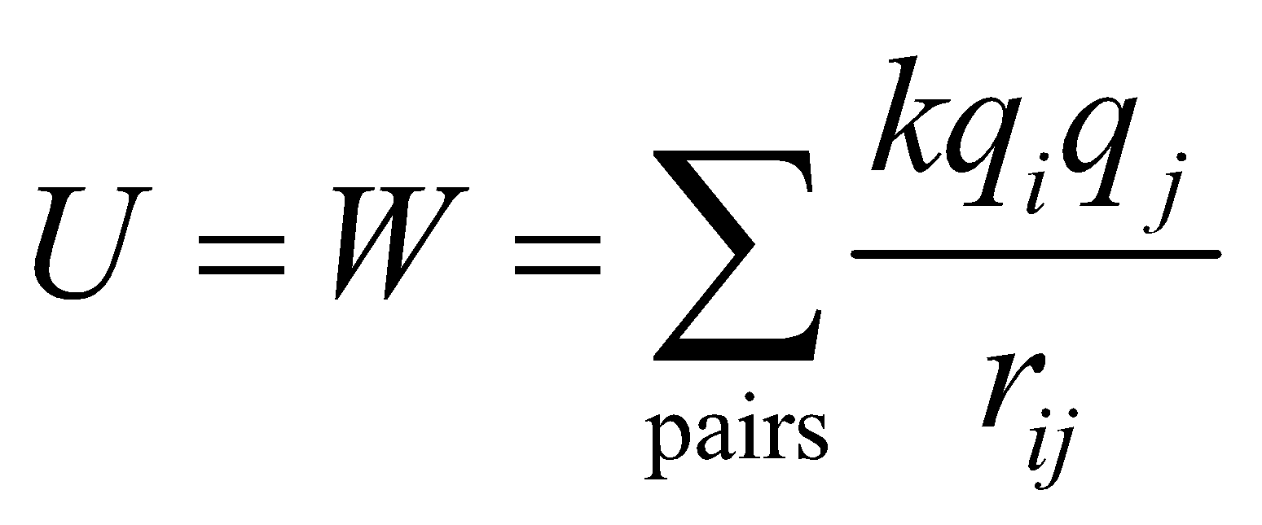

The two oxygen-hydrogen pairs have separation 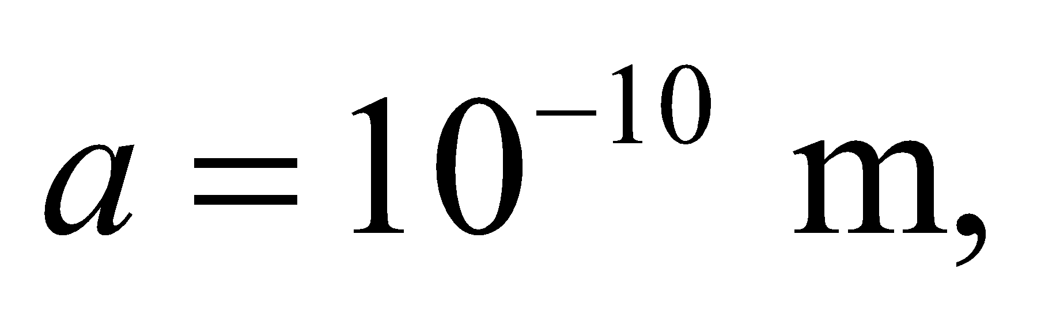 while the hydrogen-hydrogen pair has separation

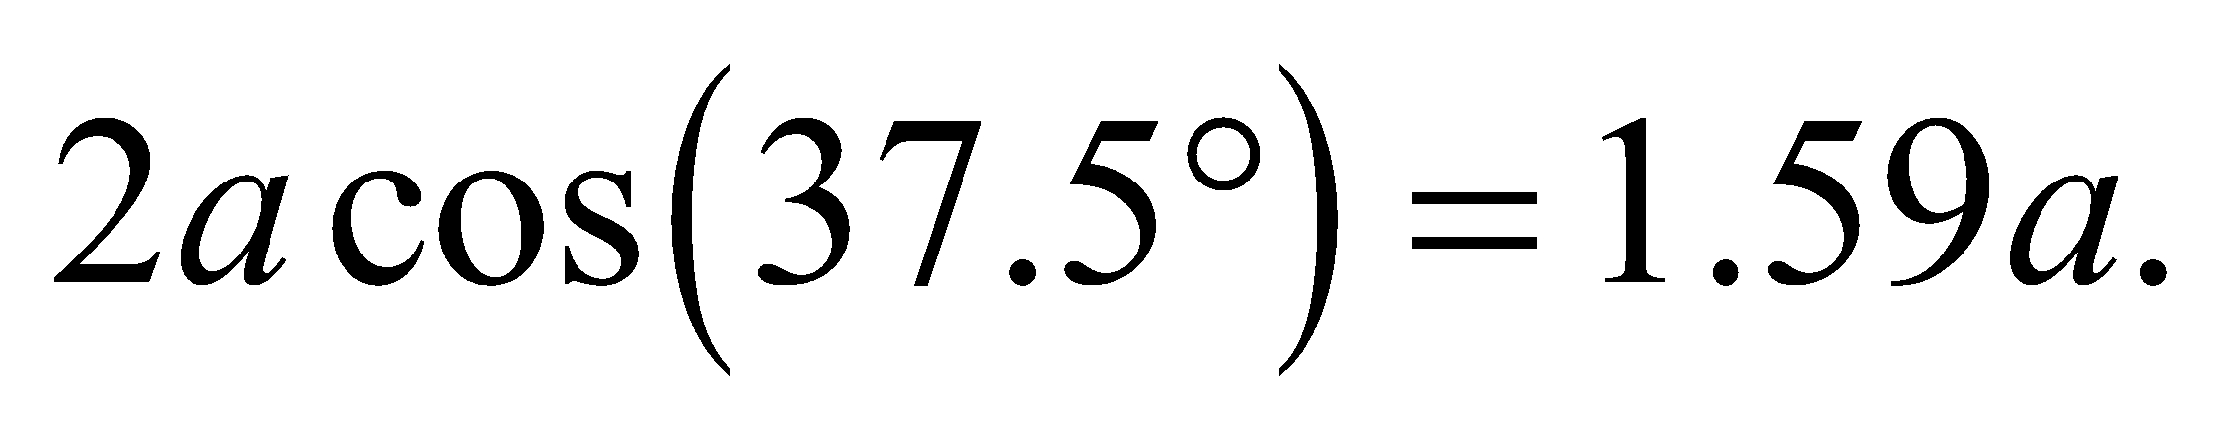

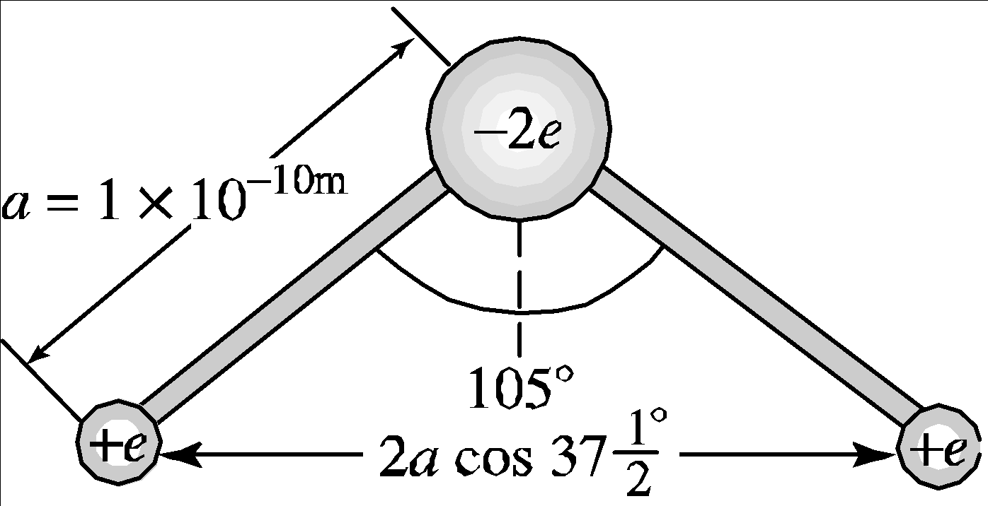

**Evaluate** Evaluating this expression gives

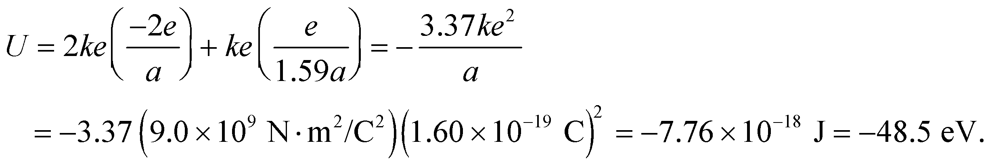

**Assess** Because the potential energy is negative, assembling this molecules releases energy (or does work). Note that the electrostatic potential energy of the assembled molecule is with respect to the constituents being infinitely far apart, so the work done equates to the change in potential energy caused by bringing the charges together from infinity.

**Section 23.2 Capacitors**

**18. Interpret** This problem is about a parallel-plate capacitor. We are given the plate separation and the charges on the plates and are asked to find the electric field between the plates, the potential difference between the plates, and the energy stored in the capacitor.

**Develop** The electric field between two closely spaced, oppositely charged, parallel conducting plates is approximately uniform (directed from the positive to the negative plate), with strength (see Equation 21.8)

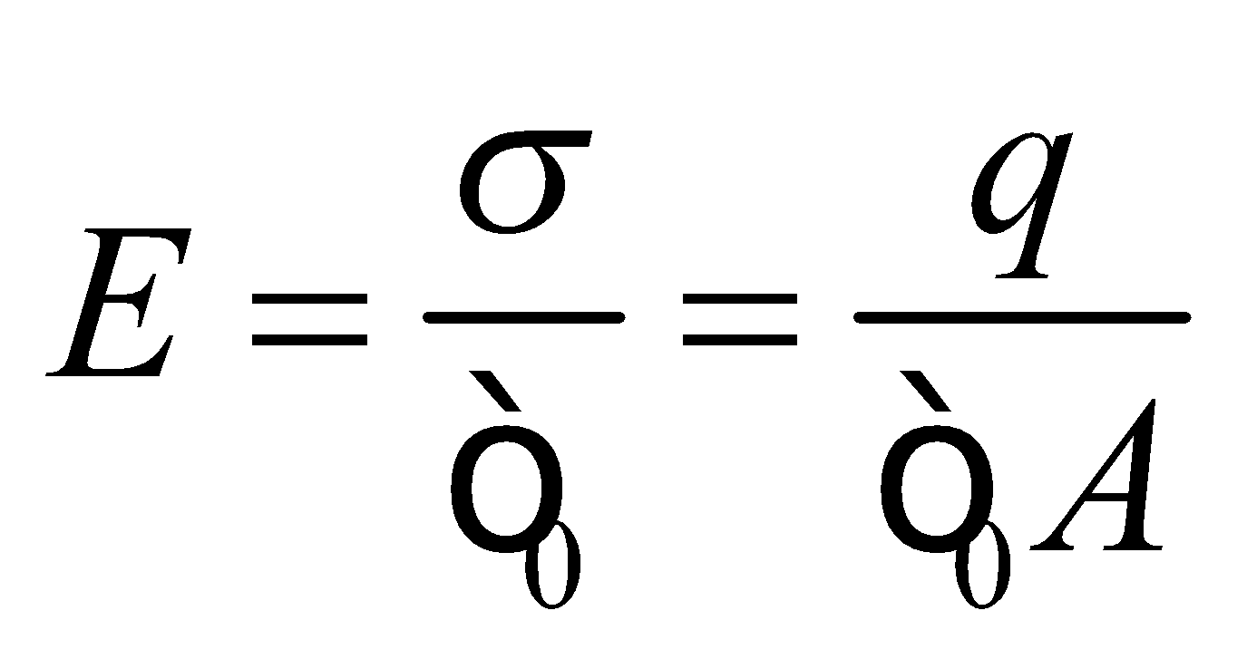

Since the electric field is uniform, the potential difference between the plates is given by Equation 22.1b,

*V* = *Ed*, where *d* is the plate separation. Finally, the energy stored in the capacitor can be calculated using

Equation 23.3: 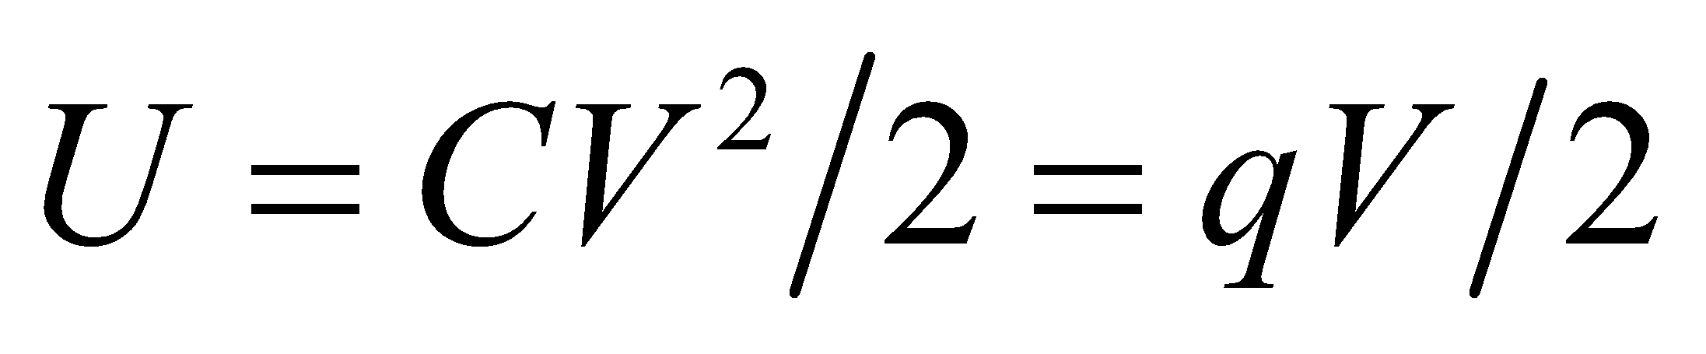 where 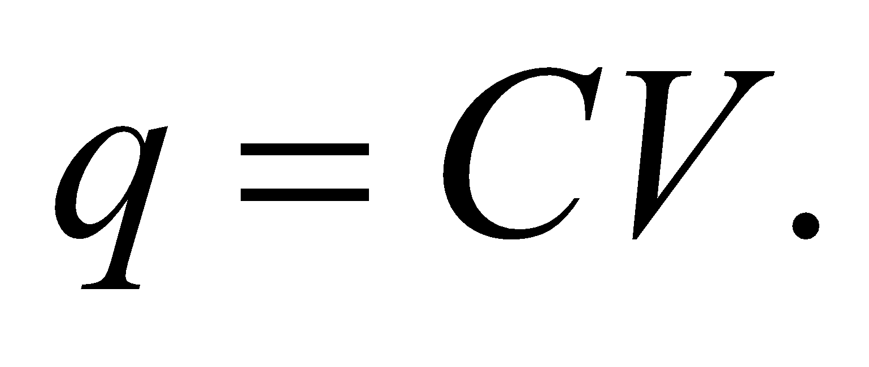

**Evaluate** **(a)** Using the equation above, the electric field is

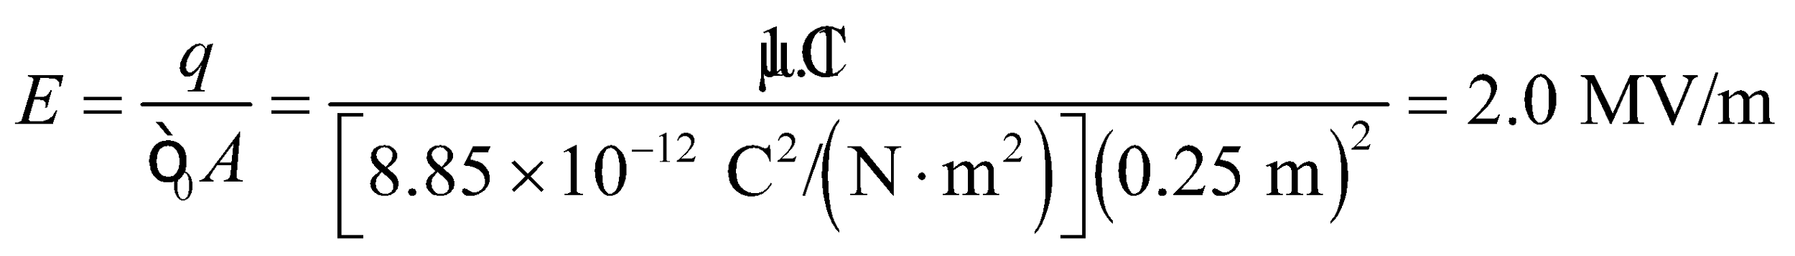

**(b)** The potential difference is

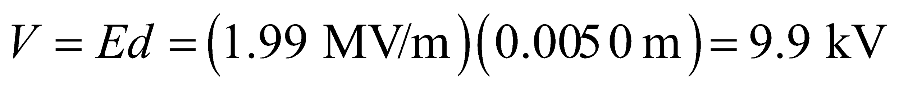

**(c)** The energy stored is

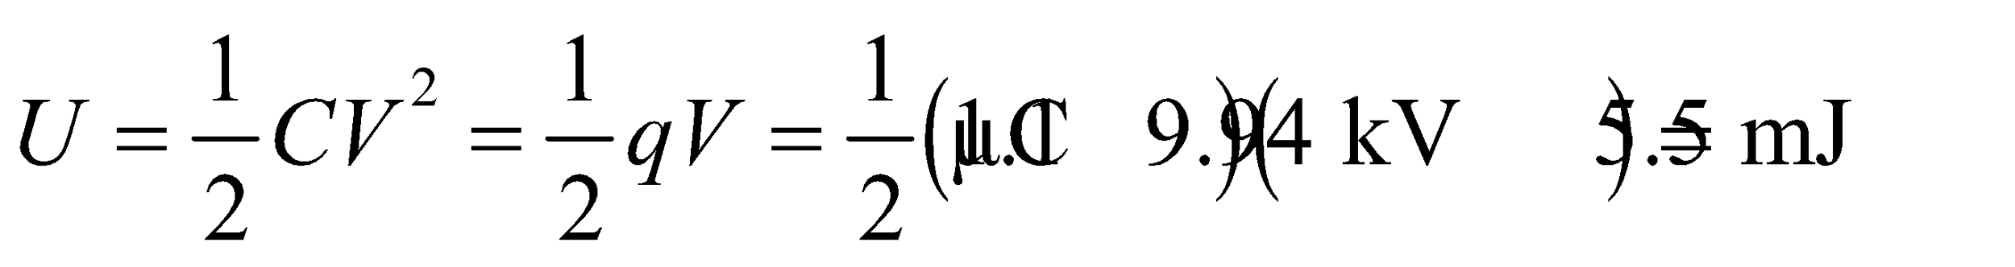

**Assess** Note that the final results are given to two significant figures, as warranted by the data. When used as intermediate results, however, 3 significant figures are retained. For completeness, the capacitance of the capacitor is

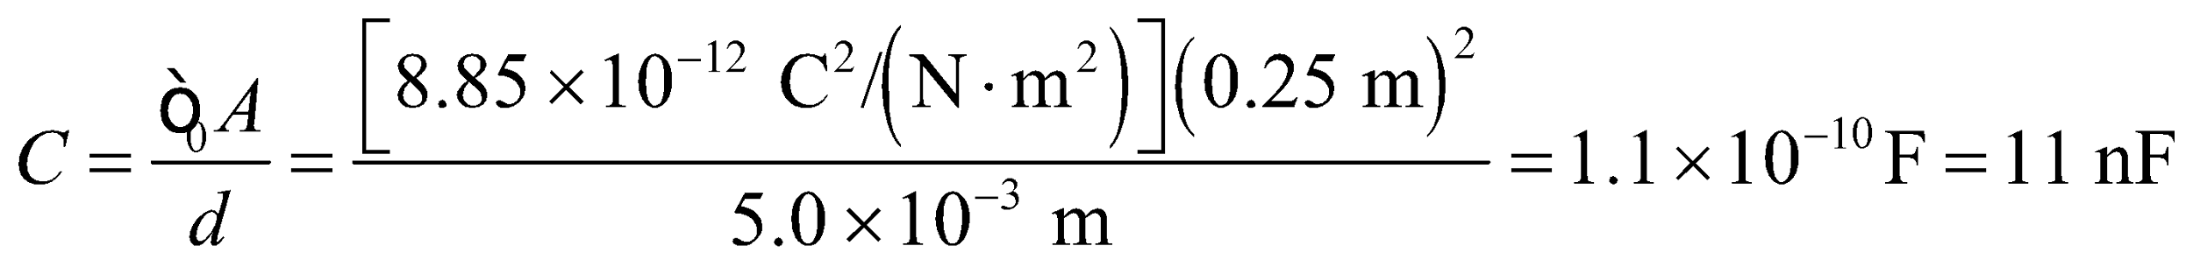

The value is typical of a capacitor.

**19.** **Interpret** We are to find the work required to charge a capacitor with the given charge, then find the additional work required to double the charge.

**Develop** The separation between capacitor plates is much smaller than the linear dimensions of the plates, so the discussion in Section 23.2 applies. From Equation 23.3, we see that the work is

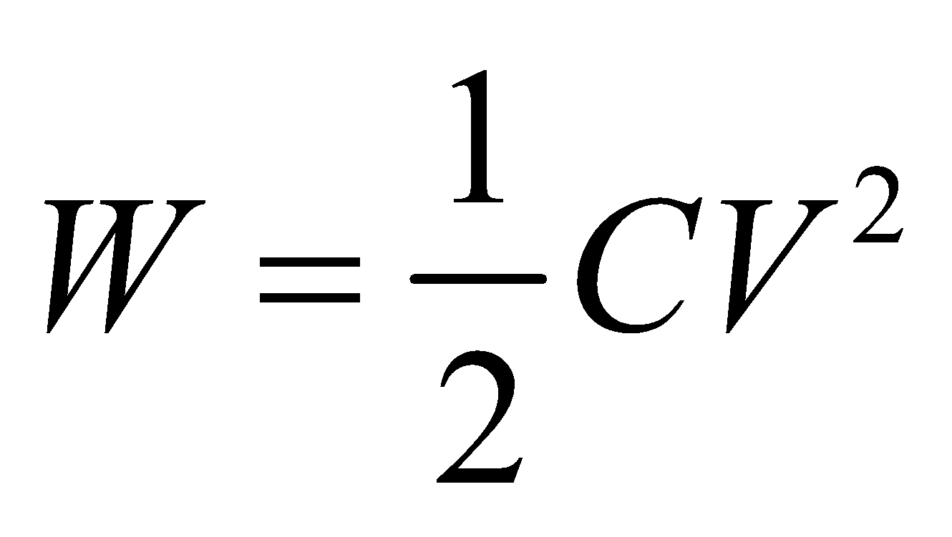

where *V* is the final voltage and may be expressed using Equation 23.1, *C* = *Q*/*V*. This gives

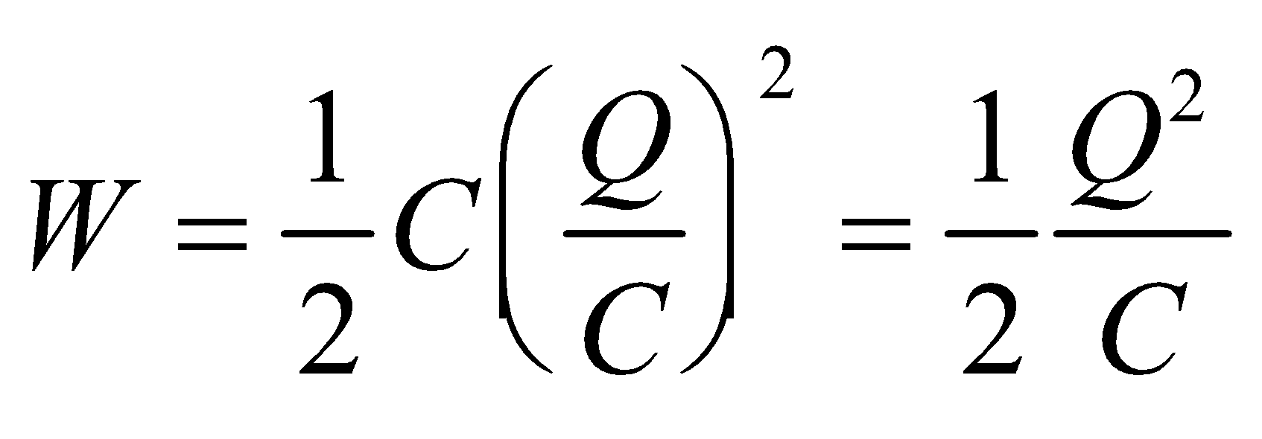

The capacitance can be expressed in terms of the geometry of the capacity (Equation 23.2, 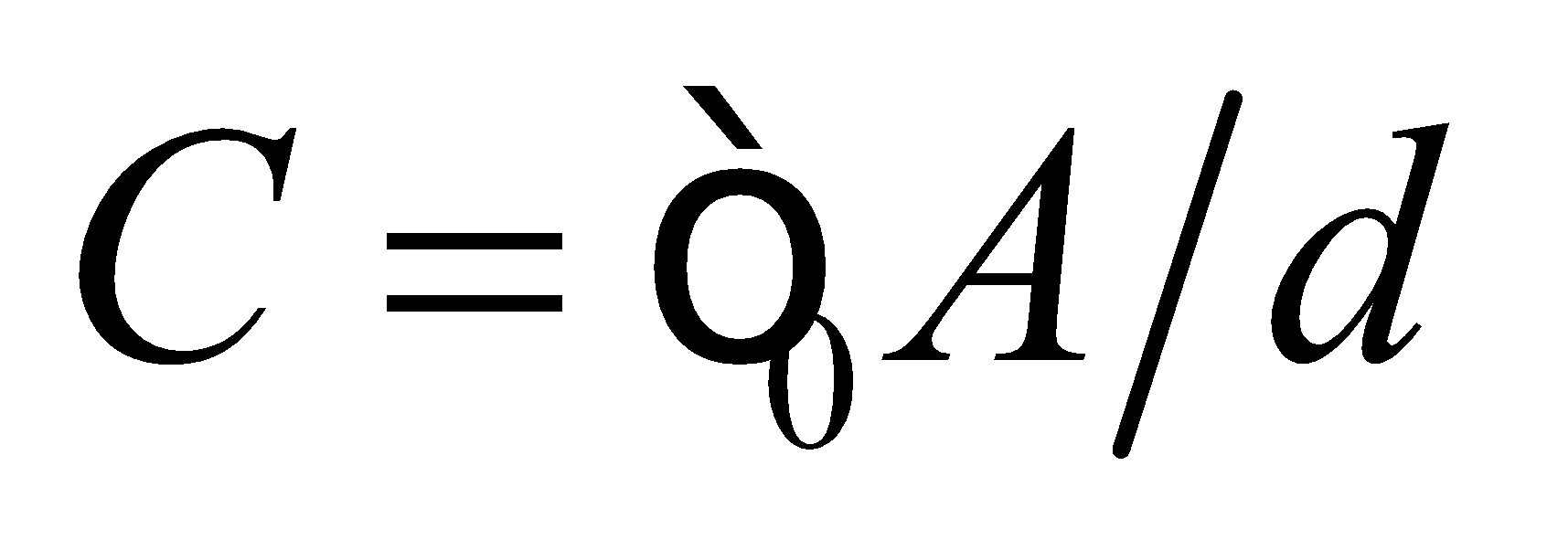 which leads to

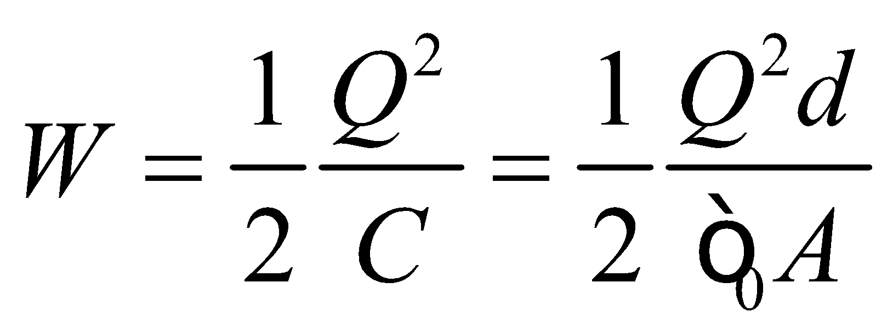

**Evaluate** (**a**) The work required to transfer Q =7.2 μC is

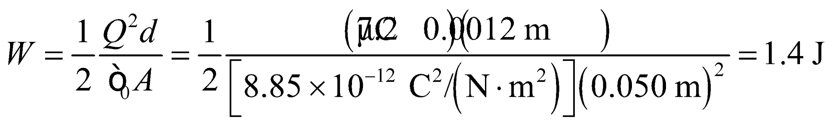

(**b**) The additional work required to double the charge on each plate is

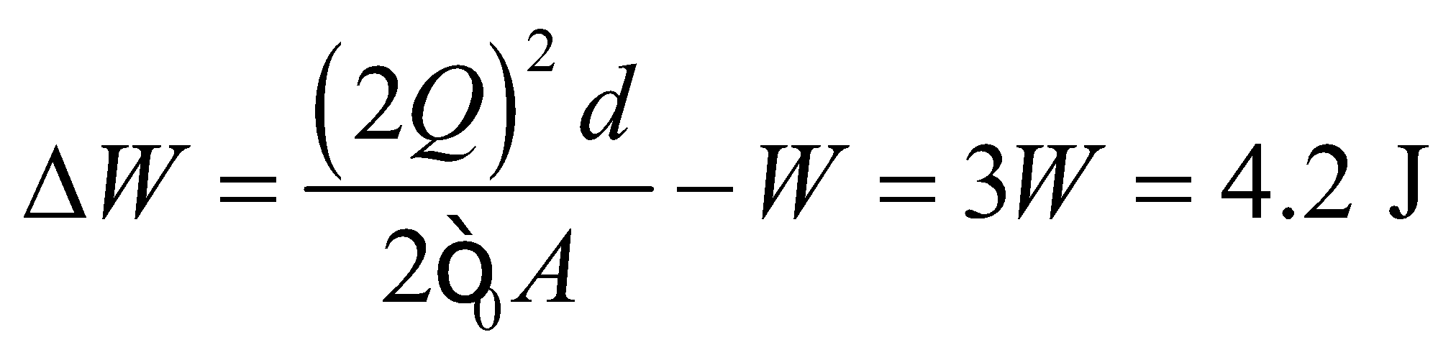

**Assess** This energy is stored in the capacitor and can be released by electrically connecting the two capacitor faces.

**20. Interpret** This problem is about the energy stored in a parallel-plate capacitor. We are to find the charge on each plate (oppositely charged, of course) needed to store the given energy, and the resulting electric potential between the plates.

**Develop** Using the expression from Problem 23.19 for the work (i.e., change in potential energy) required to charge the plates, we can solve for the charge:

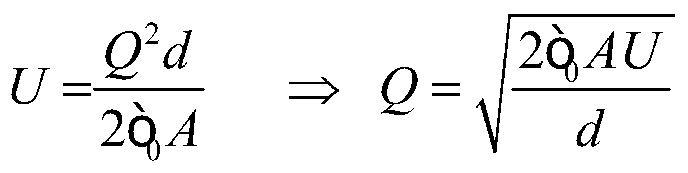

Once *Q* is known, the potential difference *V* between the plates is

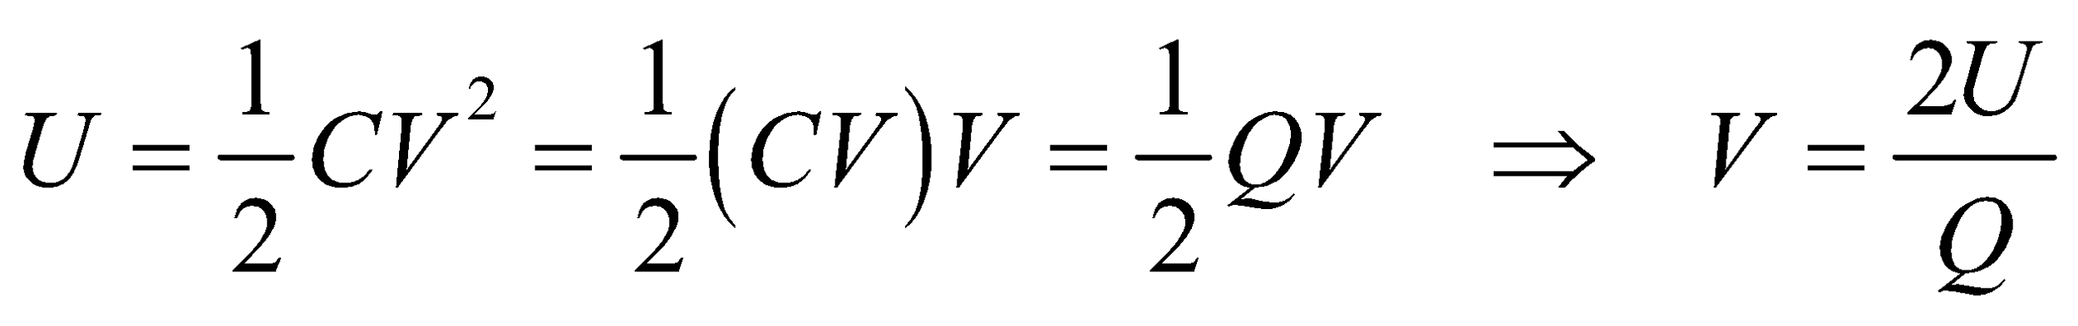

**Evaluate** **(a)** Using the values given in the problem statement, we find the charge to be

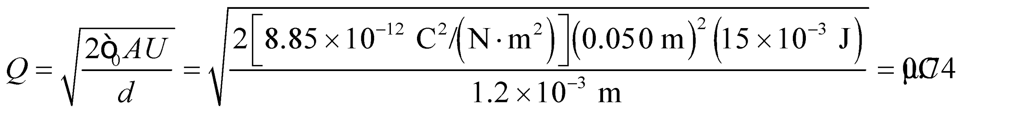

**(b)** The potential difference is

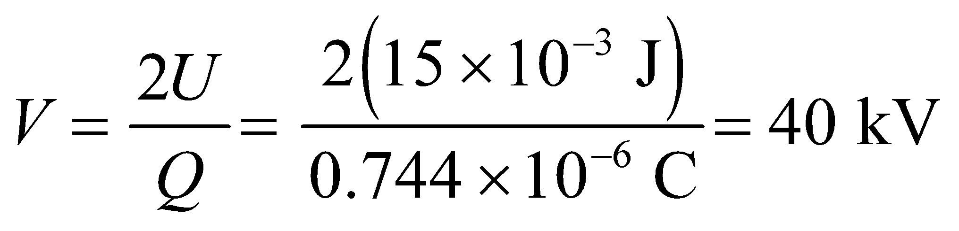

**Assess** Since the electric field between the plates is 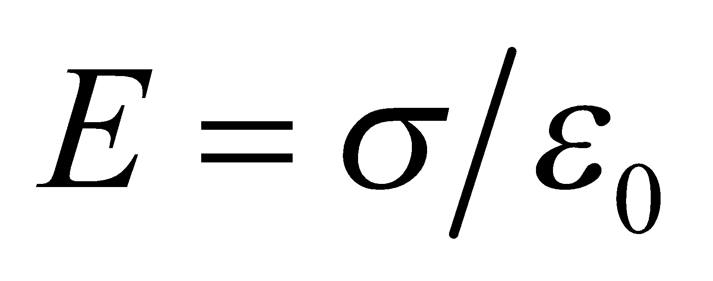 the potential can also be found using

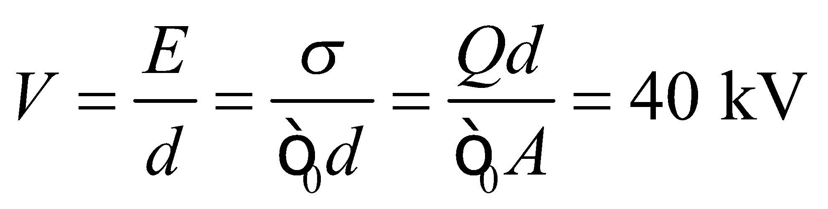

**21.** **Interpret** We are given the charge and voltage of a capacitor and are to find the capacitance.

**Develop** Apply Equation 2.31, *C* = *Q*/*V*.

**Evaluate** From Equation 23.1,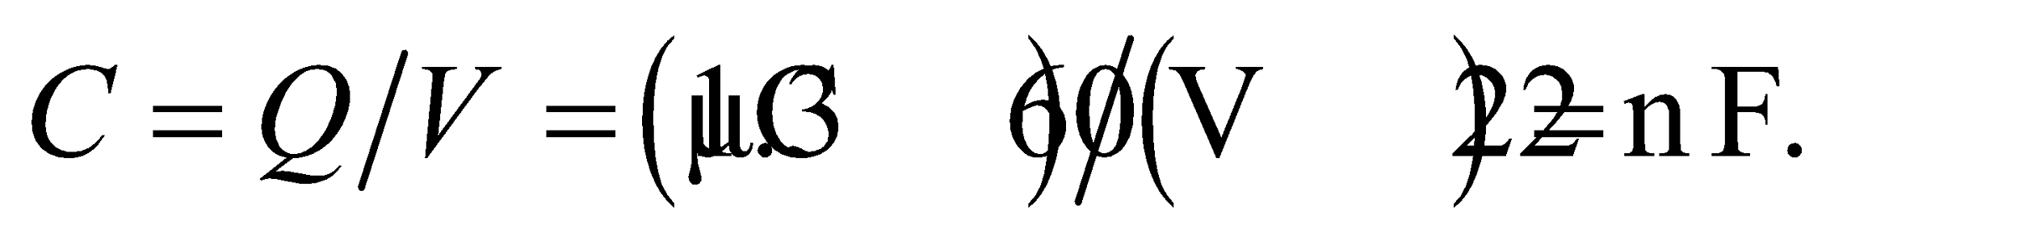

**Assess** The capacitance is the charge per unit voltage.

**22. Interpret** This problem deals with the electrostatic energy stored in a capacitor.

**Develop** Equation 23.1, 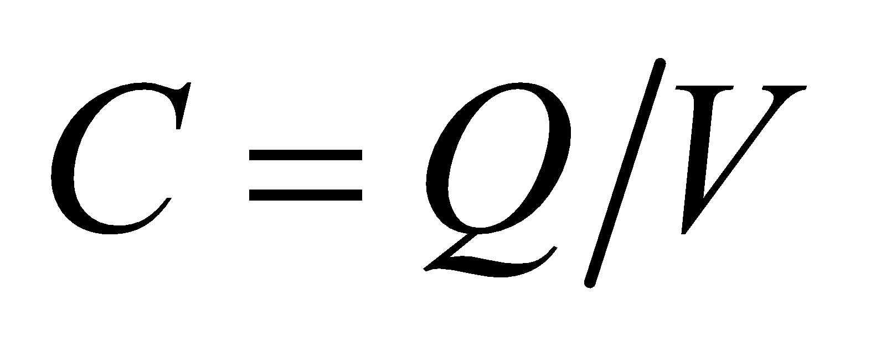 provides the connection between capacitance *C*, charge *Q*, and potential difference *V*. Solve this equation for *Q*.

**Evaluate** The magnitude of the charge on both plates is

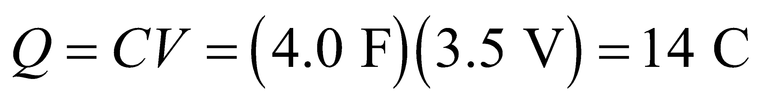

**Assess** This is a very large capacitor, since the capacitance of most capacitors falls in the range of 1 pF to 1 F.

**23.** **Interpret** We are given the capacitance and charge of a capacitor and are to find the voltage.

**Develop** Solve Equation 23.1, *C* = *Q*/*V*, for the voltage *V*.

**Evaluate** Equation 23.1 gives 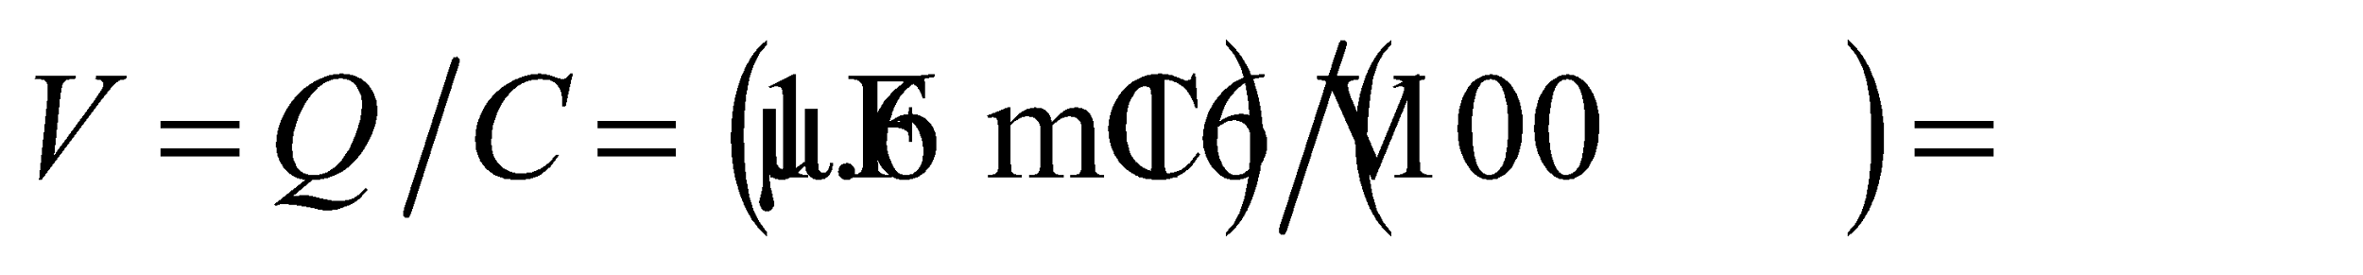

**Assess** This is a typical-sized capacitor.

**24. Interpret** We are to derive an alternate form of the units of 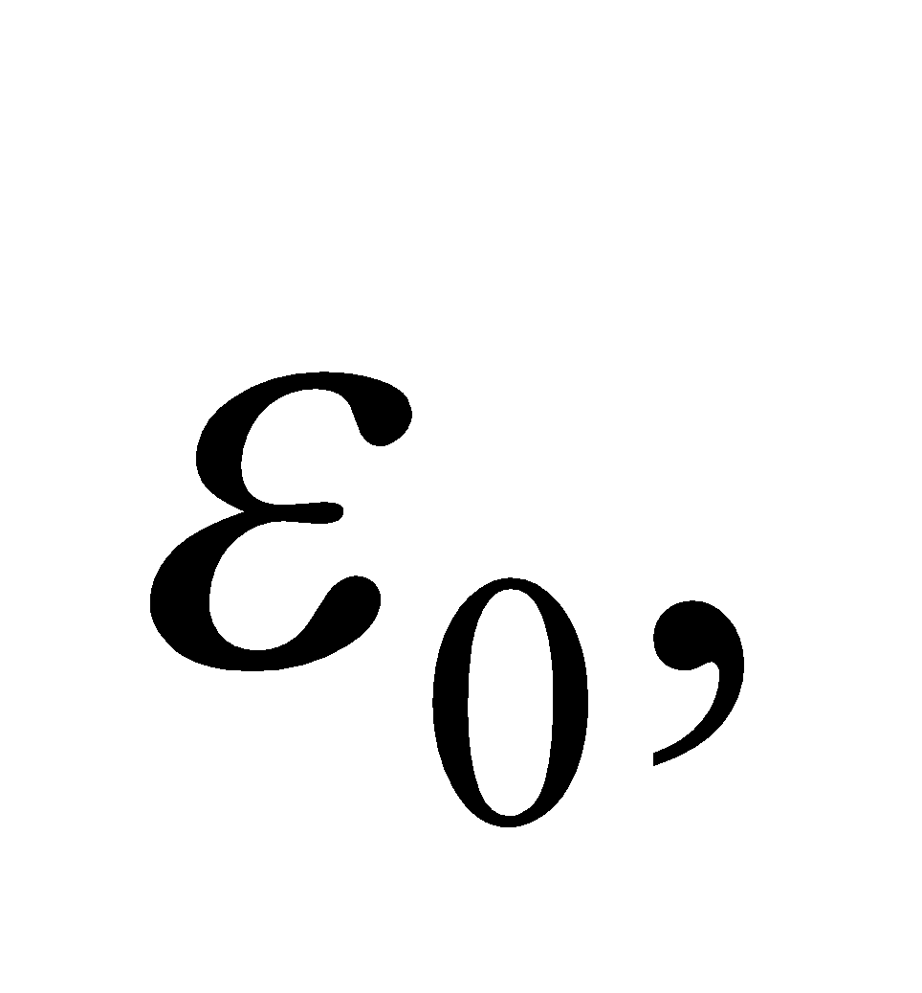 the permittivity constant.

**Develop** The value of 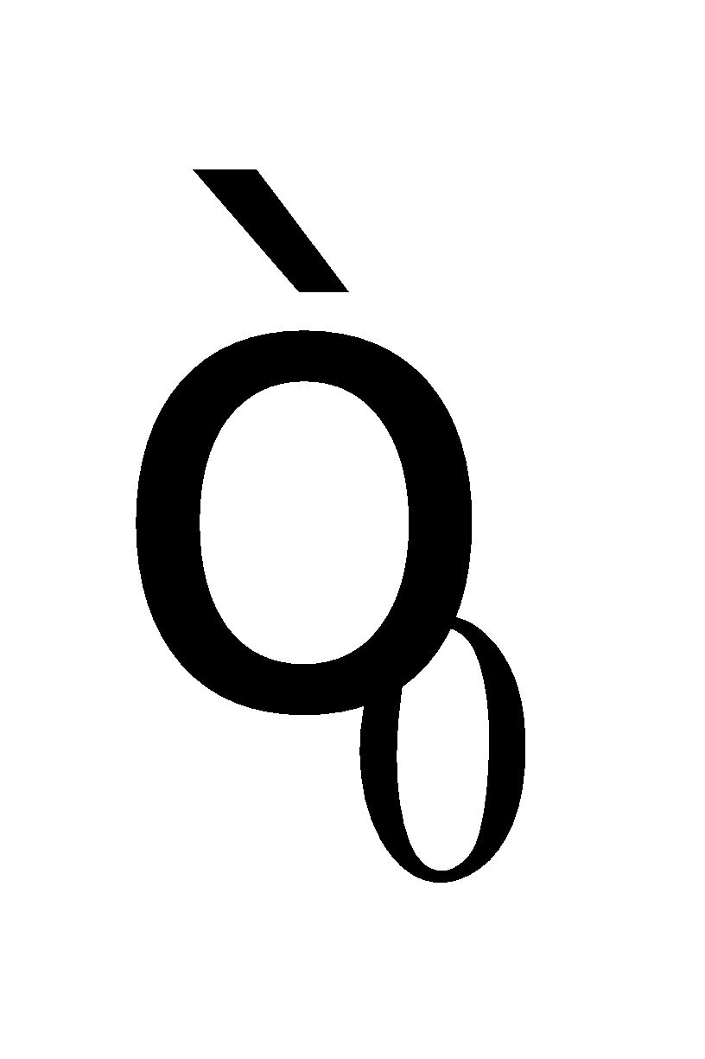 is 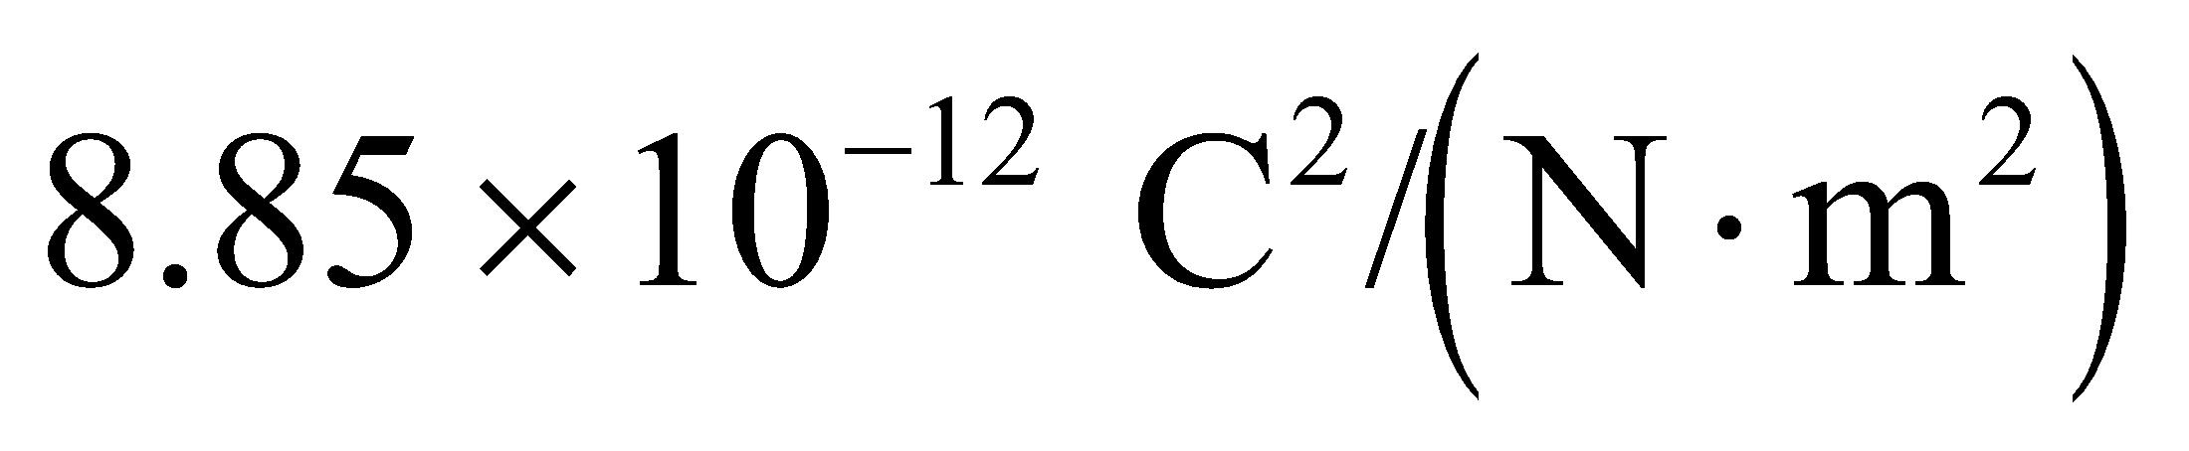 with units 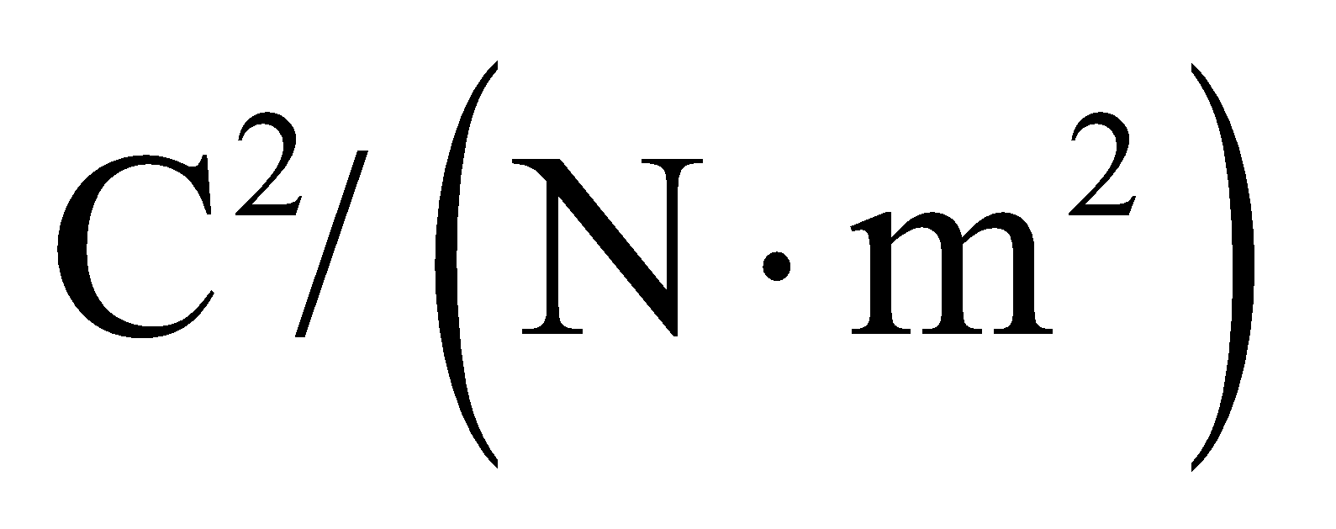. However, because 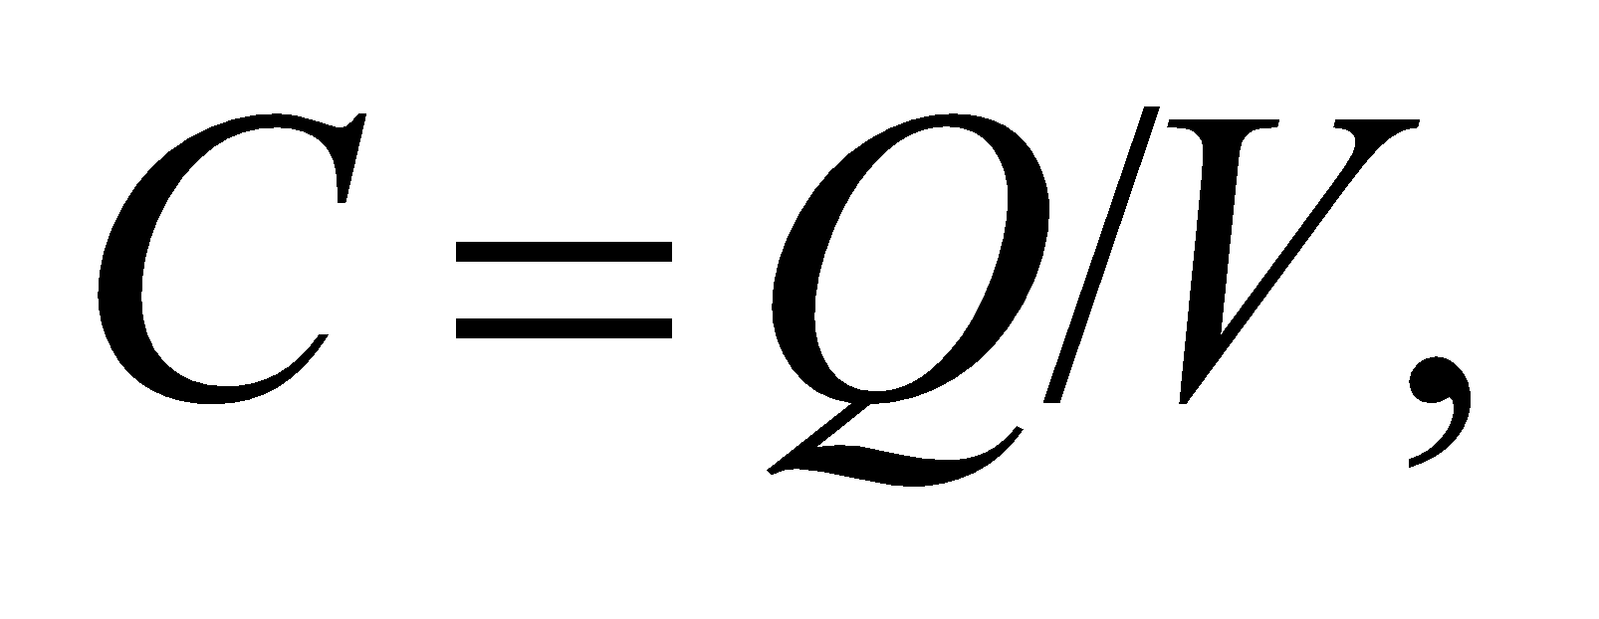 1 F (farad) is equivalent to 1 C/V.

**Evaluate** From the above, we see that the units of  are



**Assess** To see that the result makes sense, we can use Equation 23.2 and write

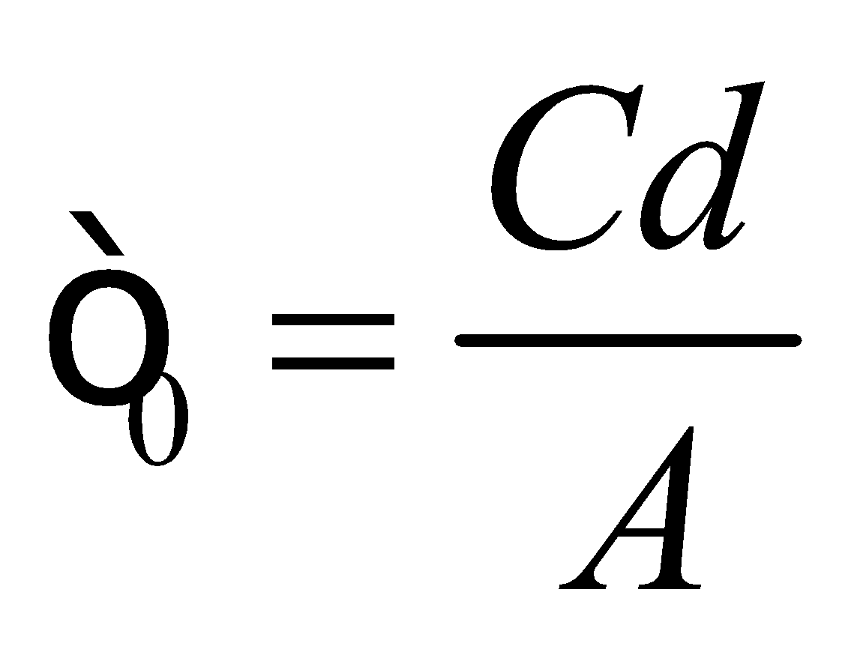

The units of *C* are F, while the units of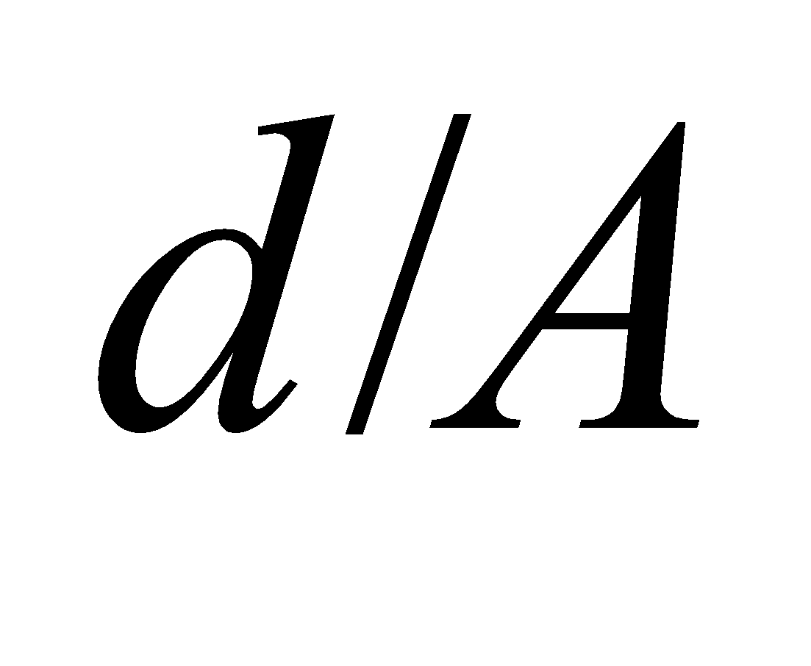are m−1.

**25.** **Interpret** We are given the separation of a parallel-plate capacitor, its charge, and its voltage and are to find its capacitance.

**Develop** Because the plate separation *d*  *r*, the radius of the capacitor, and apply Equation 23.2, 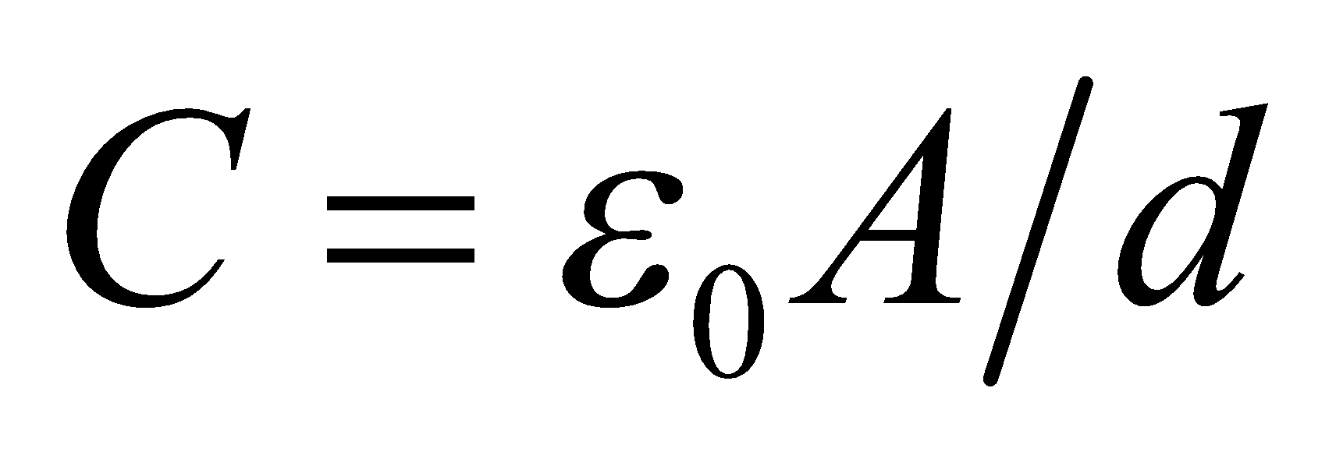, with A = *πr*2.

**Evaluate** Inserting the given quantities gives

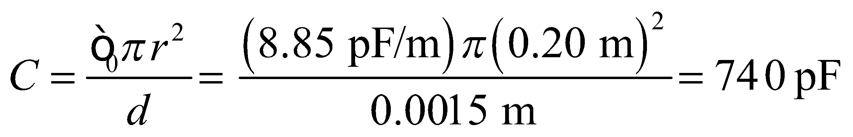

to two significant figures.

**Assess** This is a typical value for a capacitance.

**26. Interpret** For a parallel-plate capacitor, we are given the plate spacing, the charge, and the voltage and are to find the plate area.

**Develop** Combining Equations 23.1 and 23.2 for capacitance gives

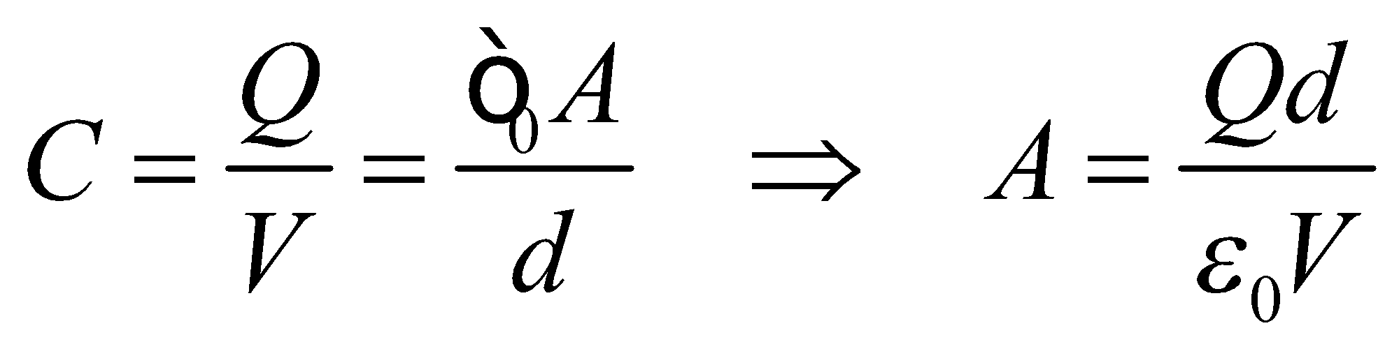

**Evaluate** Inserting the given quantities gives

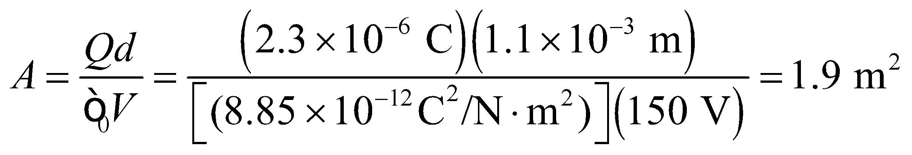

**Assess** If we take the plate to be square, then each side has a length of 1.38 m, which indeed is much greater than the distance of 1.1 mm between the plates. Note expressing voltage in its SI units of N·m/C gives the proper units.

**27.** **Interpret** We are given the capacitance and the voltage of a capacitor and are to find the stored energy.

**Develop** Apply Equation 23.3, *U* = *CV*2/2.

**Evaluate** From Equation 23.3,

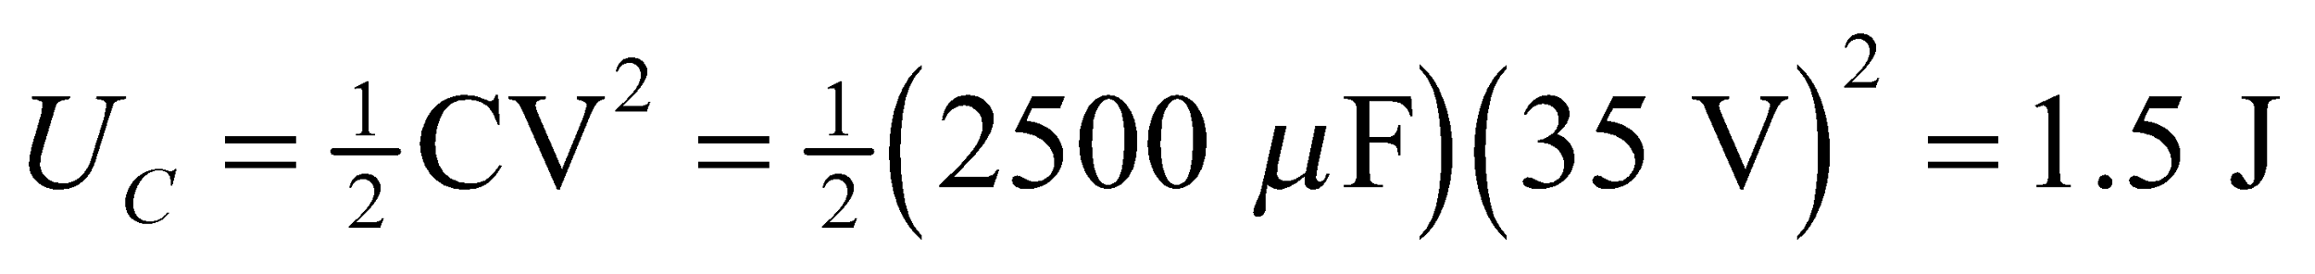

**Assess** This is the energy it would take to lift 1.0 liter of water through a height of

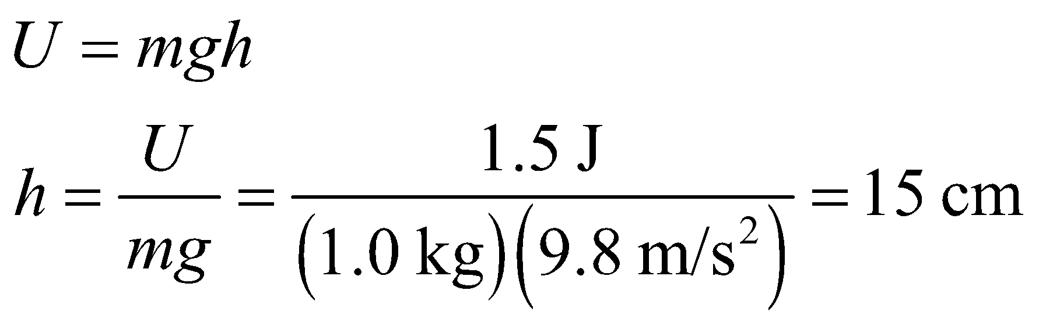

**28. Interpret** We are given the energy stored in a capacitor and its voltage and are to find its capacitance.

**Develop** Equation 23.3, 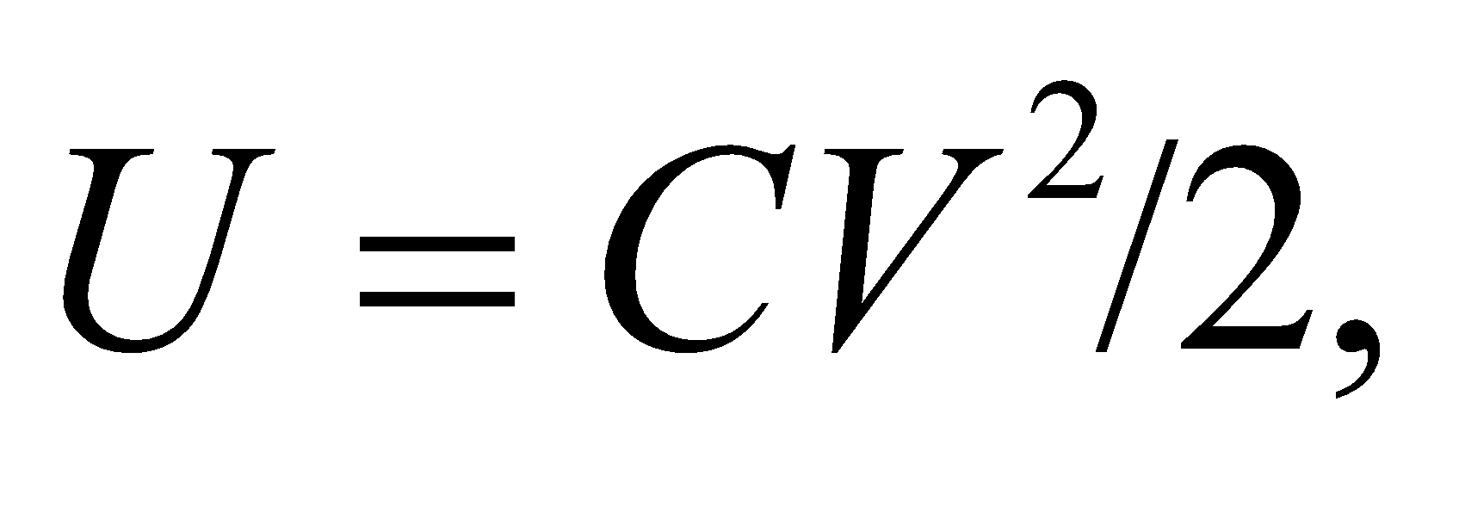 provides the connection between the stored energy *U*, the capacitance *C*, and the potential *V*.

**Evaluate** Inserting the given values gives

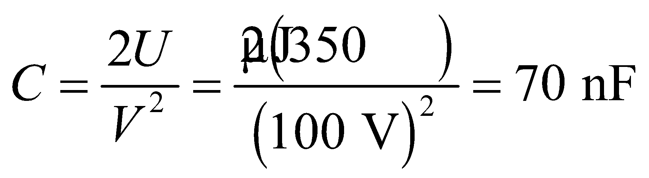

**Assess** The value is within the typical range of capacitance 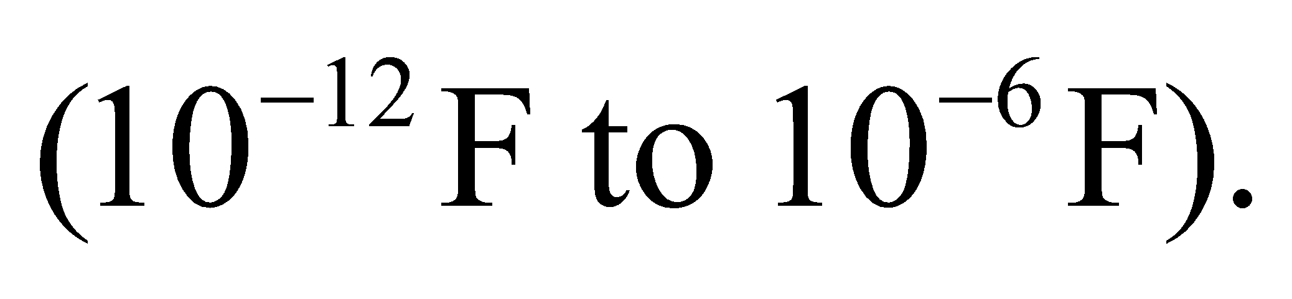

**Section 23.3 Using Capacitors**

**29.** **Interpret** This problem involves calculating the equivalent capacitance for the two given capacitors connected in series or in parallel.

**Develop** Apply Equations 23.5 to find the equivalent series capacitance and Equation 23.23.6b for the equivalent parallel capacitance.

**Evaluate** In parallel, the capacitance is



In series, the capacitance is

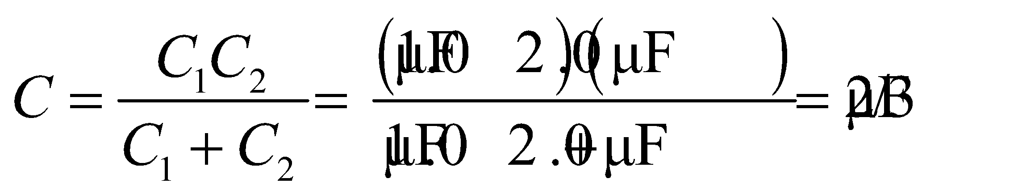

**Assess** Connecting the capacitors in parallel results in a higher equivalent capacitance than connecting them in series.

**30. Interpret** This involves connecting two capacitors in series and finding their relative capacitance, given the voltage across each capacitor and the voltage across the capacitor pair.

**Develop** For two capacitors connected in series, the charge on each capacitor must be the same (see discussion accompanying Figure 23.8),

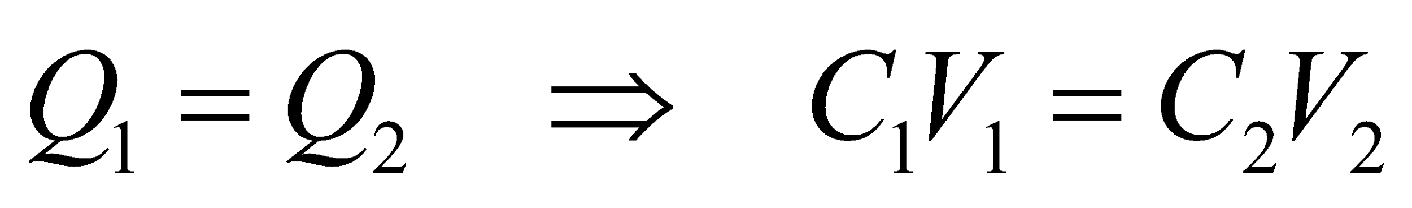

Given that *V*1 = *V*2, we can find the ratio of the capacitances.

**Evaluate** Because *V*1 = *V*2, the expression above gives

*C*1 = *C*2

**Assess** The equivalent capacitance of two capacitors connected in series is

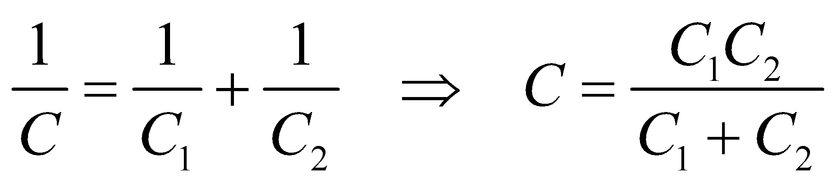

In our case, 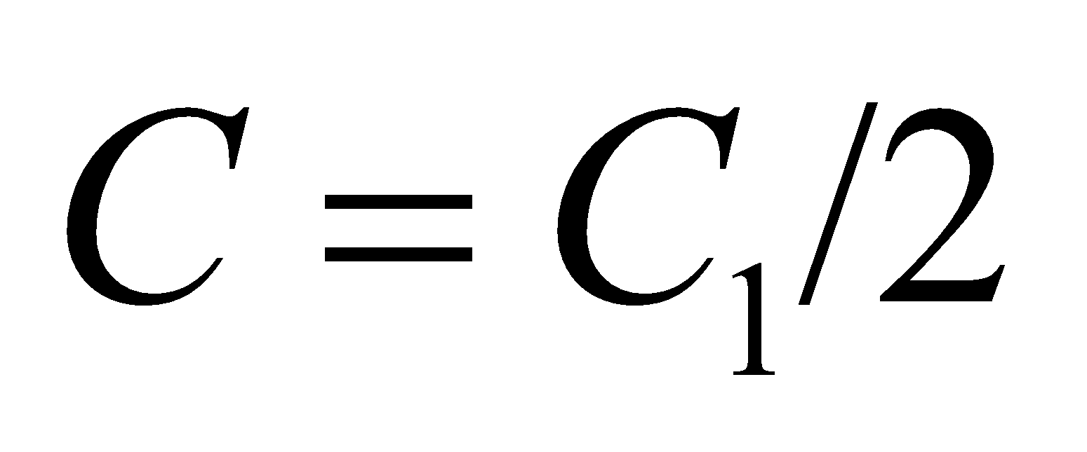 since 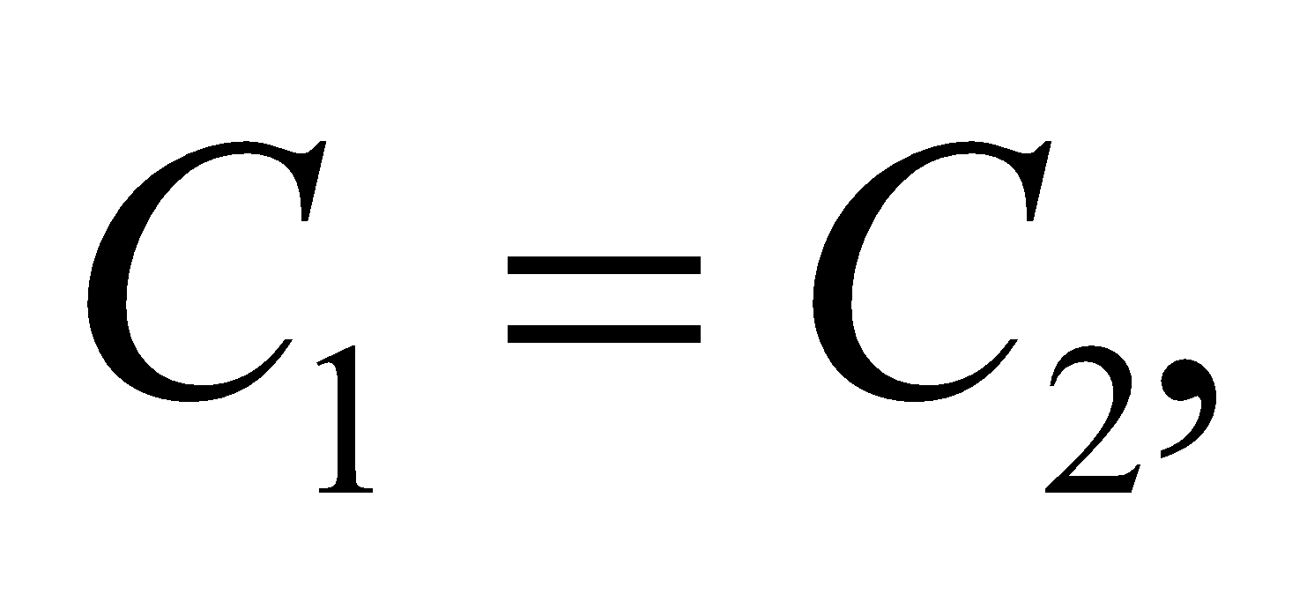 and the voltage across *C* is

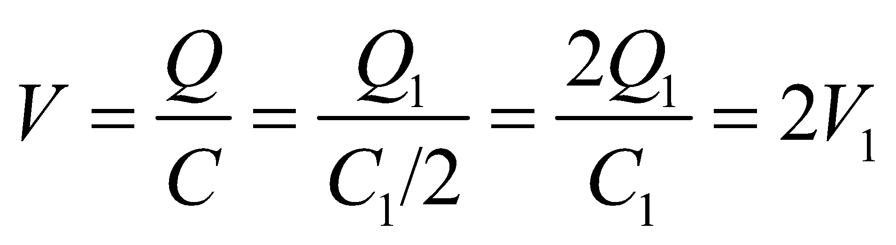

which is precisely the condition given in the problem statement.

**31.** **Interpret** This problem requires us to find the equivalent capacitance of the given arrangement of individual capacitors, which combines series and parallel connections.

**Develop** For part (a), compute the equivalent capacitance of *C*2 and *C*3 (which are in parallel), then combine this in series with *C*1 to find the overall capacitance. For part (b), note that the charge on *C*2 and *C*3 must be the same as on *C*1, which must be the same as the total charge (see discussion accompanying Figure 23.8), so

*Q*T = Q1 = *Q*2 + *Q*3

In addition, the total charge and capacitance must satisfy Equation 23.1,

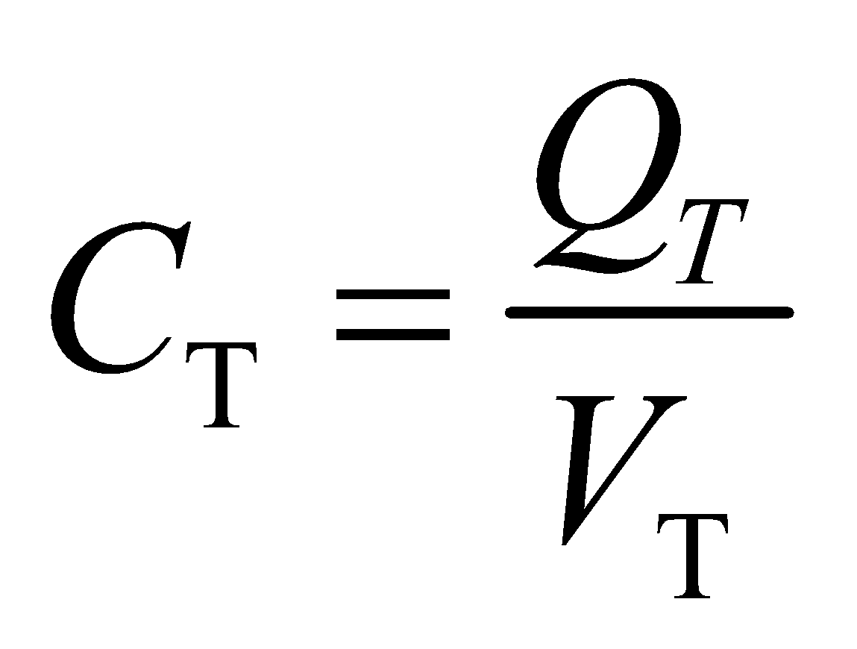

where *V*T = 100 V. Finally, the voltage drop across *C*2 must be the same as across *C*3, so

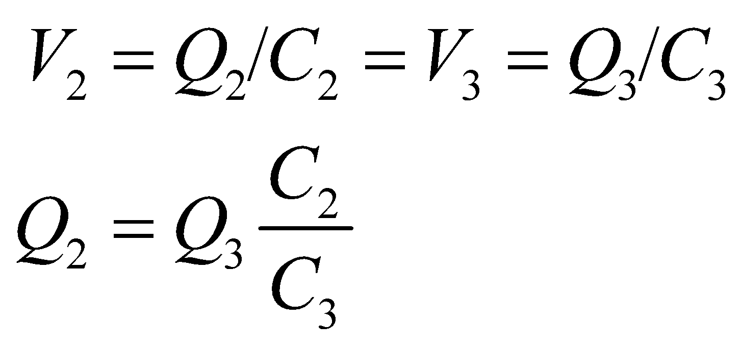

**Evaluate** (**a**) Capacitors *C*2 and *C*3 combined in parallel give an equivalent capacitance of

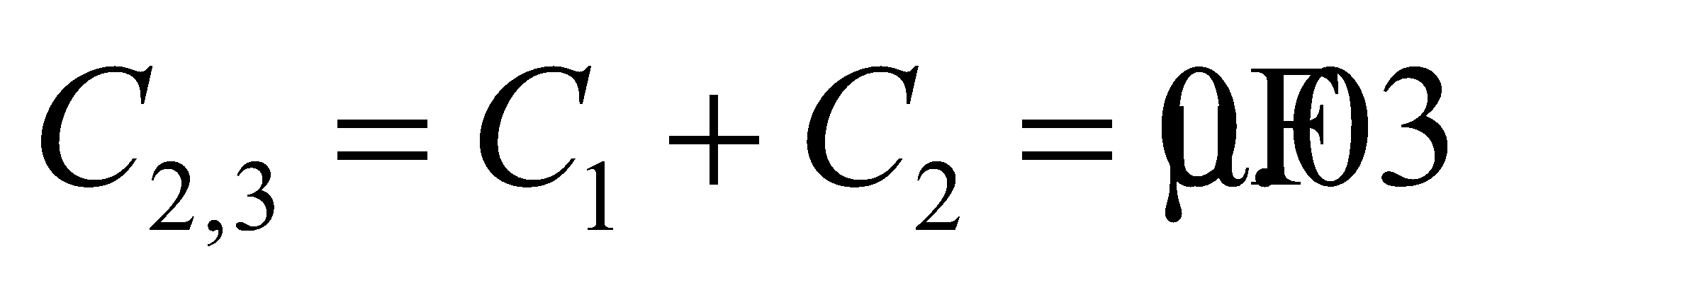

Combining this in series with *C*1 gives

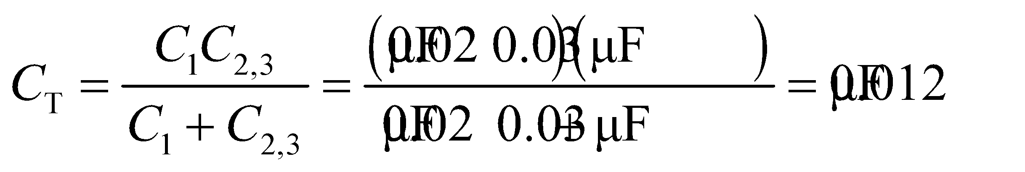

(**b**) Knowing *C*T and *V*T, we can find *Q*T, which must be the same as *Q*1 (see Example 23.3)

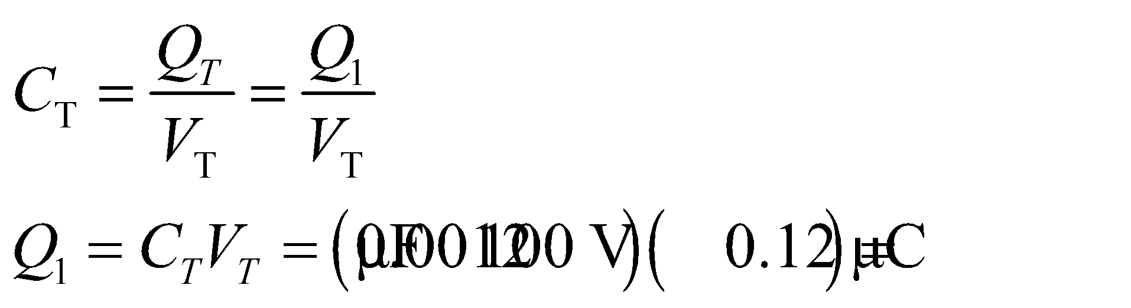

Knowing *Q*1, we can solve for *Q*2 and *Q*3 using the expressions above. The result is

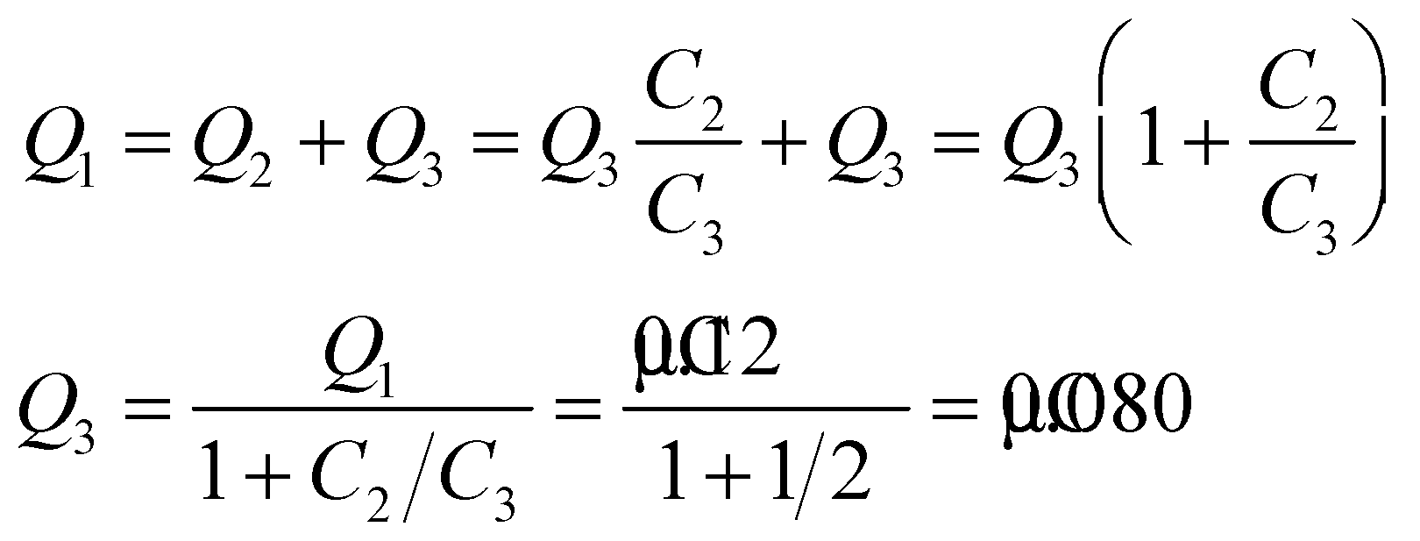

Finally, *Q*2 is

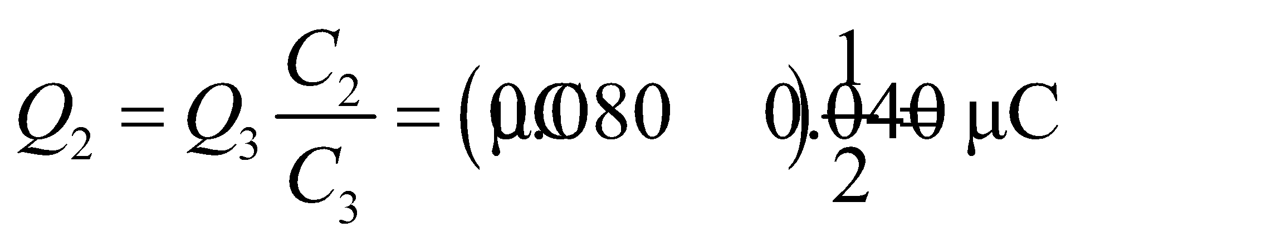

(**c**) The voltage on *C*1 can be found using Equation 23.1. The result is

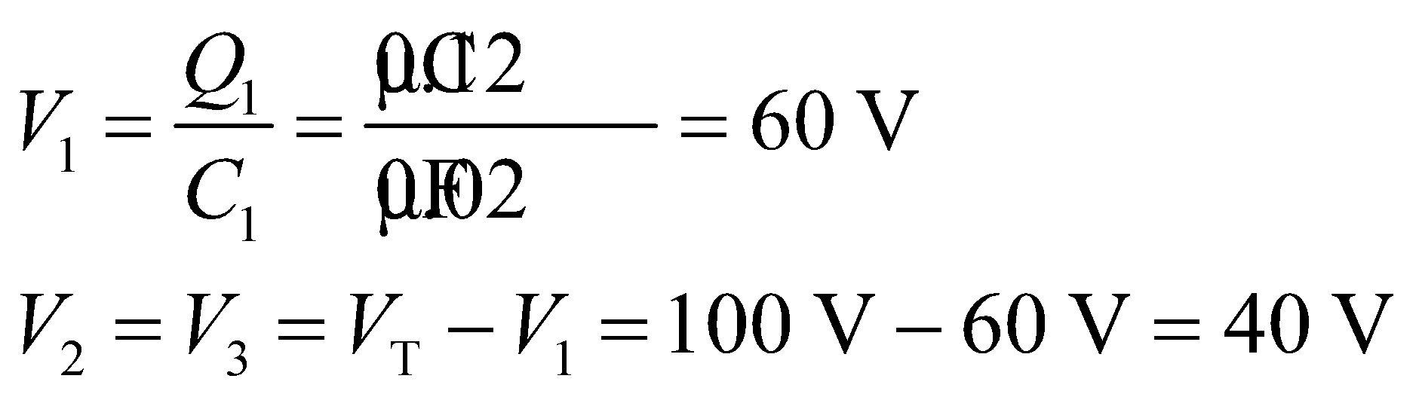

**Assess** The voltage across the parallel capacitors may also be found using Equation 23.1:

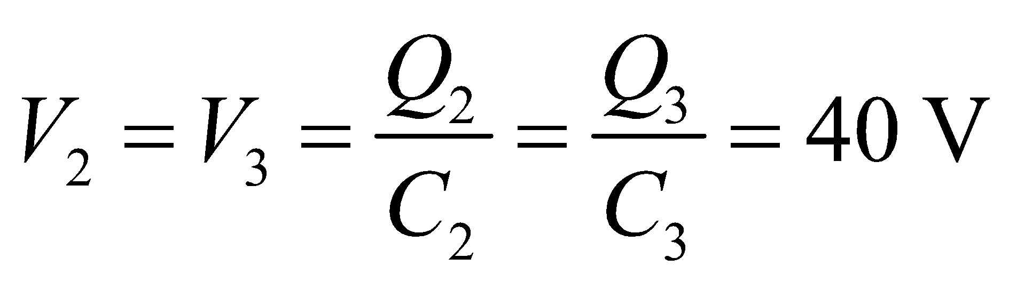

**32.** **Interpret** This problem requires us to find all possible equivalent capacitances that can be obtained connecting three capacitors in different ways (serial, parallel, and combinations thereof).

**Develop** The equivalent capacitance *C* is maximized when all capacitors are connected in parallel and is given by (Equation 23.5)

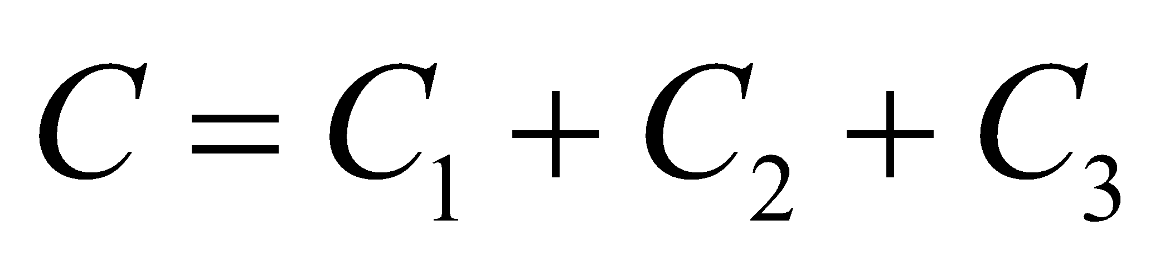

On the other hand, *C* is minimized when the capacitors are connected in series. For three capacitors connected in series, the equivalent capacitance C is given by (Equation 23.6)

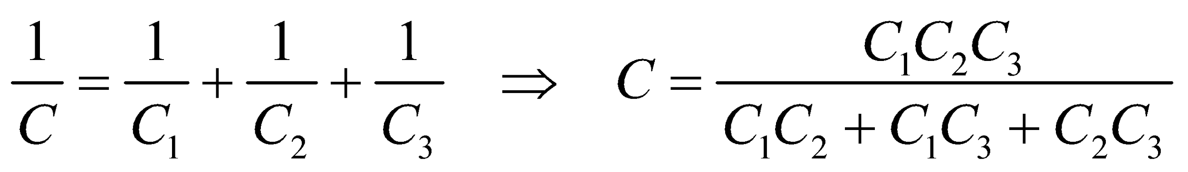

Intermediate values are obtained when one capacitor is in parallel with the other two in series, or one in series with the other two in parallel.

**Evaluate** **(a)** When all capacitors are in parallel, we have



**(b)** When all are in series, the equivalent capacitance is



**(c)** When one is in parallel with the other two in series, the possible values are

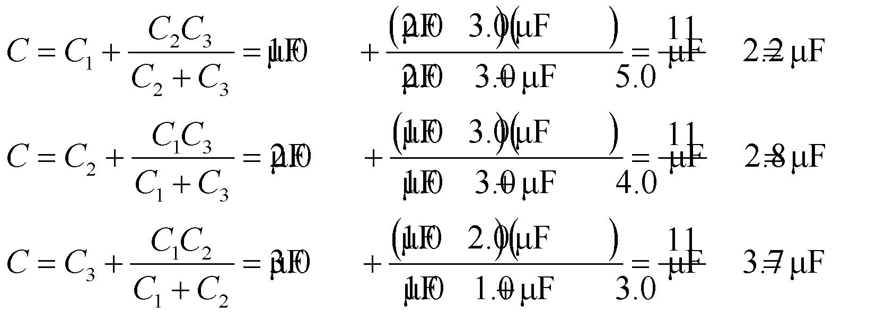

Similarly, when one is in series with the other two in parallel, the equivalent capacitance is

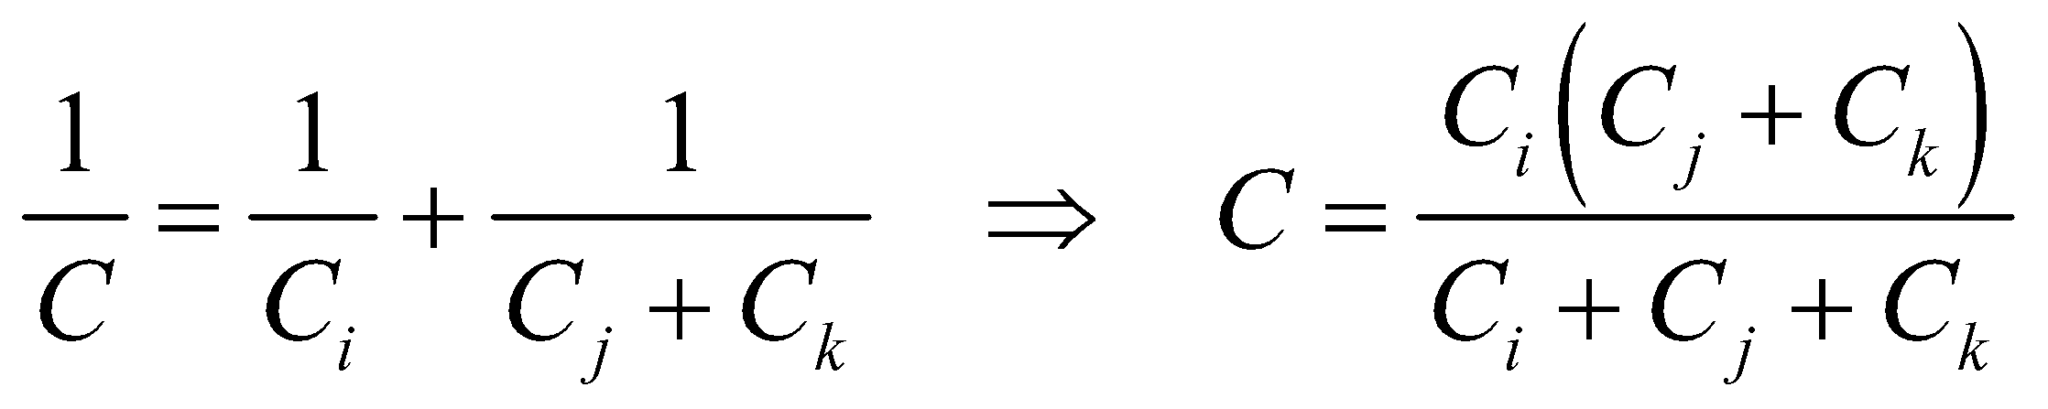

Therefore, the possible values are

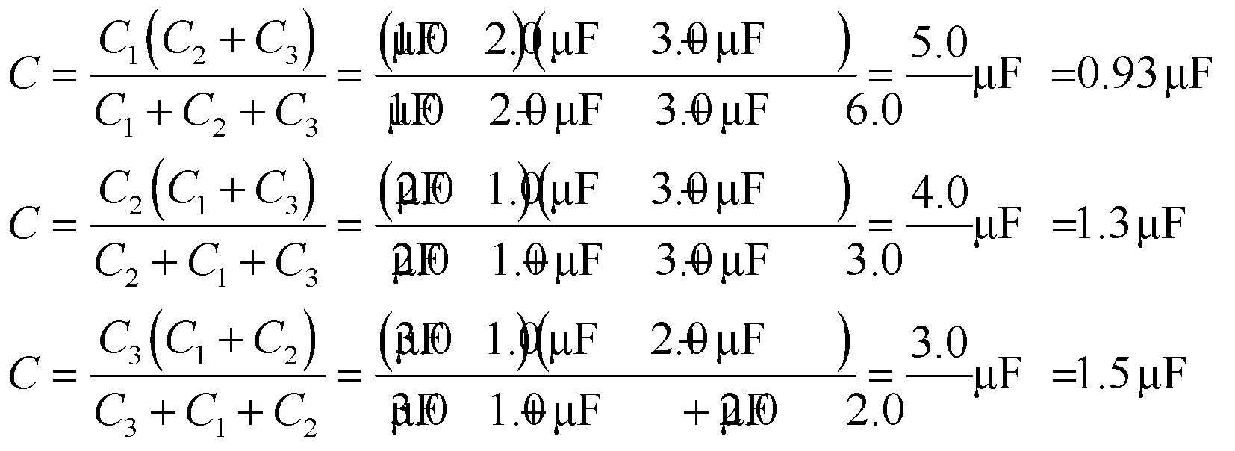

**Assess** With three capacitors, each having two options (parallel or series), there are eight possible outcomes (= 23).

**Section 23.4 Energy in the Electric Field**

**33.** **Interpret** This problem involves finding the uniform electric field that carries the given energy density.

**Develop** Apply Equation 23.7, (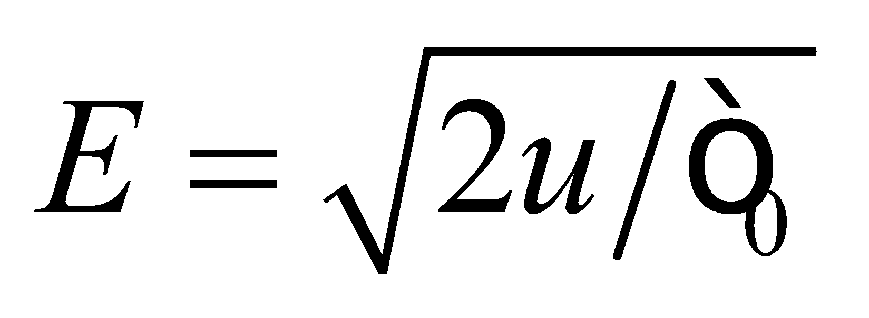) which relates the field strength and the electric energy density.

**Evaluate** Inserting the given energy density into Equation 23.7 gives

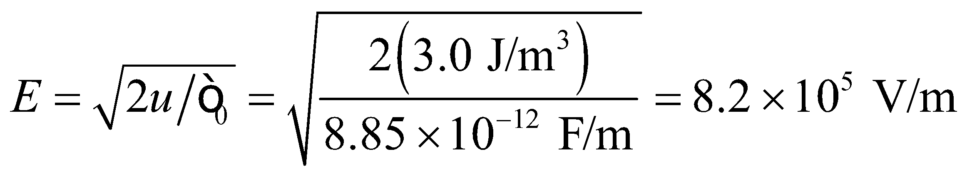

**Assess** The manipulation of units is facilitated by the relations V = J/C and F = C/V. Thus,

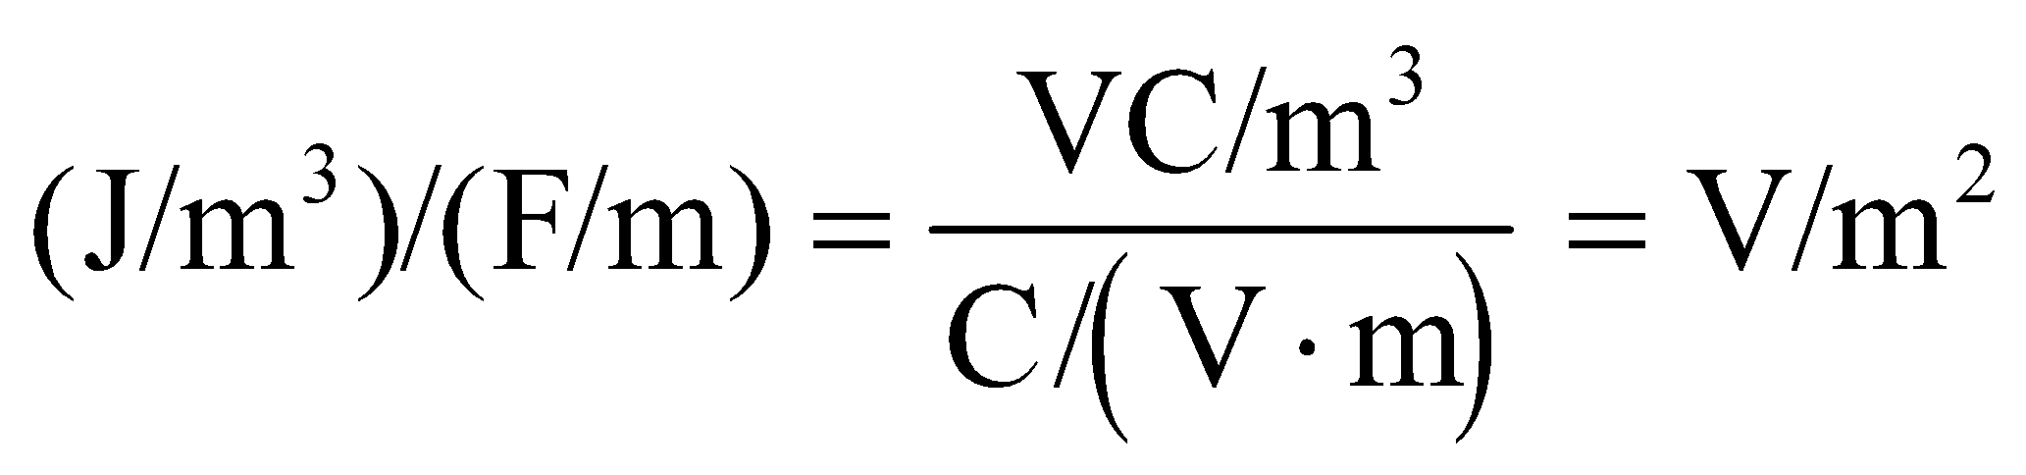

**34. Interpret** This problem is about the volume required for storing a given amount of electrostatic energy.

**Develop** For a uniform electric field, Equation 23.8 can be written as

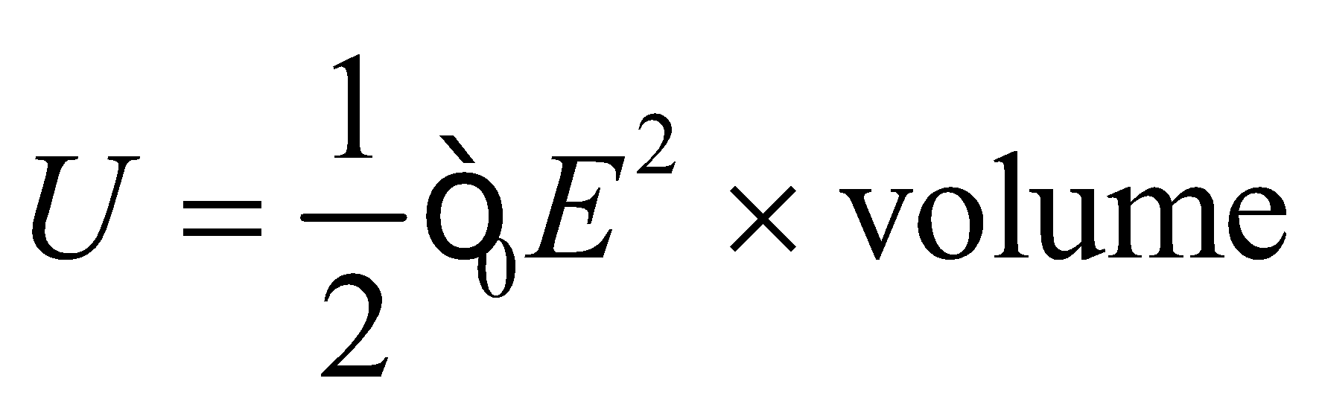

Knowing *U* and *E* allows us to find the volume.

**Evaluate** Substituting the values given in the problem statement gives the volume as

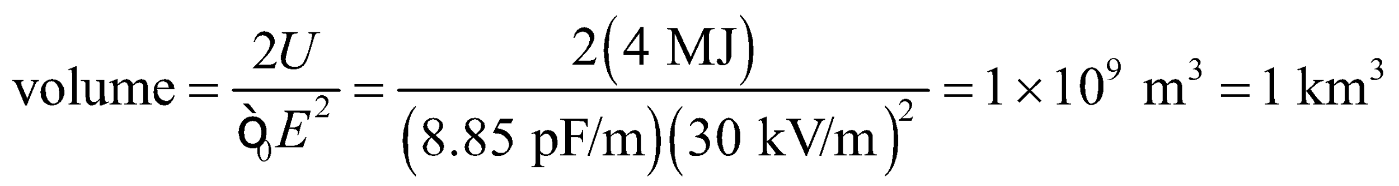

**Assess** This is a very big volume occupied by a car battery. In reality, not all the stored energy goes into creating the field.

**35.** **Interpret** This problem involves finding the maximum electrical energy density possible in air.

**Develop** From Appendix C, we find that the energy content of gasoline is 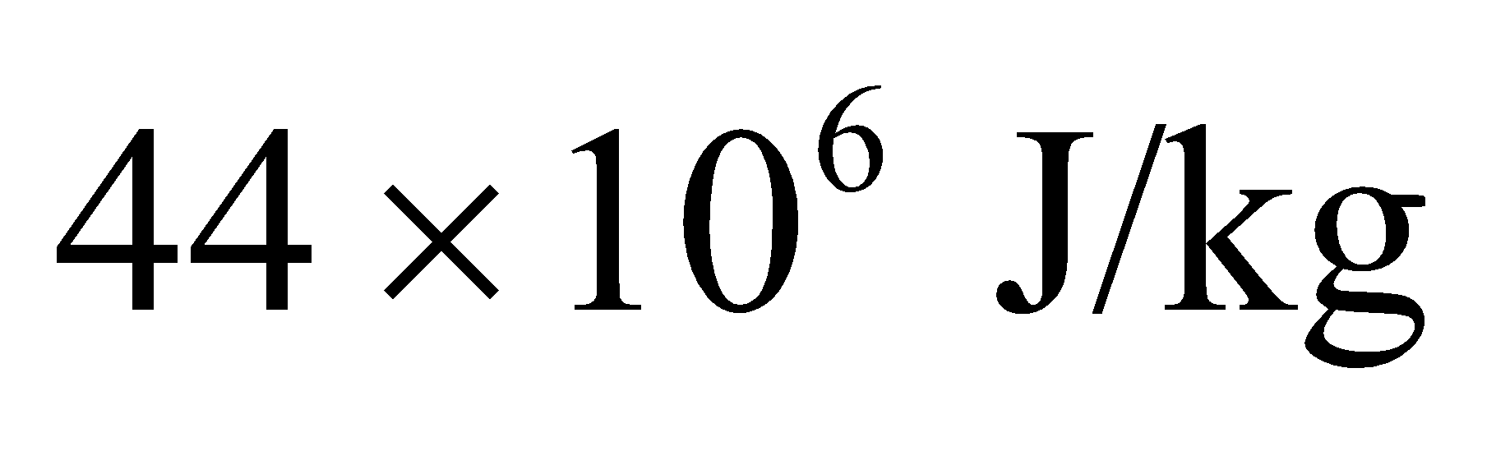, and the density of gasoline is 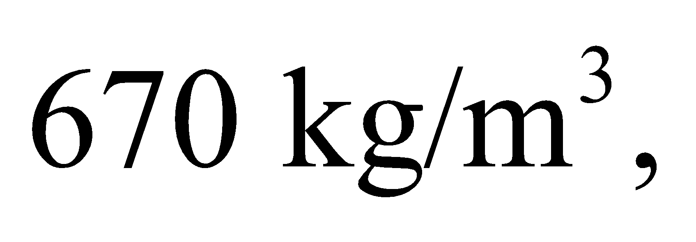 so the equivalent energy density is



**Evaluate** From Equation 23.7, the field strength giving the same electrostatic energy density is

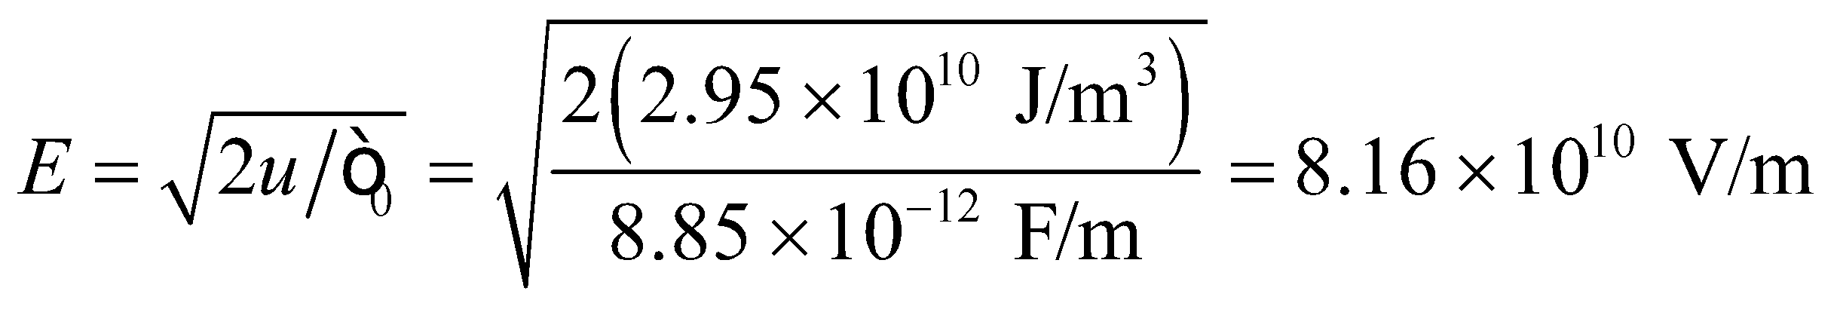

which greatly exceeds the breakdown field in air.

**Assess** Gasoline is actually a very dense form of energy storage, which is one reason it is hard to replace!

**36. Interpret** In this problem we are asked to find the electric energy stored in a proton by assuming it to be a uniformly charged sphere.

**Develop** For this model of the proton, the field strength at the surface is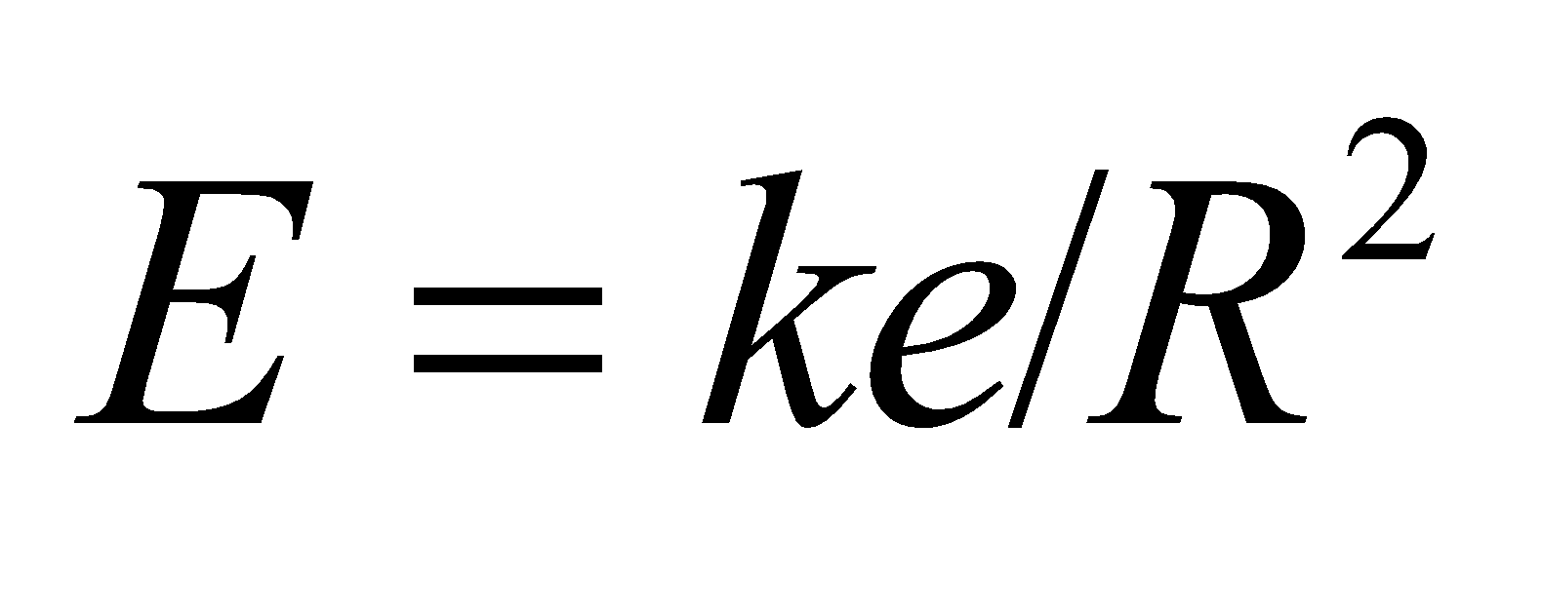(from spherical symmetry and Gauss’s law). Thus, the energy density in the surface electric field is

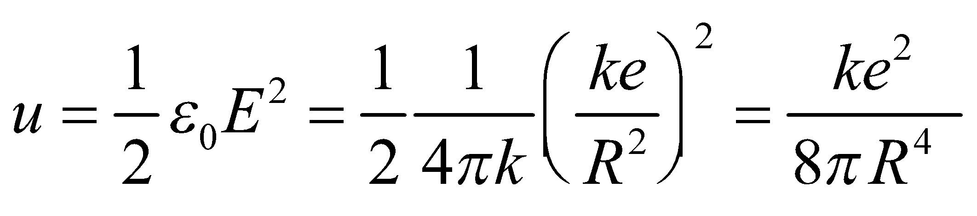

**Evaluate** With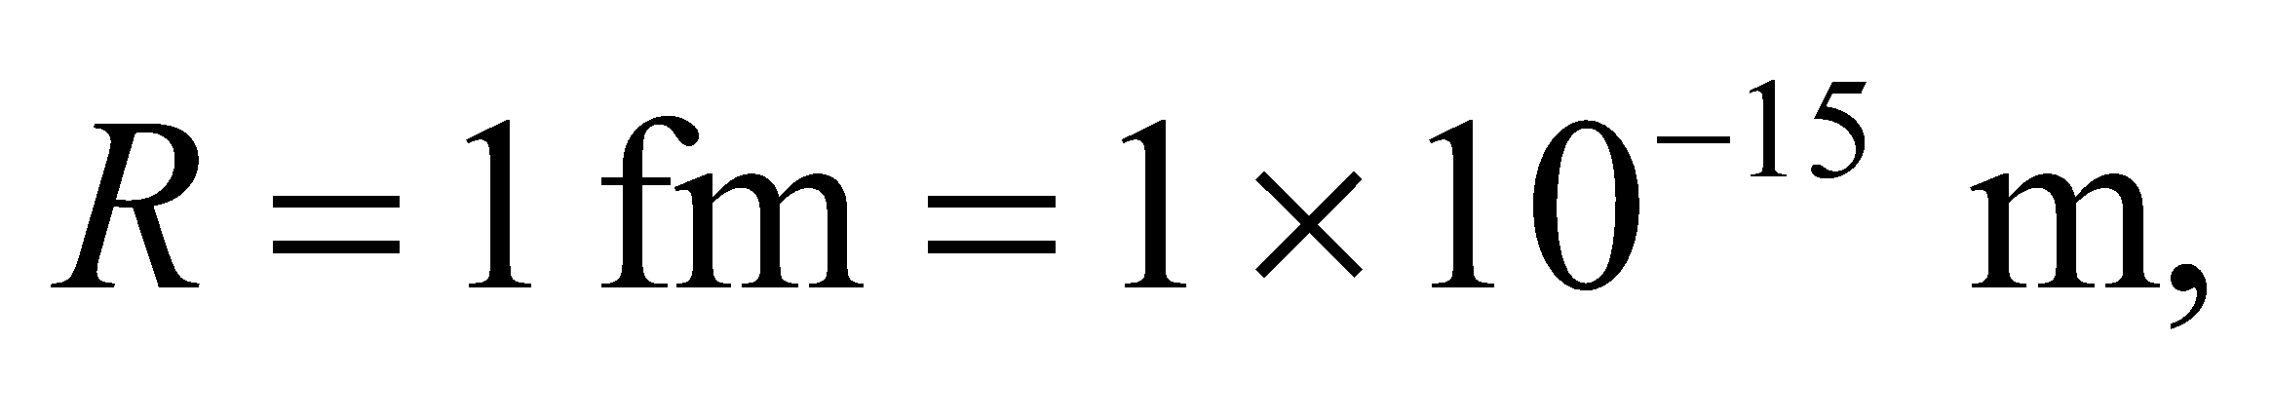the energy density is



**Assess** The energy density is enormous, given the small size of the proton.

**Problems**

**37.** **Interpret** This problem involves finding an expression of the work required to assemble the given charge configuration, and using this expression to find the relative charge on one of the charges with respect to the initial charge.

**Develop** The work necessary to position *Qx* is

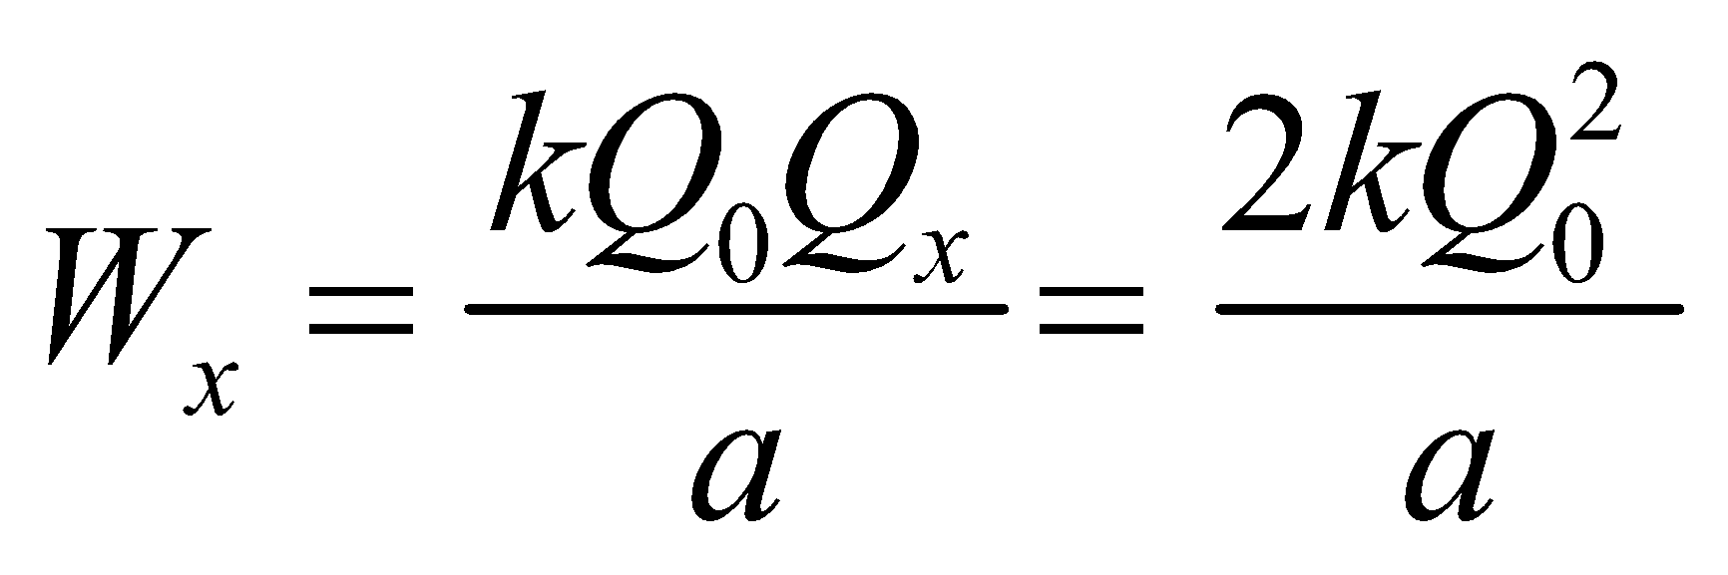

while the work necessary to bring up *Qy* is

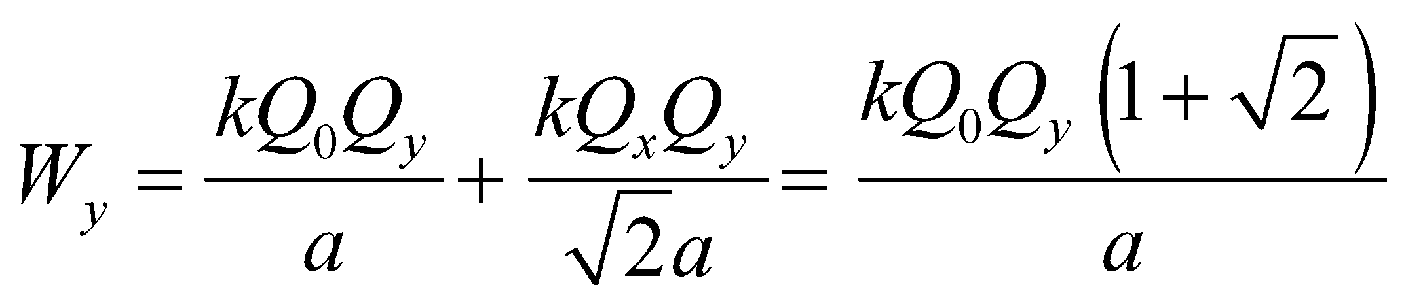

Given that 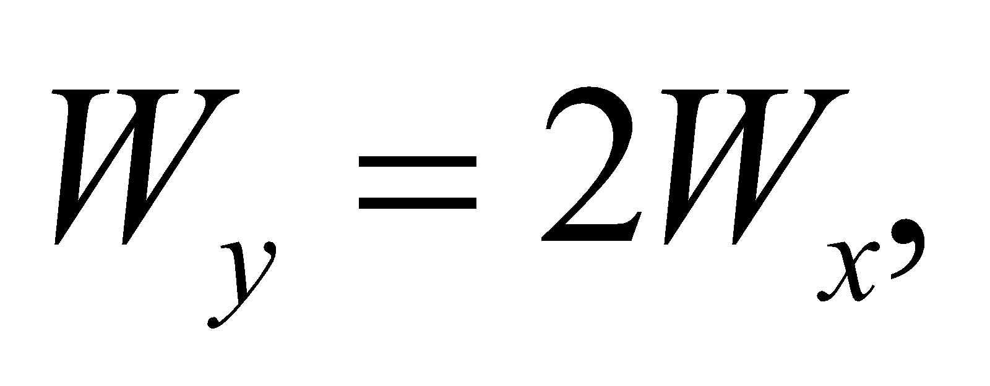 we can solve for *Qy* in terms of *Q*0.

**Evaluate** 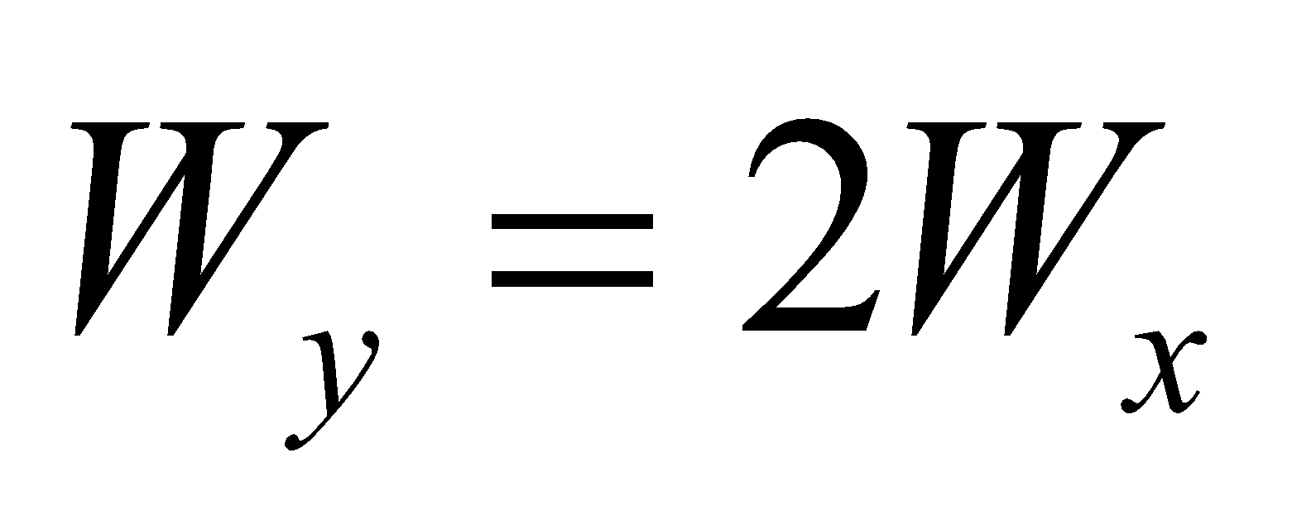 gives

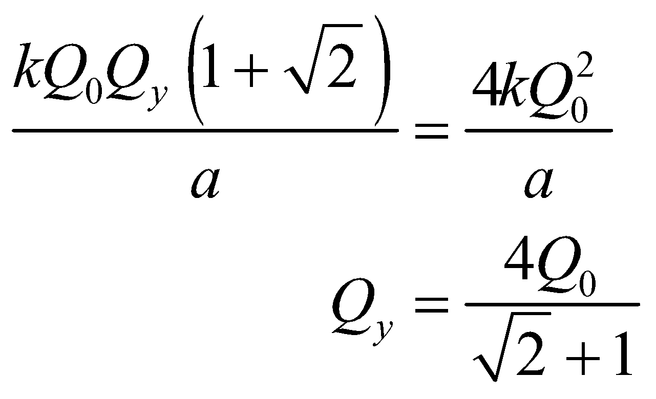

**Assess** More explicitly, we can write *Qy* = 1.66*Q*0, so *Qy* is a little less than twice *Q*0.

**38. Interpret** This problem involves finding the work required to create the given charge distribution. The work is equal to the energy stored in the system.

**Develop** When a charge *q* (assumed positive) is on the inner sphere, the potential difference between the spheres is (Equation 22.1a)



where we have used the fact (from Gauss’s law; see Example 21.1) that the field outside a spherical charge distribution is the same as a point charge at the center of the sphere. To transfer an additional charge *dq* from the outer sphere requires work 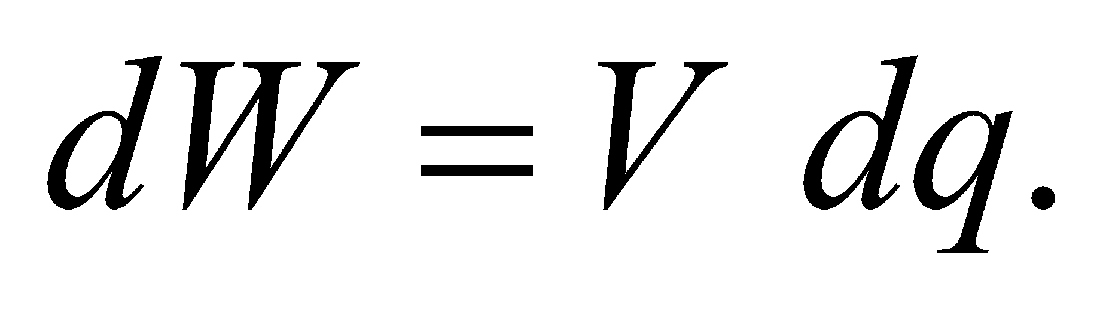

**Evaluate** The total work required to transfer charge *Q* (leaving the spheres oppositely charged) is



**Assess** Since 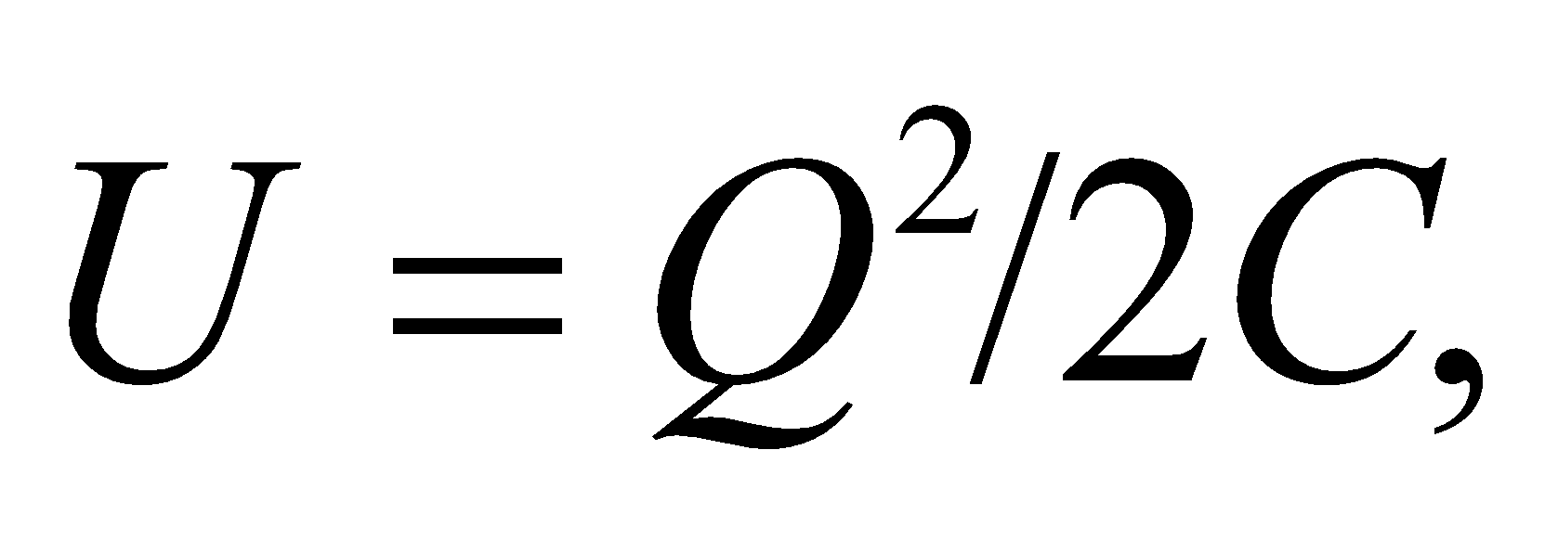 this shows that the capacitance of this spherical capacitor is

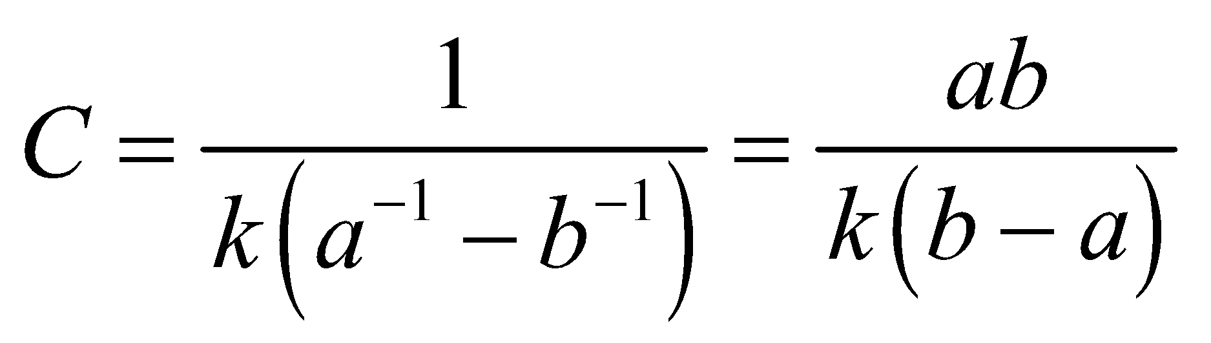

Note that capacitance depends only on the geometry of the system, and is independent of *V* and *Q*.

**39.** **Interpret** This problem requires us to find the charge on a pair of parallel, square conducting plates (i.e., a parallel-plate capacitor) given the energy density in the electric field between the plates.

**Develop** Combine Equation 23.7, which relates the electric field to the energy density,

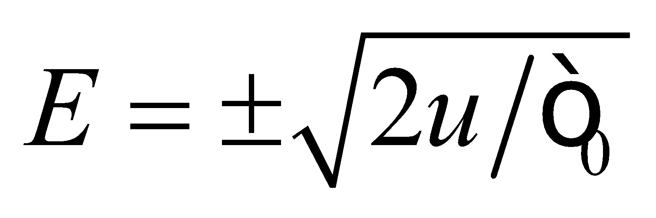

with Equation 21.8, which gives the electric field near the surface of a charged conducting plate:

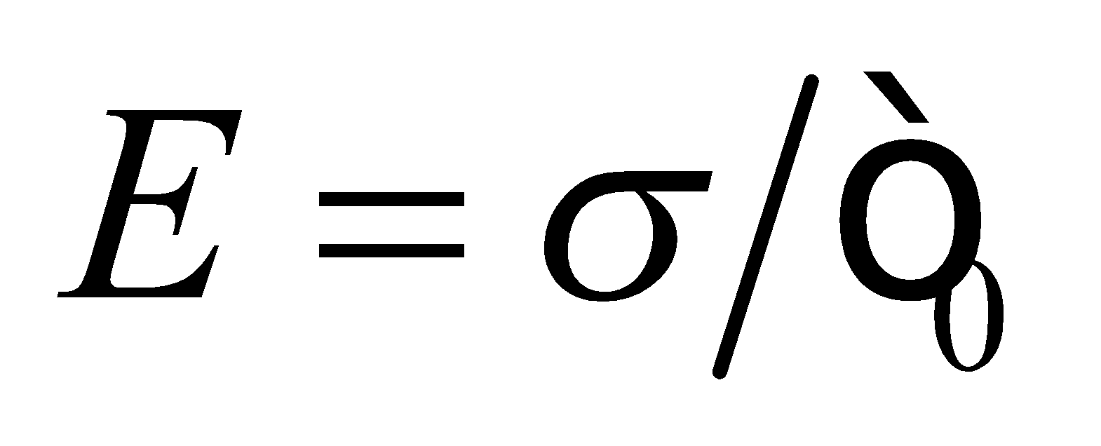

**Evaluate** Eliminating the unknown electric field *E* and solving for the surface charge density *σ* gives



Using the given surface area, the total charge on a plate is



**Assess** Notice that we do not know the sign on the charge because of the charge symmetry involved.

**40. Interpret** We are to find the capacitance of the given pair of coaxial cylinders.

**Develop** From Example 22.4, we can see that the magnitude of the potential difference between two points distances *a* and *b* from a cylinder with charge per unit length *λ* is



for *b* > *a*. The total charge on the inner cylinder is 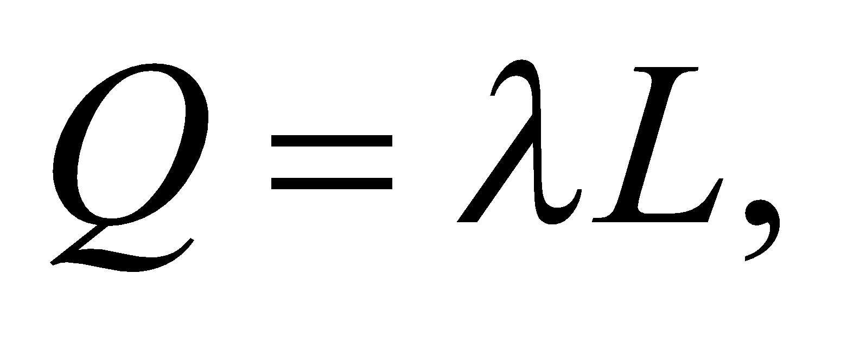 and the definition of capacitance is *C* = *Q*/*V*.

**Evaluate** Combining these expressions to find the capacitance gives



**Assess** The capacitance depends only on the geometry, as expected. Note that this result assumes that *a*, *b*  *L*, which is used in the derivation of the expression for the voltage difference.

**41.** **Interpret** We are to find the capacitance of a sphere surrounded by a concentric shell.

**Develop** This geometry is the same as for Problem 23.38, for which we found the potential between the spheres to be

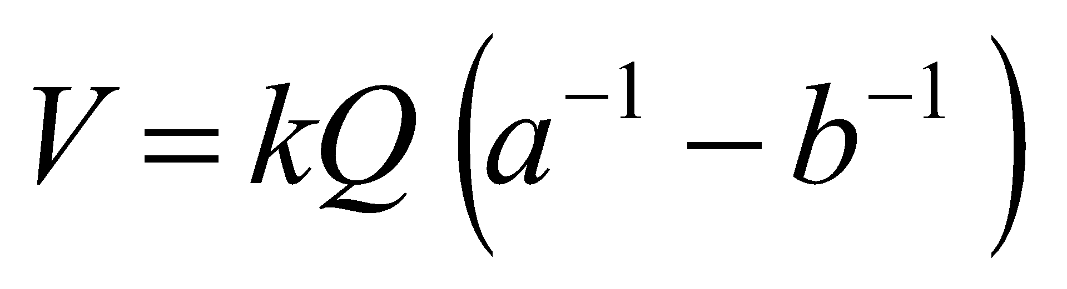

from which we can find the capacitance using Equation 23.1, *C* = *Q*/*V*.

**Evaluate** The capacitance is

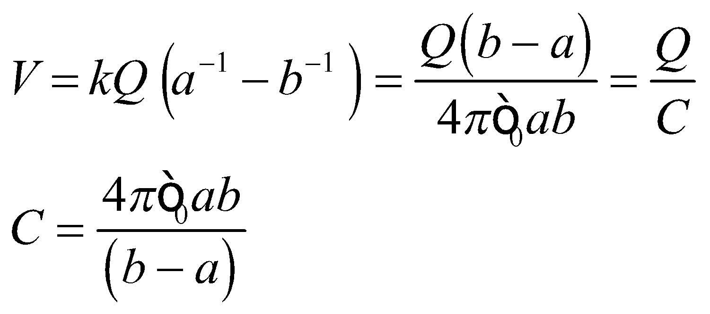

**Assess** The capacitance depends only on the geometry of the capacitor, as expected.

**42.** **Interpret** The problem involves the capacitance of a cell membrane, given the potential difference and charge across the membrane.

**Develop** The capacitance is in general 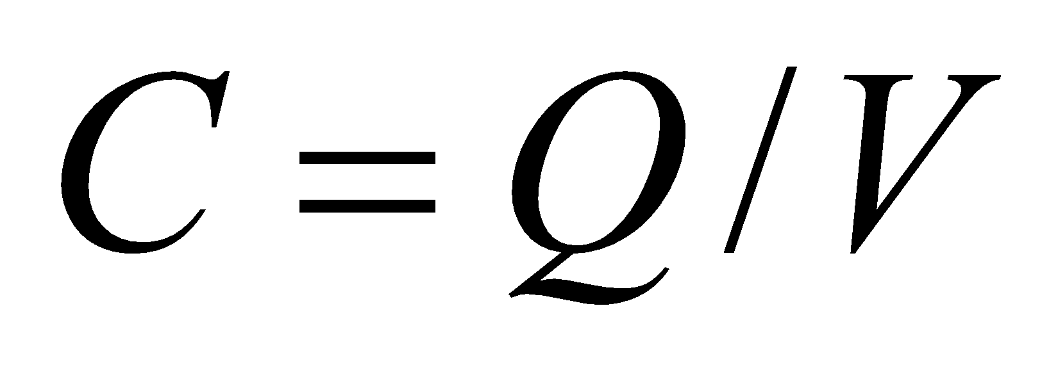(Equation 23.1). The charge in this case is 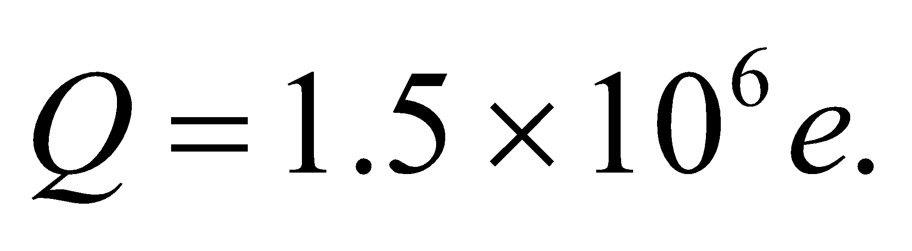

**Evaluate** Given the values for the cell membrane, the capacitance is

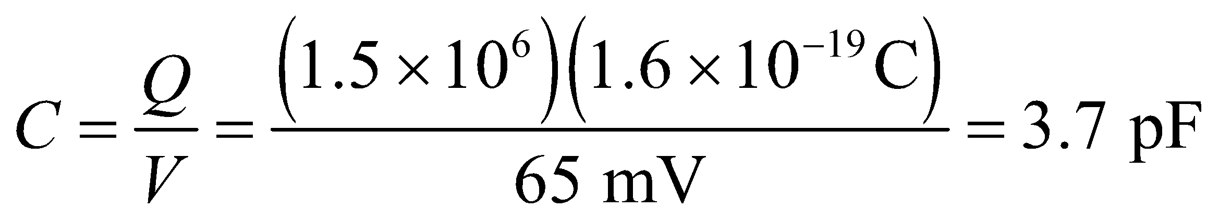

**Assess** Does this make sense? What if we assumed the cell membrane was a parallel-plate capacitor with a dielectric. Then Equation 23.4 applies: 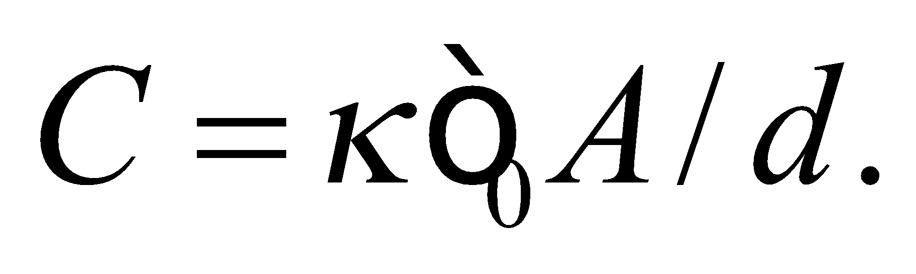 For the membrane thickness, let 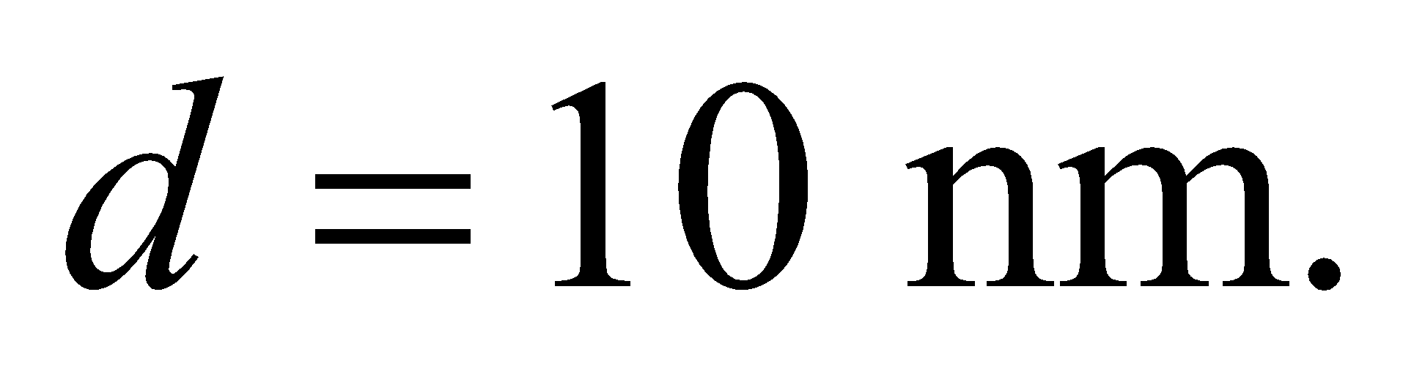 For the cell surface area, let  And for the dielectric constant, let's use the one for water since the cell is largely made up of water:  With these choices, the capacitance comes out as 7 pF, so our answer seems to make sense.

**43.** **Interpret** This problem involves finding the energy stored in a capacitor for a given voltage and finding the capacitance of the capacitor.

**Develop** Apply Equation 23.3 to express the energy stored as a function of voltage. Take the ratio of the two expressions to find the energy stored at 25 V. The same equation may be used to find the capacitance.

**Evaluate**  **(a)** Equation 23.3, expressed as a ratio for the same capacitor charged to two different voltages, gives

 Therefore, 

**(b)** Solving Equation 23.3 for the capacitance gives 

**Assess** The energy stored scales as the voltage squared so, for example, twice the voltage gives four times the energy.

**44. Interpret** In this problem, we are asked to compare the amount of energy stored in two different capacitors.

**Develop** The energy stored in a capacitor can be calculated using Equation 23.3: 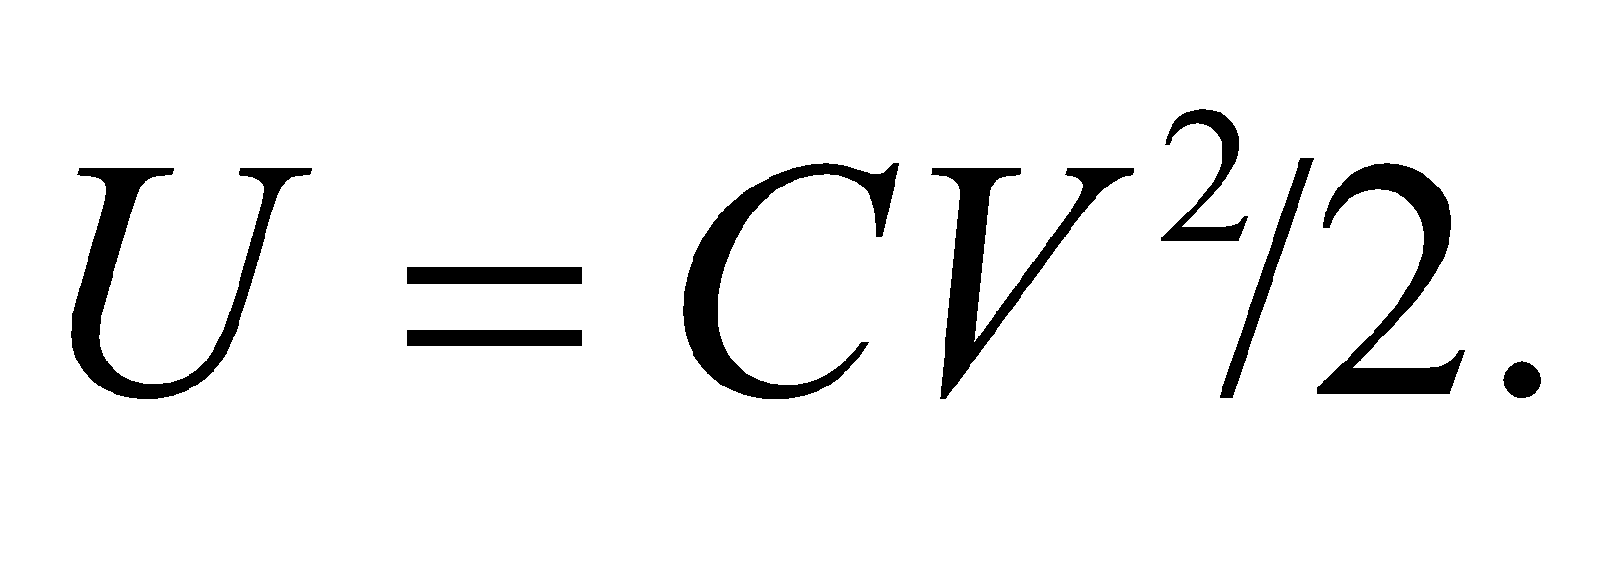

**Evaluate** The energy stored in each capacitor is



Thus, the energy stored in capacitor 2 is about 15 times less than that stored in capacitor 1.

**Assess** The general expression for the ratio of the energies stored in two capacitors is



so the energy stored is linear in capacitance but quadratic in voltage.

**45.** **Interpret** This problem requires us to find the voltage across a capacitor given its capacitance and stored energy.

**Develop** Solve Equation 23.3 for the voltage.

**Evaluate** The capacitor must withstand a potential difference of 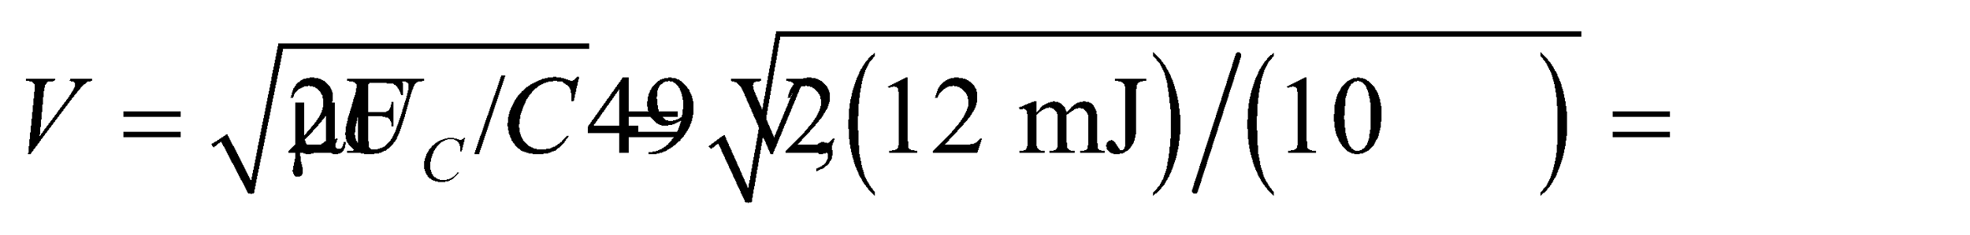 so one rated at 50 V would just suffice.

**Assess** If more than 50 V were to put across the capacitor, dielectric breakdown would occur.

**46. Interpret** In this problem we are asked to compare the amount of charge and energy stored in three different capacitors.

**Develop** The charge stored in a capacitor is *Q* = *CV* (Equation 23.1), and the energy stored is  (Equation 23.3).

**Evaluate** **(a)** The charge stored is

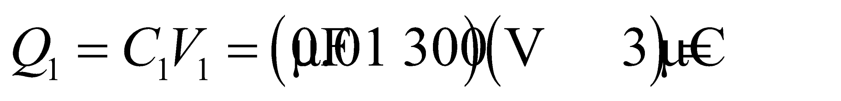 for the first capacitor

 for the second

 to one significant figure for the third

**(b)** To one significant figure, the energy stored in each capacitor is



**(c)** The cost effectiveness *eff*, measured in  and to a single significant figure, is



**Assess** Notice that, for part (c), more significant figures were retained for the results of part (b) because these are intermediary results for part (c). The first capacitor is the most cost effective of the three.

**47.** **Interpret** We are to find the voltage across the given capacitor and the power it discharges if all its energy is discharged in the given time.

**Develop** Solve Equation 23.3 for voltage to find the voltage across the capacitor. Use the definition of average power,  to find the average power.

**Evaluate** **(a)** From Equation 23.3, 

(b) 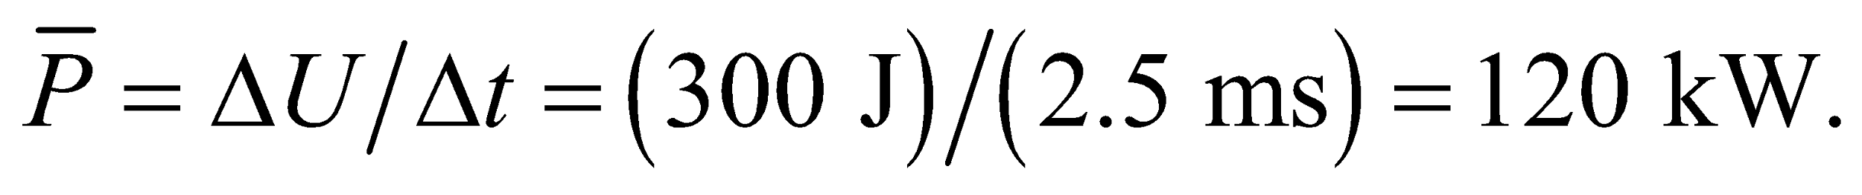

**Assess** This is like connecting yourself to 2000 60-W light bulbs for 2.5 ms. Care to try?

**48. Interpret** This problem involves finding the power consumption of a camera flashtube per flash and the average power consumed if the flash is used every 10 s. From this power, we are to find the capacitor required to power the flash.

**Develop** Equation 6.15 gives the average power 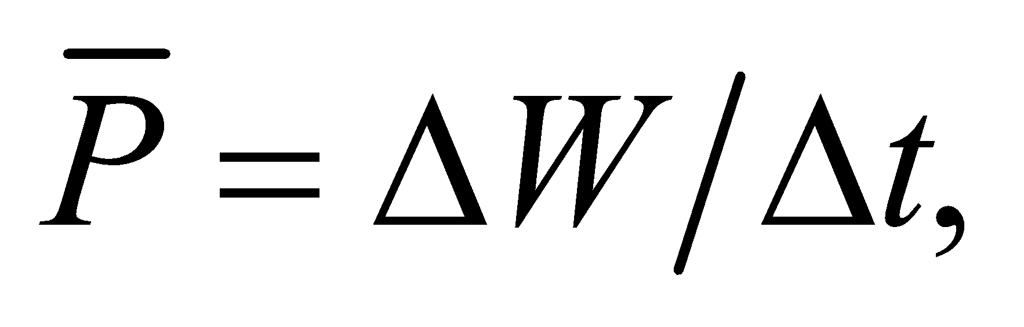 where *ΔW* is the work done (or the energy used). Apply this to find the power consumed by the flash for the different time intervals *Δt*. Once we find the average power required, we apply Equation 23.3, *U* =*CV*2/2 to find the capacitance required.

**Evaluate** **(a)** The power delivered to the tube during the flash is

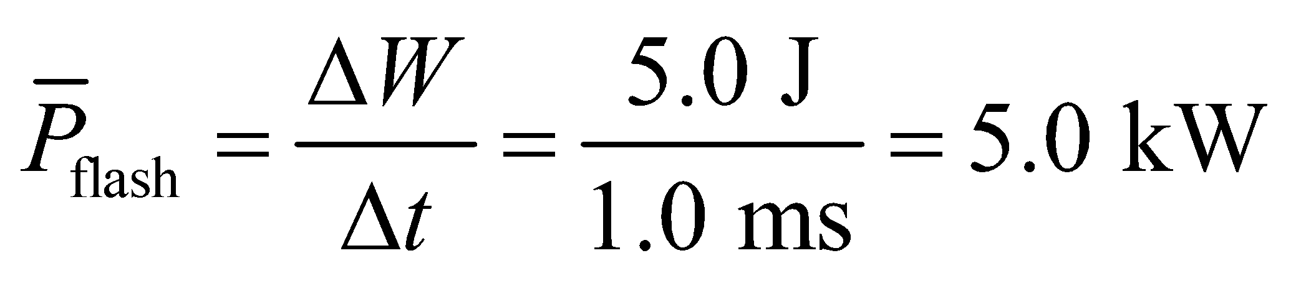

**(b)** The energy stored in a capacitor is  Thus, the capacitance needed to supply the flash energy is

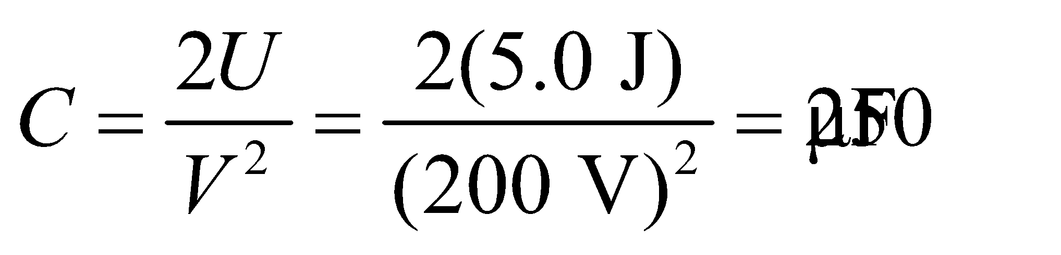

**(c)** The average power consumption during the 10-s interval is 

**Assess** The average power  is , which is the same ratio as for the time intervales (1 ms to 10 s).

**49.** **Interpret** This problem involves calculating the equivalent capacitance of a group of capacitors connected as shown in Figure 23.15.

**Develop** Consider the same circuit, but drawn as shown in the figure below. This circuit has two parallel components that consist of (1) C1 and (2) *C*2,3,4. The second component may be further divided into two components in series: (3) *C*2 and (4) *C*3,4. Finally, the fourth component consists of *C*3 and *C*4 in parallel. Thus, the entire circuit can be described as



where || means “in parallel with” and  means “in series with”. Apply Equations 23.5 for the parallel capacitances and Equation 23.6b for the series capacitances to find the total capacitance *C*tot.



**Evaluate** Because *C*1 and *C*2,3,4 are in parallel, the total capacitance is



Because *C*2 is in series with *C*3,4, *C*2,3,4 is



Because *C*3 and *C*4 are in parallel, *C*3,4 is



Therefore, the total capacitance is



Because the capacitors are all identical (*C*1 = *C*2 = *C*3  *C*), this reduces to



**Assess** Note that redrawing the circuit made it easier to understand (hopefully).

**50. Interpret** In this problem we want to connect capacitors of known capacitance and voltage rating to obtain the desired equivalent capacitance and voltage rating.

**Develop** In parallel, the voltage across each element is the same, so to increase the voltage rating of a combination of equal capacitors, series connections must be considered. The general result of Problem 31 shows that the voltage across *n* capacitors in series, each of which is rated at voltage *V*, is simply *nV*. The voltage across capacitors in parallel does not change, so we can combine capacitors in series to adjust the voltage and capacitors in parallel to adjust the overall capacitance (without changing the voltage rating).

**Evaluate** **(a)** To obtain the desired voltage rating, we must use two capacitors in series so that the voltage becomes

.

However, the overall capacitance is now



and we need to increase the total capacitance to twice that of just two in series, without altering the voltage rating. This can be accomplished with a parallel combination of two. This gives a voltage rating of *V*series pair and a capacitance of 2*C*series pair = 2.0 μF. Thus, the equivalent capacitance would be as shown in part (a) of the figure below.

**(b)** For an equivalent capacitance of 0.5 mF and a voltage of 50 V, four capacitors in series are required, which gives a rating *V*tot = 4*V* = 4(50 V) = 200 V, and capacitance

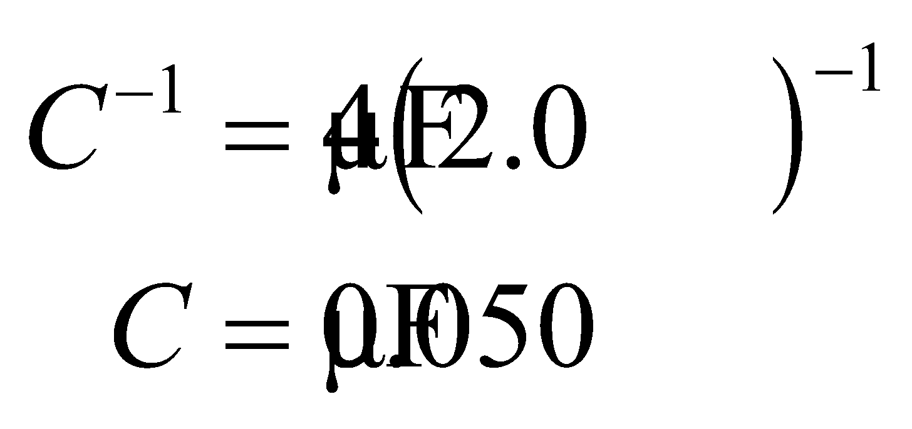

**Assess** Schematically the connections described look like the following:



One may use Equations 23.5 and 23.6 to verify that the configurations indeed have the desired capacitance and voltage rating as specified in the problem statement.

**51.** **Interpret** For this problem, we are to find the equivalent capacitance for the given capacitor.

**Develop** Number the capacitors as shown in the figure below. Relative to points *A* and *B*, *C*1, *C*4, and the combination of *C*2 and *C*3 are in series, so the capacitance is given by Equation 23.6a:



*C*23 is a parallel combination, so , and we can find *CAB*.



**Evaluate** Inserting the expression for *C*23 into that for *CAB* gives



**Assess** The result is given to two significant figures, as justified by the data.

**52. Interpret** This problem involves an assemblage of capacitors in a circuit, and we are interested in the energy stored in one of the capacitors. To do this, we will need to find the voltage across that capacitor when the given voltage is applied across the entire circuit.

**Develop** Number the capacitors as shown below. Relative to points *A* and *B*, *C*1, *C*4, and the combination of *C*2 and *C*3 are in series. The energy of the  capacitor is 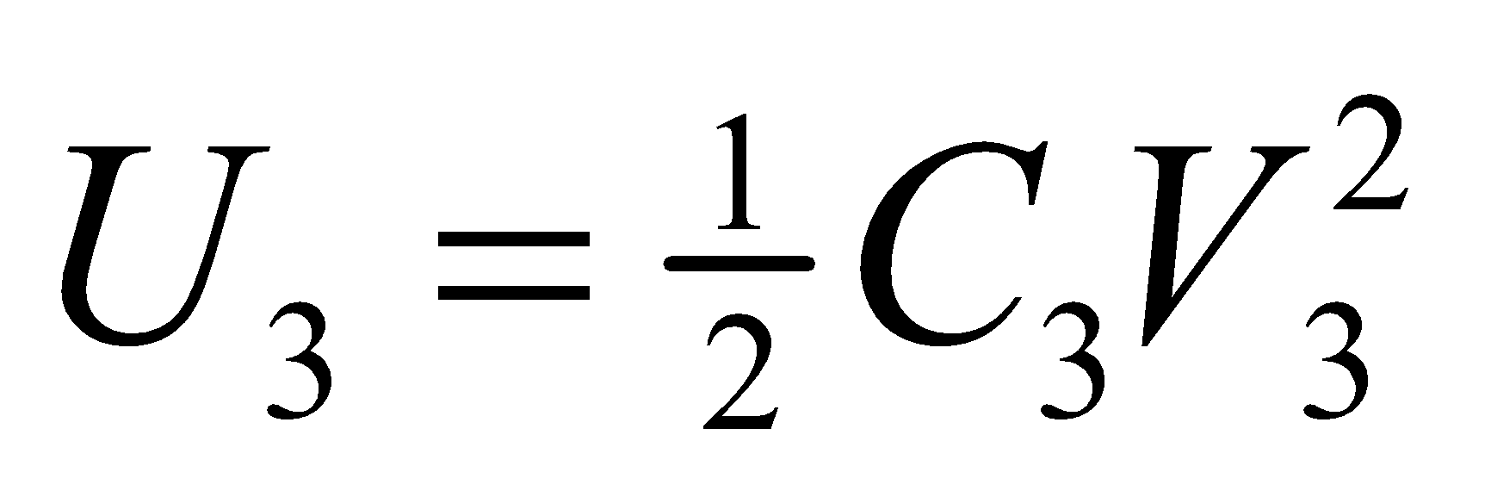 (Equation 23.3), where the voltage drop across *C*3 is  since *C*2 and *C*3 are in parallel. In addition, since *C*1, *C*4, and *C*23 are in series, we have  and 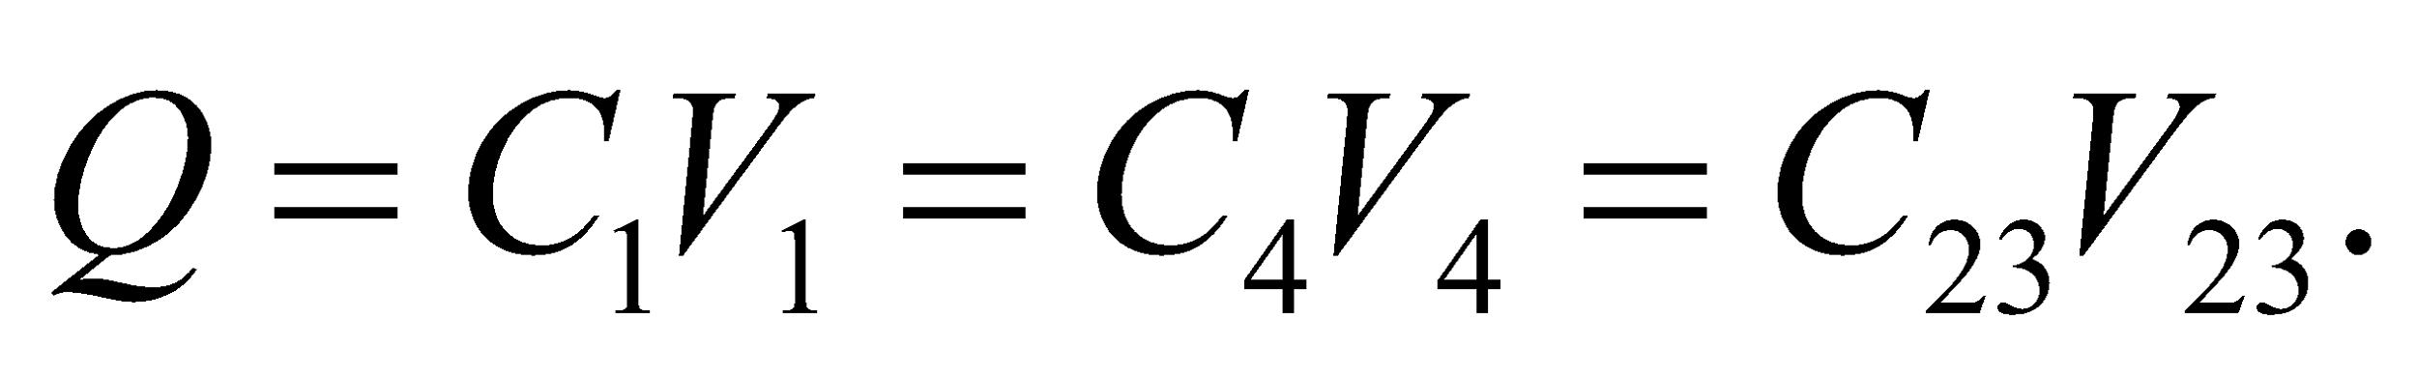 Once we know 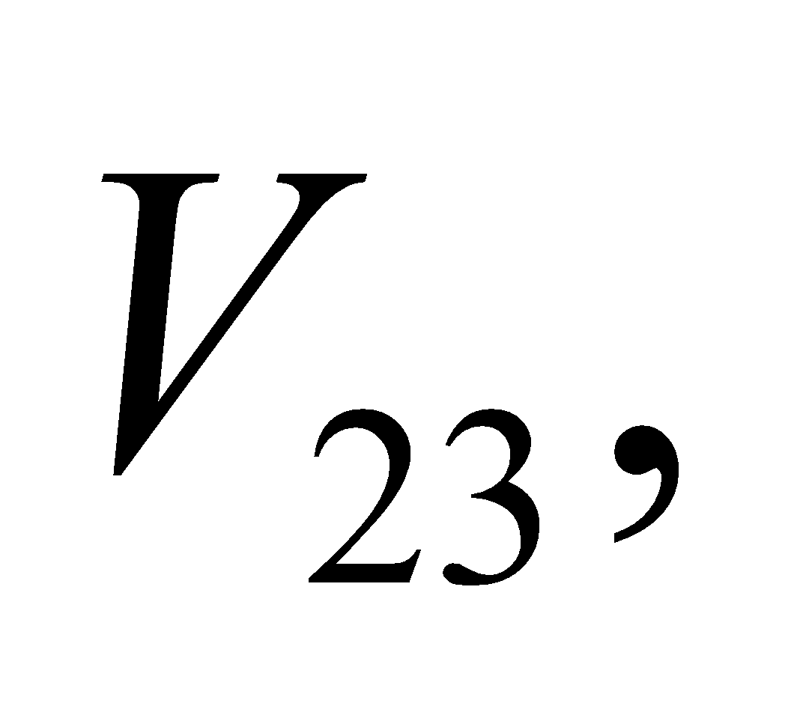  can be calculated.



**Evaluate** From the equations above, we find

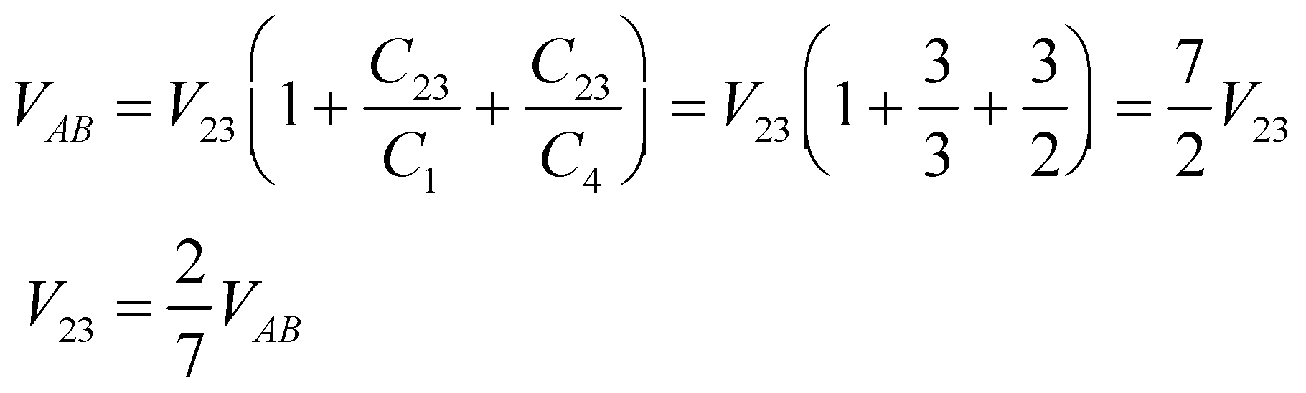

This gives



to two significant figures.

**Assess** Since the combination of *C*2 and *C*3 are in series with *C*1 and *C*4, *C*3 does not “feel” the full 50 V applied across *AB*, so its working voltage is lower. In fact we find it to be

**53.** **Interpret** This problem involves two capacitors in series. We are to find an expression for the voltage across each capacitor.

**Develop** From Equation 23.5, we have



Furthermore, the charge on each capacitor must be the same, as argued in the text accompanying Figure 23.8 so, from Equation 23.1, *Q* = *CV*1 = *CV*2 = *CV*. In addition, the voltages across each capacitor must sum to the voltage across the equivalent capacitor, so *V* = *V*1 + *V*2.

**Evaluate** Combining the expressions above to solve for *V*1 in terms of *V*, *C*1, and *C*2 gives



Solving for V2 likewise gives



**Assess** These expressions agree with that given in the problem statement.

**54.** **Interpret** You want to know the working voltage for two capacitors connected in series.

**Develop** The voltage across two capacitors in series is just the sum of the voltage across each capacitor. Your company's new hire applied this same logic to the working voltage, which is the maximum that the capacitors can handle. However, the working voltage basically tells you the maximum charge that a capacitor can handle: Since the charge on each capacitor in the series is the same (see Figure 23.8), the working voltage will be set by the smallest maximum charge of the capacitors in the series.

**Evaluate** The maximum charges on the two capacitors are



Even though the first capacitor could handle that would be too much for the second capacitor. The most charge that the series can handle is which means the working voltage is



The new hire was wrong: 240 V is the safe limit.

**Assess** What this tells you is that you should try to match the maximum allowable charge of capacitors that you put in series.

**55.** **Interpret** For this problem, we are to find the capacitance and working voltage of a capacitor given its geometry and dielectric material.

**Develop** Apply Equations 22.4 and use Table 23.1 for the dielectric constant of polyethylene.

**Evaluate** **(a)** From Equation 23.4, and Table 23.1, one obtains



**(b)** Dielectric breakdown in polyethylene occurs at a field strength of 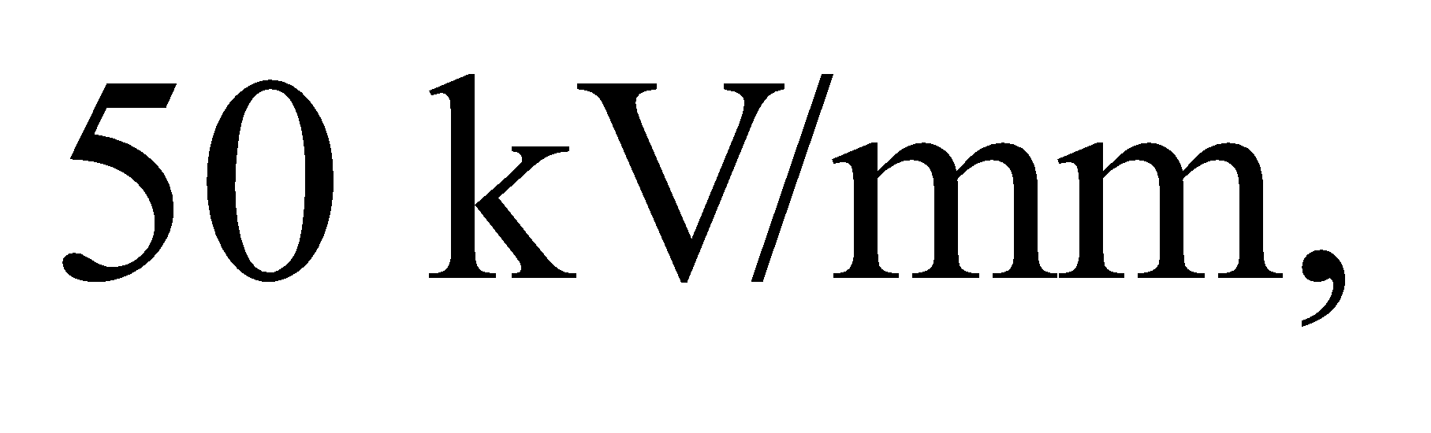 corresponding to a

maximum voltage for this capacitor of



**Assess** The results are given to two significant figures, as warranted by the data.

**56.** **Interpret** This problem involves a capacitor using polystyrene as the dielectric between the conductor plates.

**Develop** From Equation 23.4, the capacitance of two parallel plates with a dielectric in between is 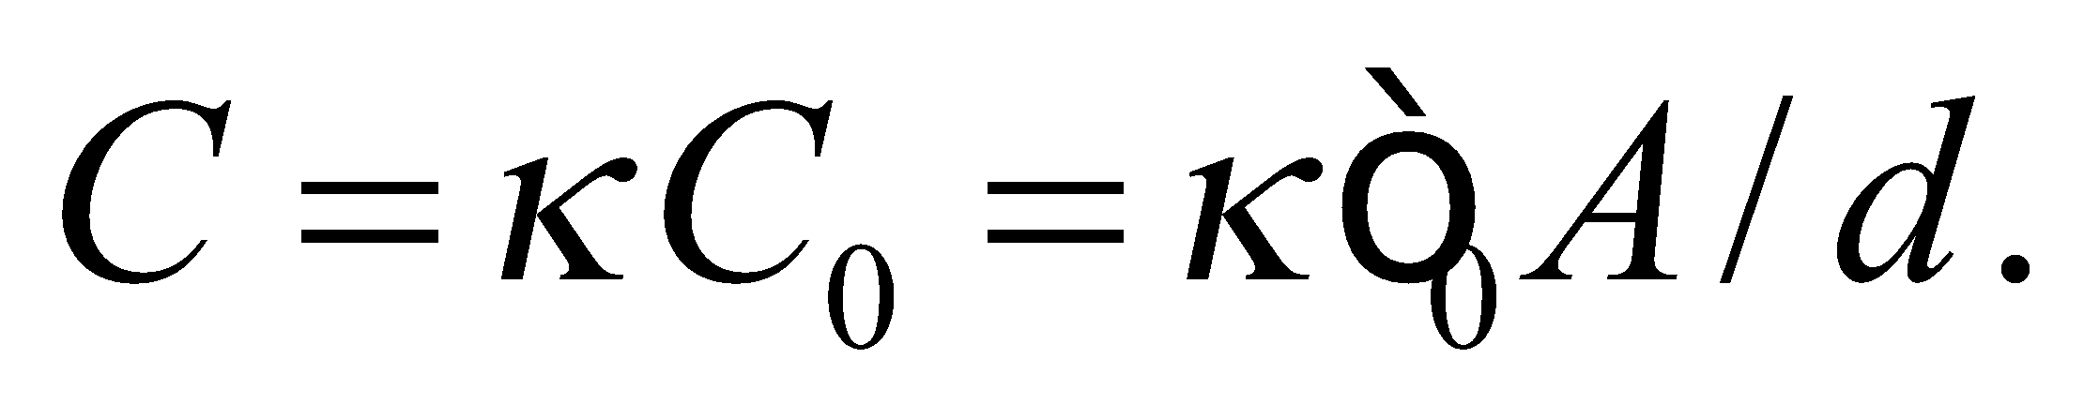As for part (b), the maximum voltage for a parallel plate capacitor is the breakdown field times the distance between the plates: 

**Evaluate**  (a) The dielectric constant of polystyrene is given in Table 23.1, so its thickness is:



(b) The breakdown field of polystyrene is given in Table 23.1, so the maximum voltage is:



**Assess** These values seem reasonable for the thickness and working voltage of a capacitor. Notice that to increase the working voltage for a given geometry one would like a material with both a large dielectric constant and a large breakdown field.

**57.** **Interpret** In this problem, we are given the capacitance per unit area and the dielectric strength for a capacitor and are asked to find the plate separation.

**Develop** If we assume that the inner and outer surfaces of the membrane act like a parallel plate capacitor, with the space between the plates filled with material of dielectric constant  then we can use Equation 23.4 to find the separation *d*.

**Evaluate** The capacitance per unit area is  Thus, .

**Assess** This result is about an order of magnitude larger than the Bohr radius, which gives an idea of the thickness of the membrane in terms of atoms (biological molecules being largely hydrogen and carbon).

**58.** **Interpret** You want to see if "trimmer" capacitors can provide the extra capacitance you are looking for.

**Develop** Placing the trimmer capacitors in parallel with the cheap 2-μF capacitors will result in a combined capacitance of 

**Evaluate** Since you want 2.0 μF of capacitance and the cheap capacitors only provide between 1.7 and 1.9 μF, the trimmer capacitors have to supply between

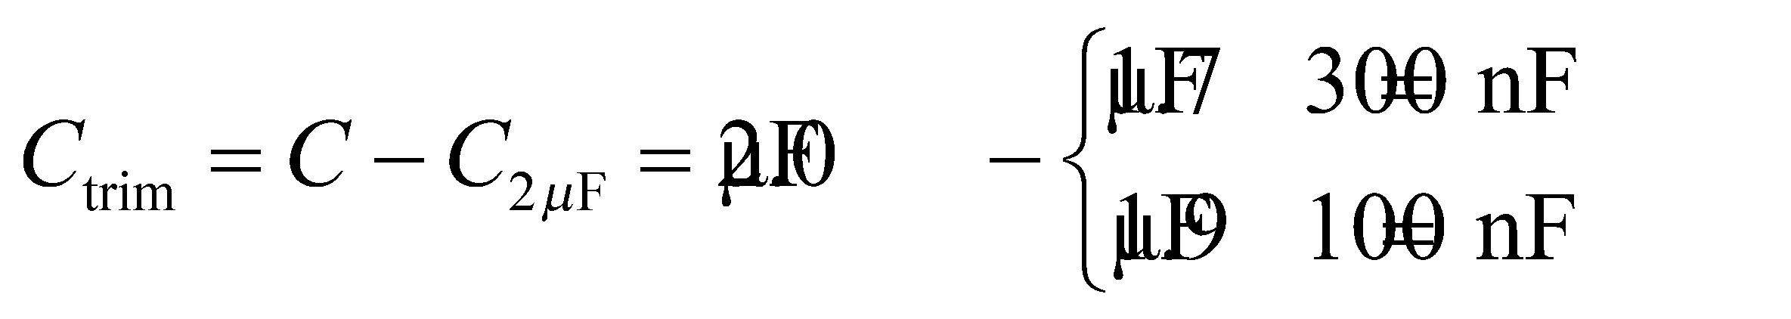

Since these values are both within the variable limits of the trimmer capacitors (25 and 350 nF), they will work for this application.

**Assess** One way to make a variable capacitor is to allow the plate separation, *d*, to be changed, say, with a small screw. Another way is to vary the area, *A*, by shifting the two plates so that there is greater or less overlap.

**59.** **Interpret** We're asked to find the total electric-field energy in a cubical region with a variable field.

**Develop** The electric-field energy for a variable field is given by Equation 23.8: 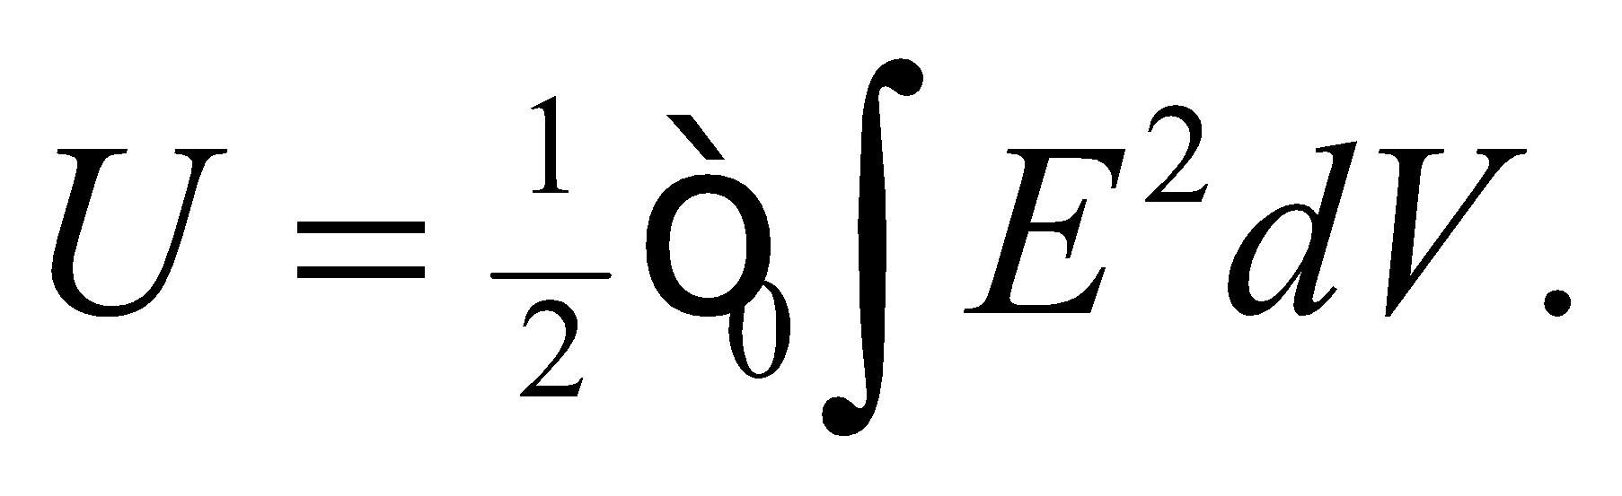 For the cubical region in this case, 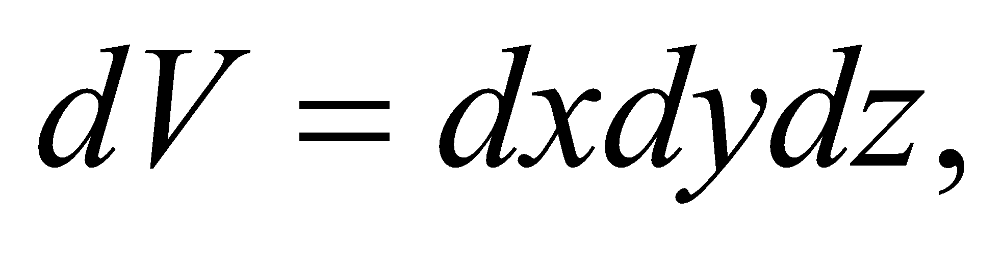 and the integration for each variable is from 0 to 1 m.

**Evaluate** Performing the integration, the energy stored in the field is



**Assess** The value seems reasonable. One can check that the units work out by using the fact that 

**60. Interpret** This problem involves electrostatic energy contained within a charged sphere. Our system has spherical symmetry.

**Develop** From Example 21.1, we see that the spherically symmetric field inside such a sphere is  so the energy density is



The energy within the sphere can be found by integrating this expression over the volume.

**Evaluate** With thin spherical shells of radius *r* for volume elements,  the integral for the energy is

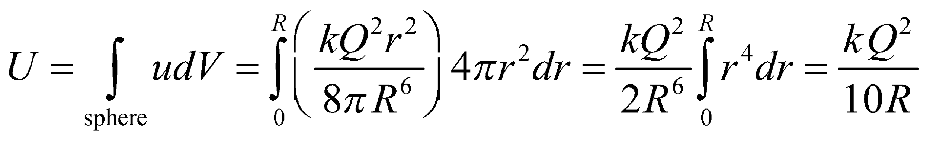

(This is just the energy stored inside the sphere. For the energy outside the sphere, and the total energy, see Problems 64 and 65.)

**Assess** The result shows that *U* is inversely proportional to *R*. This means that the stored energy decreases if the same amount of charge *Q* is distributed over a greater volume. Our result can be compared to the situation (Problem 61) where the total charge *Q* is distributed over its *surface*. In that case, the total energy stored in its electric field is 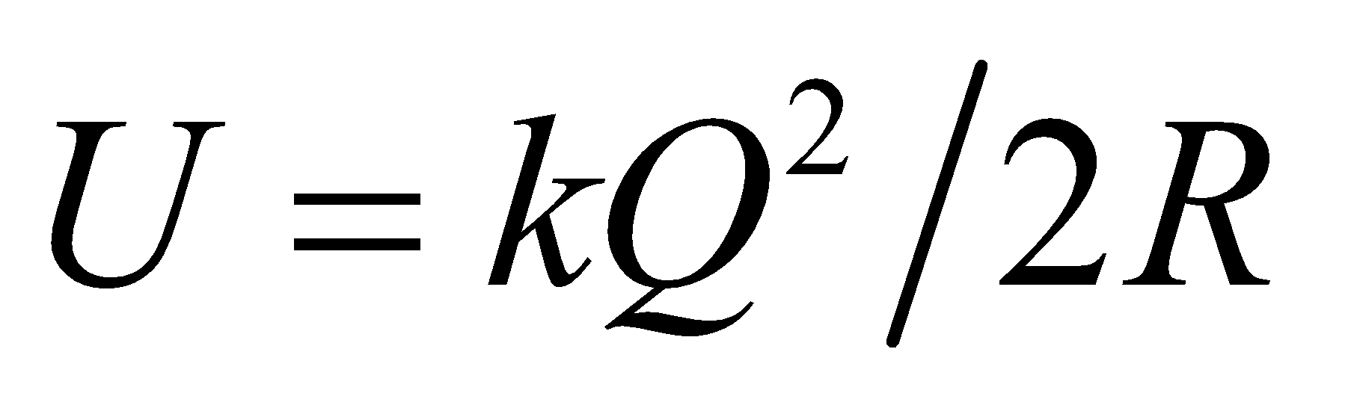.

**61.** **Interpret** This problem involves a spherical charge distribution outside of which we are to find the total energy contained in the electric field.

**Develop** This problem is the same Example 23.5 if we let *R*2 = *R* and 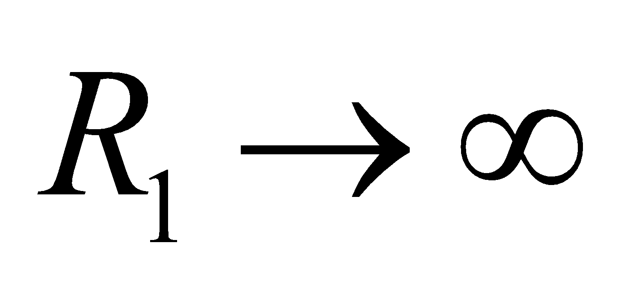 (i.e., we can consider that we are compressing an infinitely separated charge distribution to one that is on the surface of the sphere of radius *R*2).

**Evaluate** The energy is thus



**Assess** The energy is quadratic in charge so, for example, it would take 4 times the energy to assemble twice the charge.

**62. Interpret** This problem is about the electrostatic energy of a charged sphere, both within and outside the sphere. Our system has spherical symmetry.

**Develop** The field outside a spherically symmetric distribution of radius *R* is the same for the charge *Q* uniformly spread over the volume or the surface (thanks to Gauss’s law). Thus, Problem 61 gives the energy in the electric field outside a uniformly charged spherical volume. The result of Problem 63 gives the energy inside the sphere. The total energy is the sum of the two:

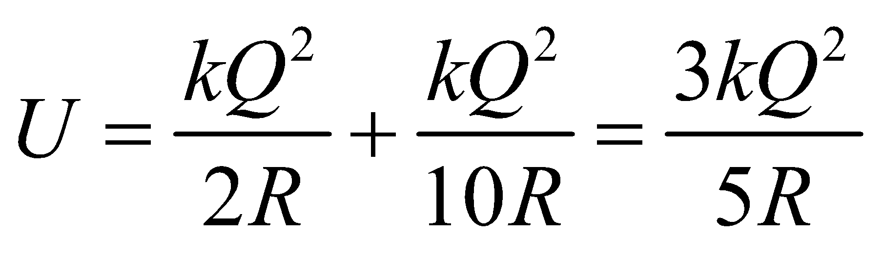

**Evaluate** Applied to a U235 nucleus, the expression gives



**Assess** This Coulomb energy is about 1% of the mass energy *mc2* of the U235 nucleus.

**63.** **Interpret** This problem involves finding the change in electrostatic potential energy between two separated, charged, water drops and a single drop with the same charge.

**Develop** The initial electrostatic energy of two isolated spherical drops, with charge *Q* on their surfaces and radii *R*, 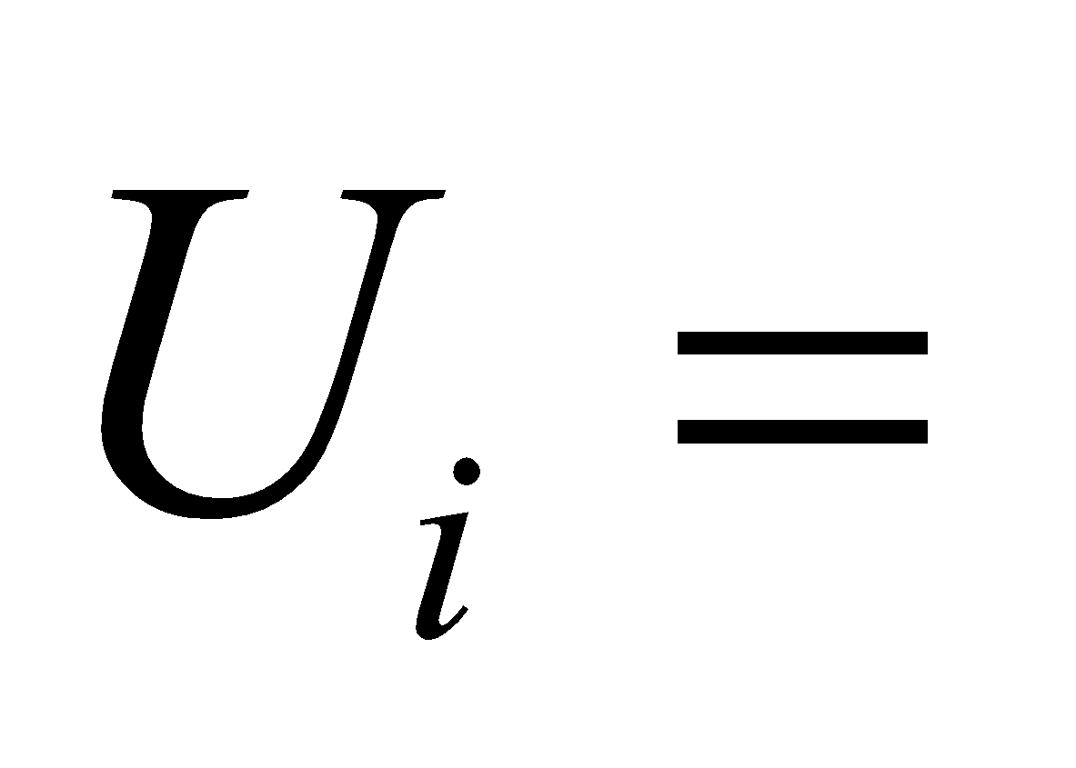(see Problem 61 and Example 23.5). Together, a drop of charge 2*Q*, radius  and energy  is created. The difference in potential energy is 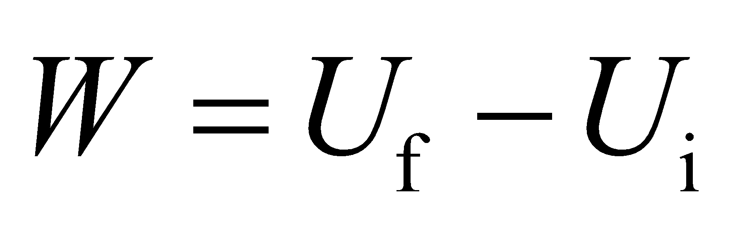

**Evaluate** Inserting the given quantities gives

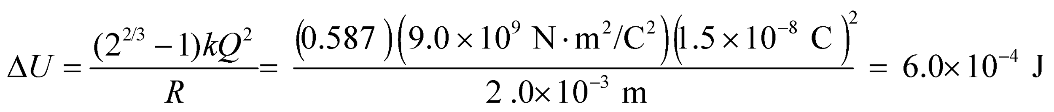

**Assess** In eV, this is



**64. Interpret** This problem involves finding the electrostatic energy contained within a volume around a charged wire. This system has line symmetry.

**Develop** If the wire length is much, much greater than its radius, and if the volume we are considering is many radii away from either end, then the system has line symmetry (i.e., we can consider it to be an infinte wire). In this case, the electric field outside the wire is radially away from the axis (for *λ* > 0) with magnitude 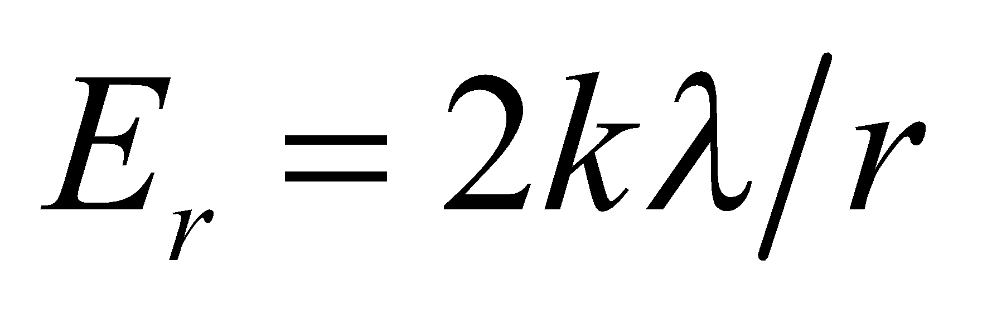 (see Equation 21.6). The energy density in a cylindrical shell of radius *r*, lengthand volume 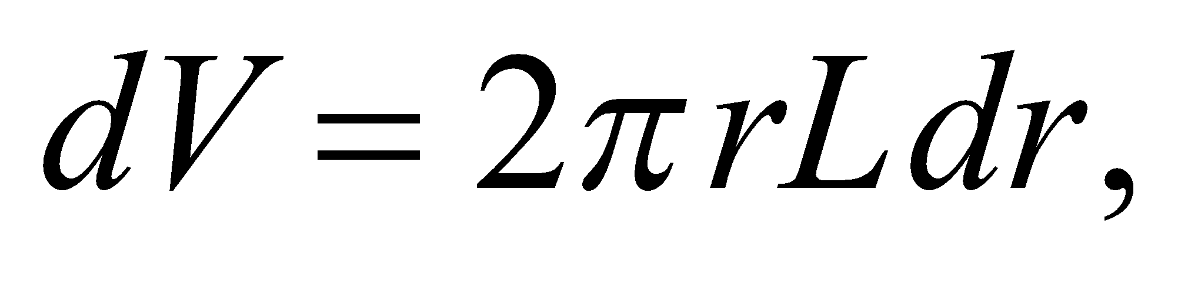 is

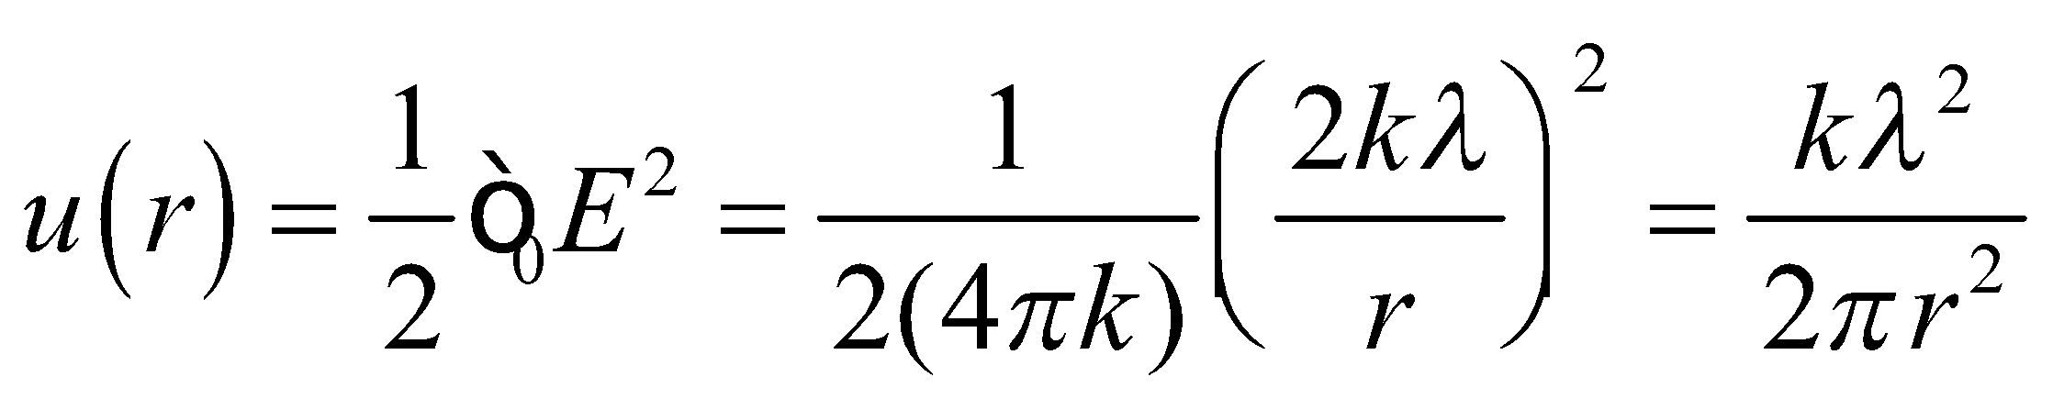

Integrate this expression over the volume of the cylinder to obtain the energy.

**Evaluate** Thus, the energy in the space mentioned in this problem is

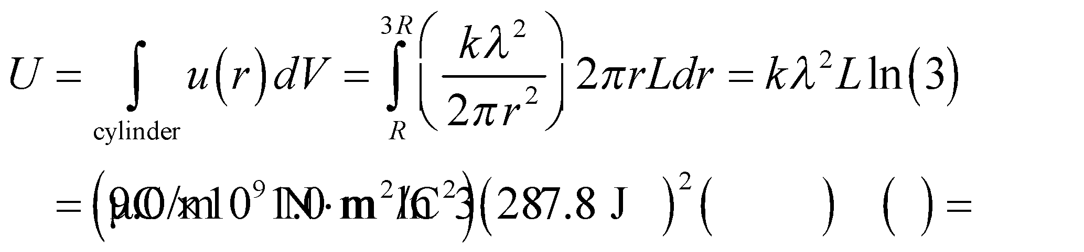

**Assess** The energy density (energy/volume) decreases as  This means that more energy is concentrated in the volume closer to the wire.

**65.** **Interpret** For this problem, we are asked to find the time required for lightening strikes to deplete a reservoir of energy, given the charge transferred, the electric potential energy difference (per charge), and the frequency of the lightening strikes.

**Develop** The energy in the thunderstorm of Example 23.4 is about  while the energy in a lightning flash is  Thus, there is energy for about 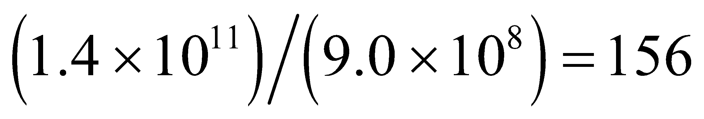 flashes.

**Evaluate** At a rate of one flash every 5 s, there is enough energy to last 

**Assess** This seems like a reasonable time frame for a summer thunderstorm.

**66. Interpret** The object of interest is a spherical capacitor, and we are to explore the limit when the separation between the concentric spheres is much, much smaller than the radii of the spheres (i.e., 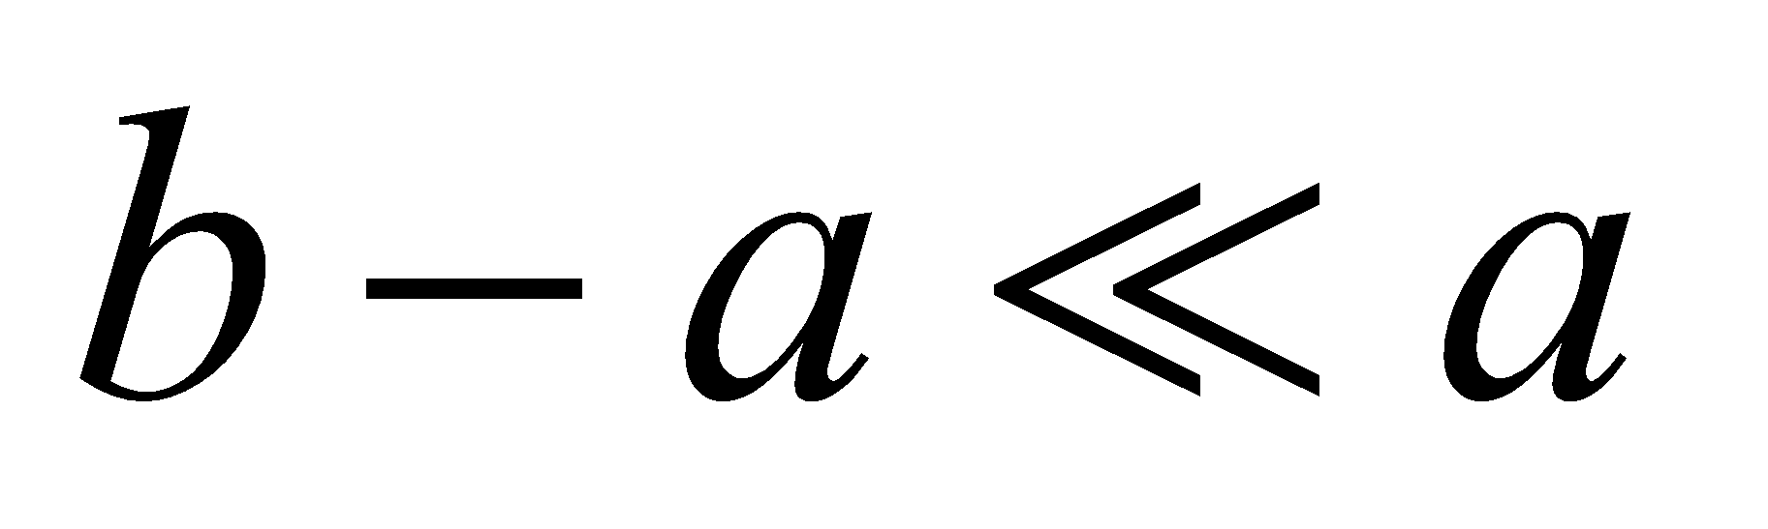).

**Develop** The capacitance for a spherical capacitor can be derived by noting that the potential difference between two concentric conducting spheres is

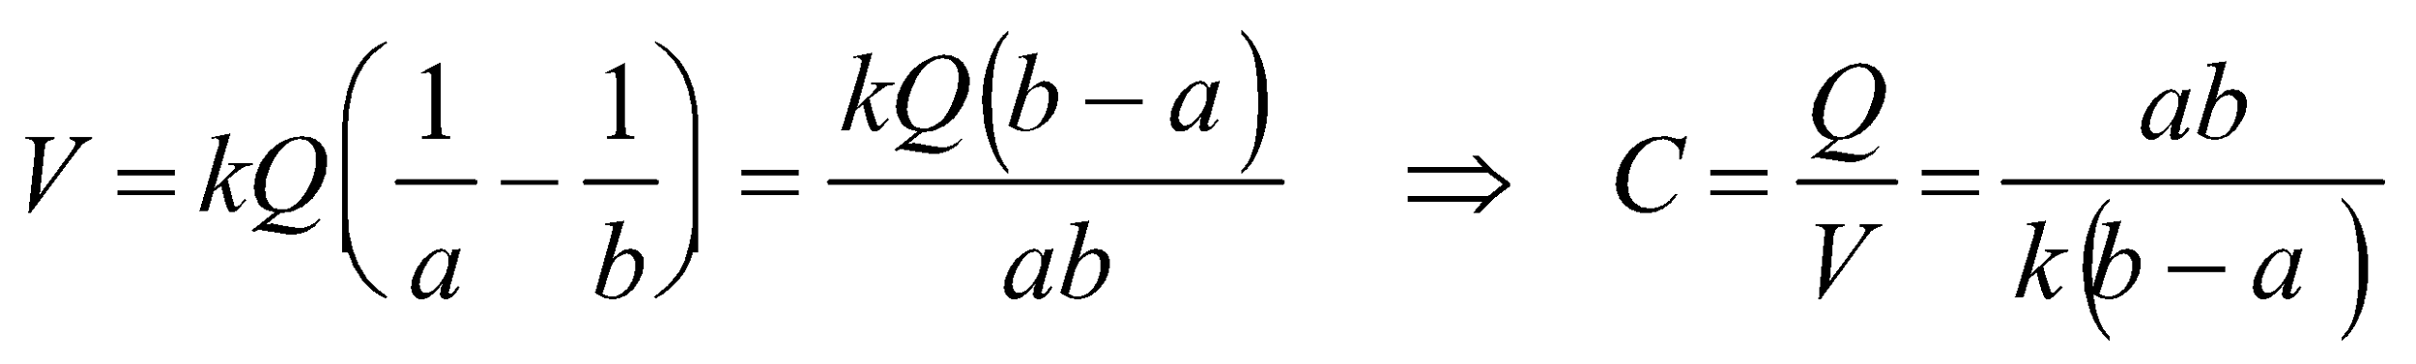

Take the limit  to show that *C* reduces to that of a parallel-plate capacitor.

**Evaluate** With  we find



which is the result of Equation 23.2, with 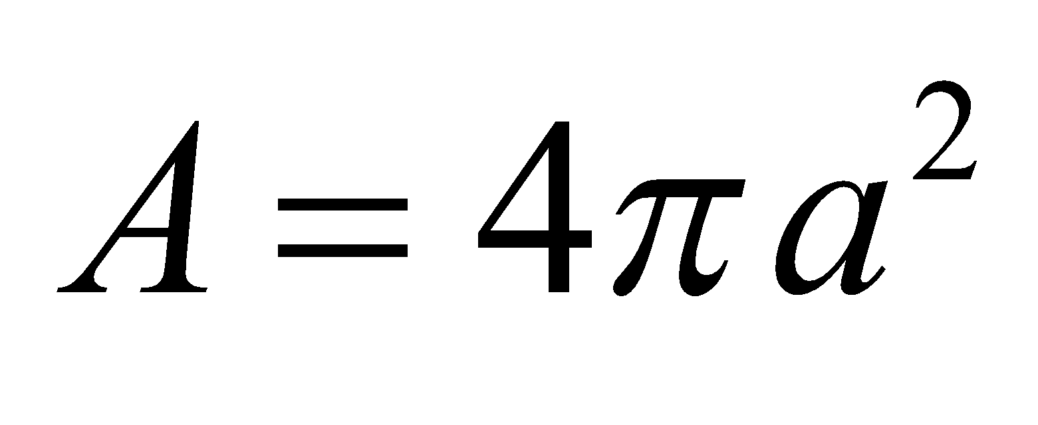 being the area of the spherical plates.

**Assess** The limit 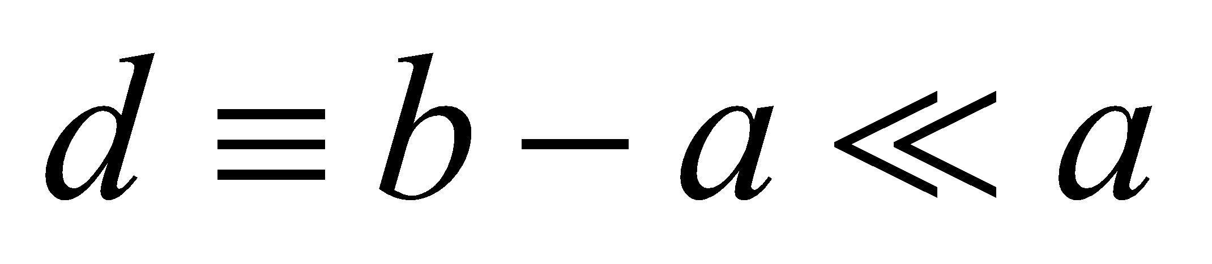 means that the radius of the sphere is much greater than the separation between the two spheres. Thus, the interface between the spheres is very similar to two parallel plates.

**67.** **Interpret** This problem involves a spherical, uniform charge density. We are to find the fraction of the total energy contained within the sphere.

**Develop** In Problem 23.60, we found that the energy within just such a charged sphere is

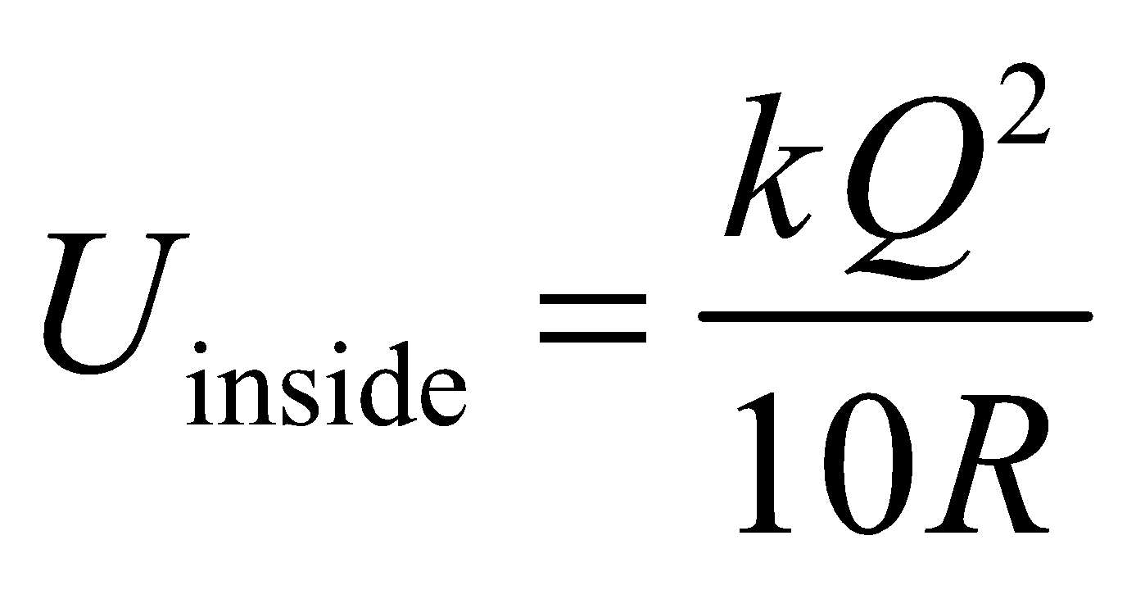

In Problem 23.61, we found that the energy outside such a sphere is



Divide U inside by the sum to find the fraction of energy inside the sphere.

**Evaluate** The fraction of energy inside the sphere is

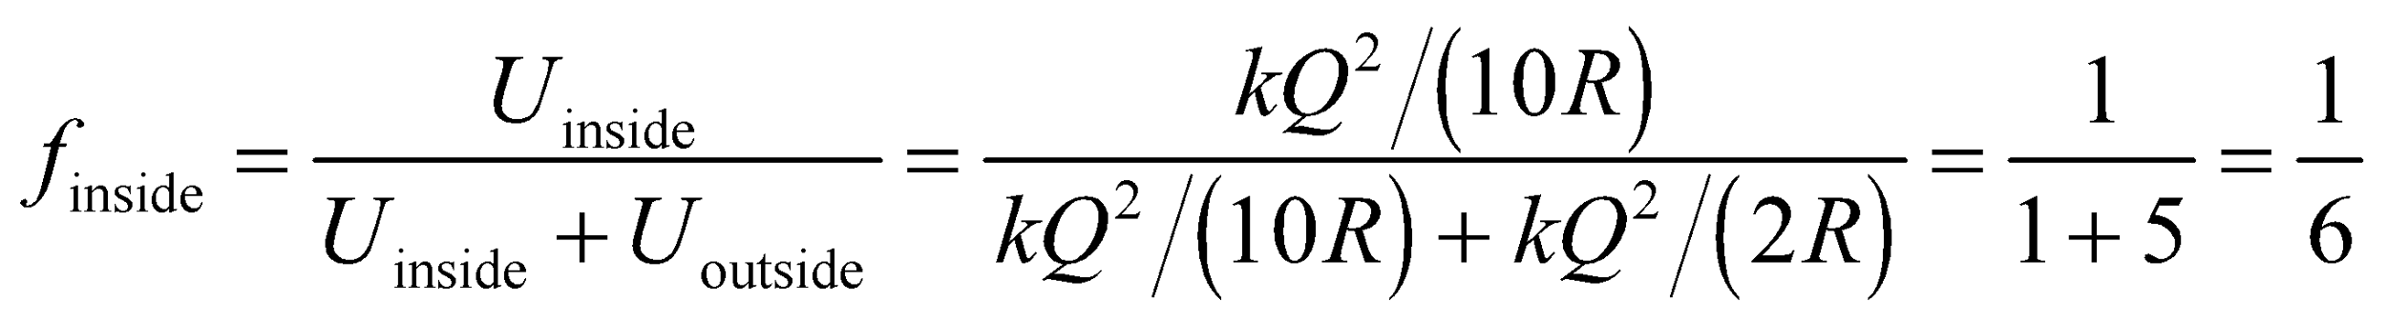

**Assess** Ignoring gravity, this result is independent of the size of the sphere.

**68. Interpret** This problem involves finding the size of an electron that makes its electrostatic energy equal to its mass energy.

**Develop** The electrostatic energy stored in the field of a classical electron, whose charge *e* is distributed uniformly over the surface of a sphere of radius *R*, is  (see Problem 61). The radius of the electron can be obtained by setting this equal to the electron’s mass energy, 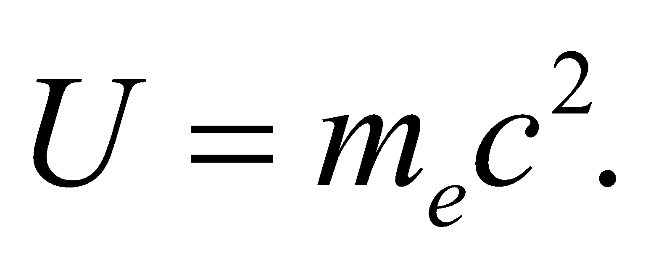

**Evaluate** Equating the two energies gives 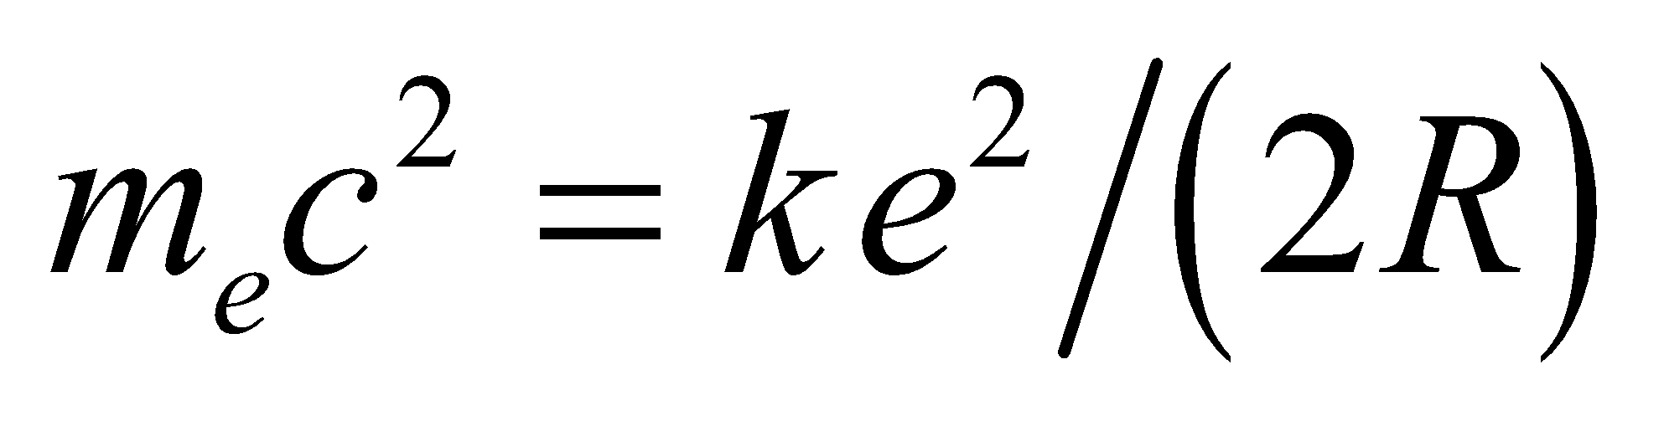, or



**Assess** The “classical radius of the electron,” based on a consideration of the scattering of electromagnetic waves from free electrons, called Thomson scattering, is actually equal to 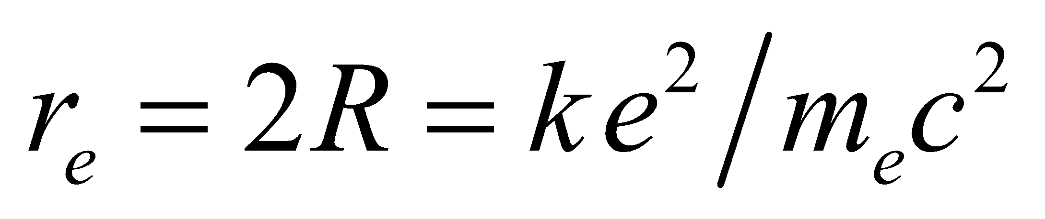. Notice also that the units cancel to give meters, because 1 N = 1 kg·m·s−2.

**69.** **Interpret** This problem involves a charged capacitor into which we insert a dielectric material so that it occupies half the volume of the capacitor. We are to find the new capacitance, the stored energy, and the force on the dielectric in this configuration.

**Develop** Use the coordinate system defined in the figure below. In so far as fringing fields can be neglected, the electric field between the plates is a uniform *E* = *V*/*d* (but when the dielectric is inserted, 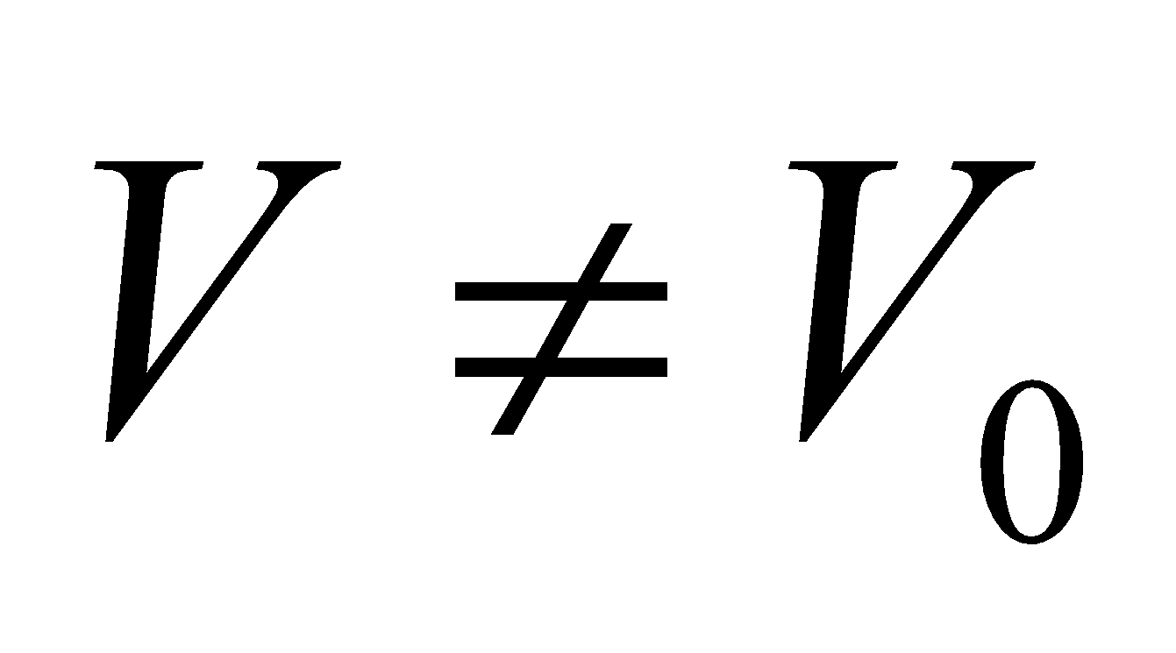 and *E* depends on *x*). In fact, on the left side, where the slab has penetrated, 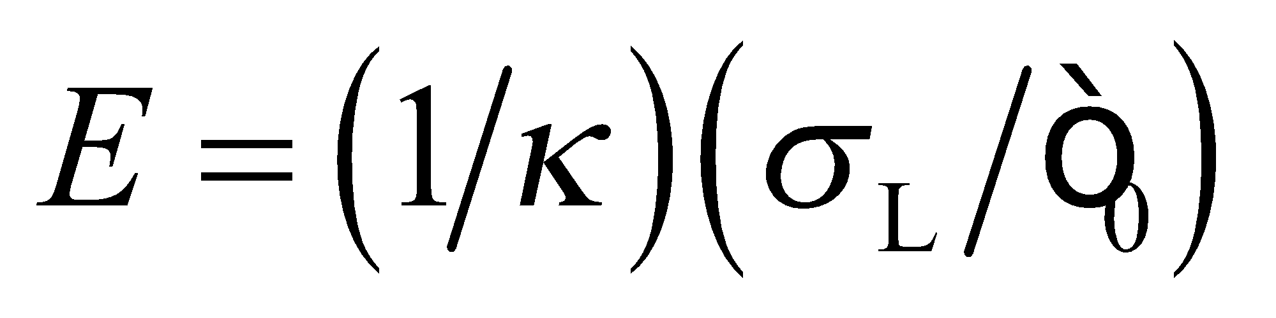 and on the right, 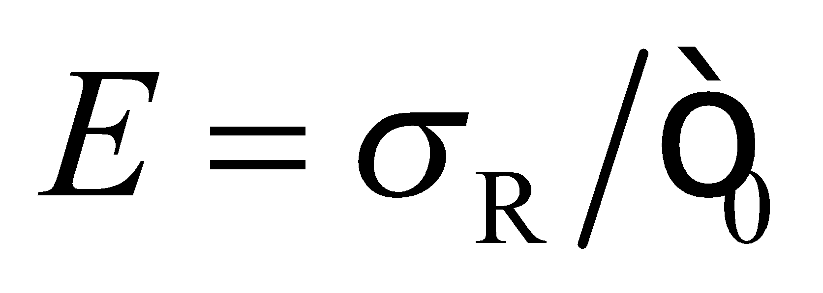, where  and 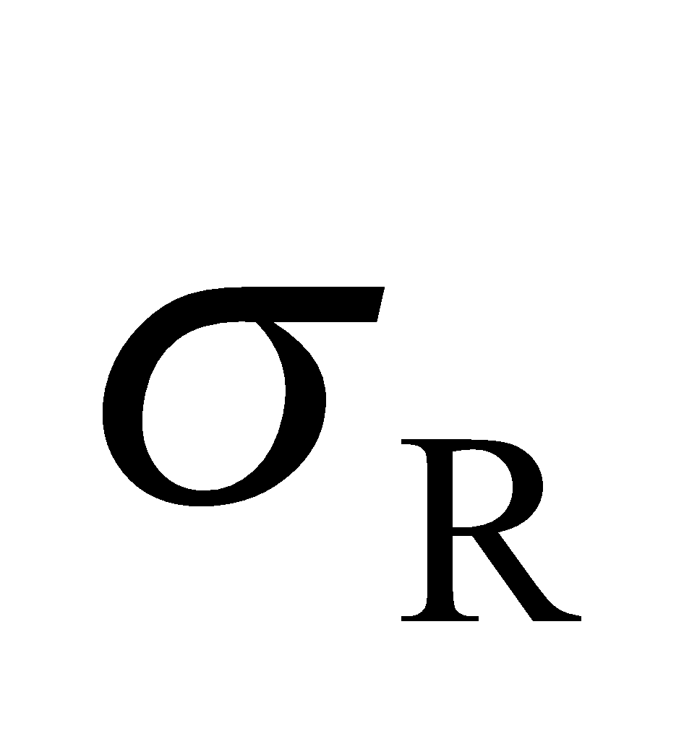 are the charge densities on the left and right sides, respectively. Thus, 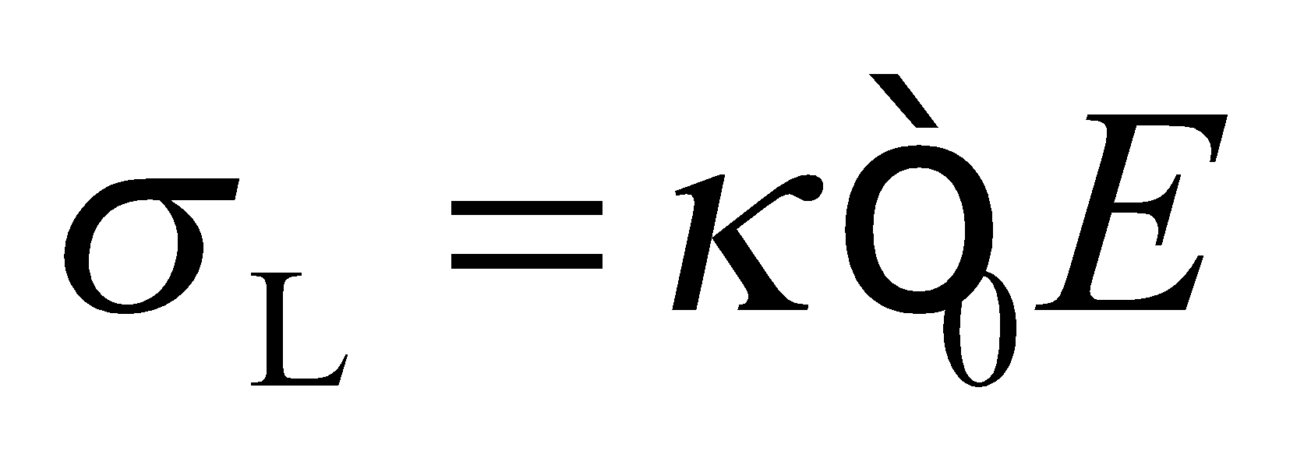 and  and the charge can be written (in terms of geometrical values taken from Fig. 23.19) as



When the battery is disconnected, the capacitor is isolated and the charge on it is a constant, 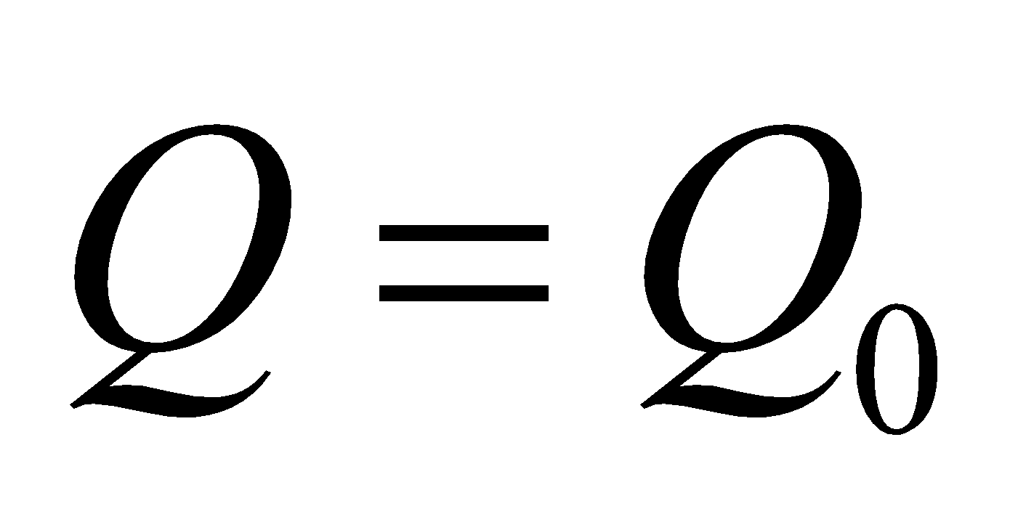, and we can use Equation 23.3 *U* =*CV*2/2 to find the energy stored in the capacitor. The force on a part of an isolated system is related to the potential energy of the system by Equation 8.9. The force on the slab is therefore

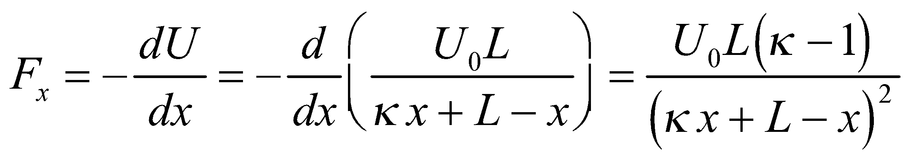

in the direction of increasing *x* (so as to pull the slab into the capacitor).

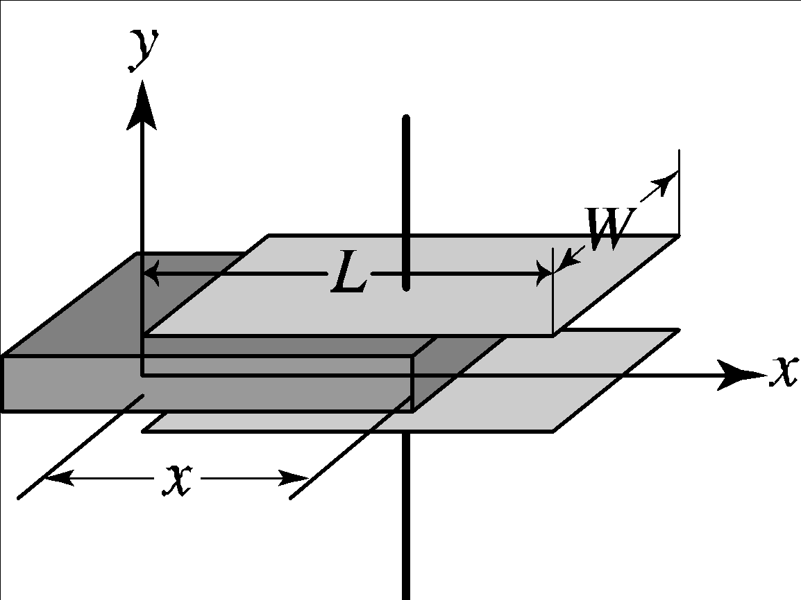

**Evaluate** **(a)** From Equation 23.1,

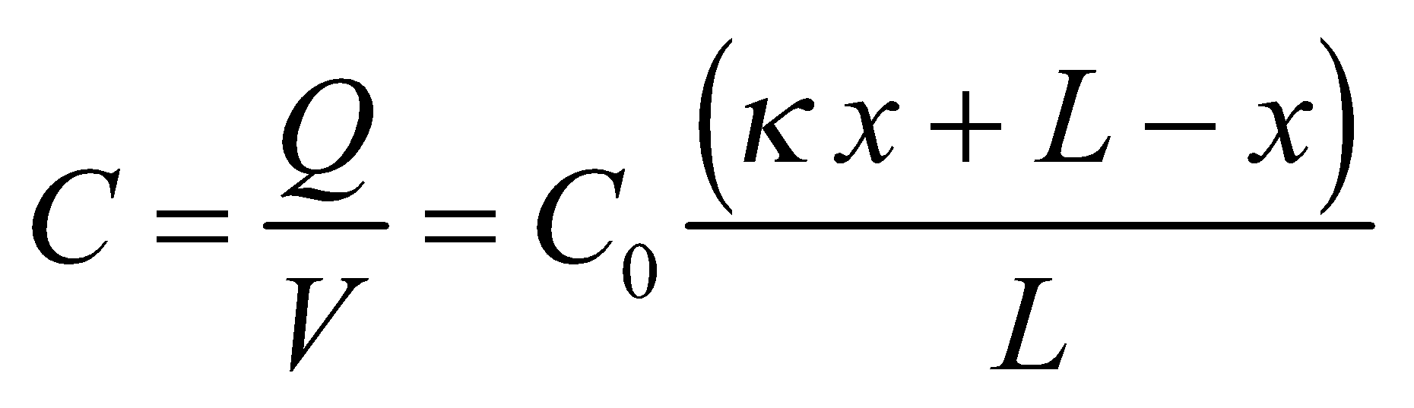

where 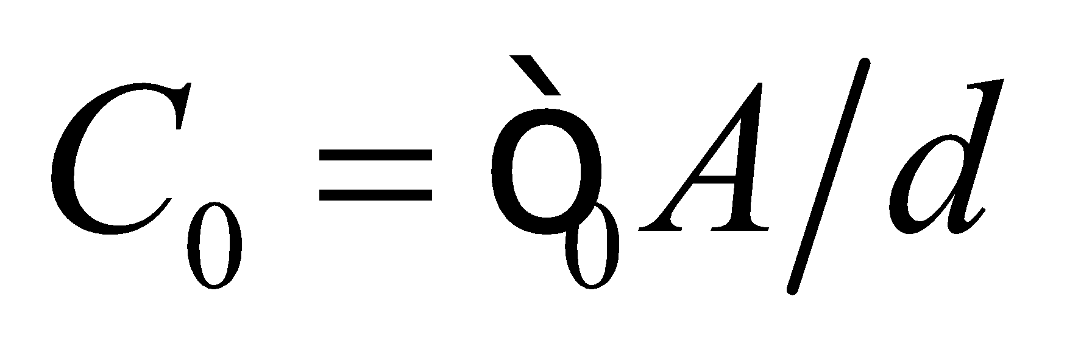 and 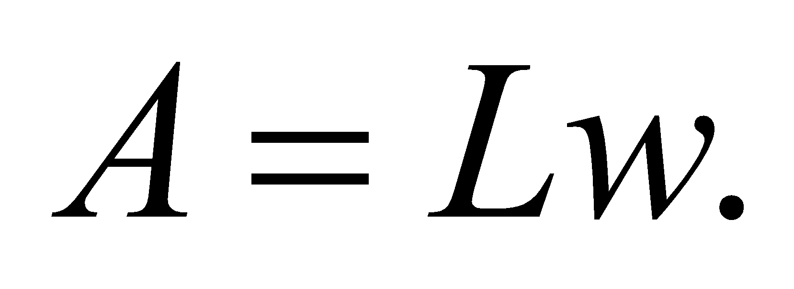 Inserting *x* = *L*/2, we find

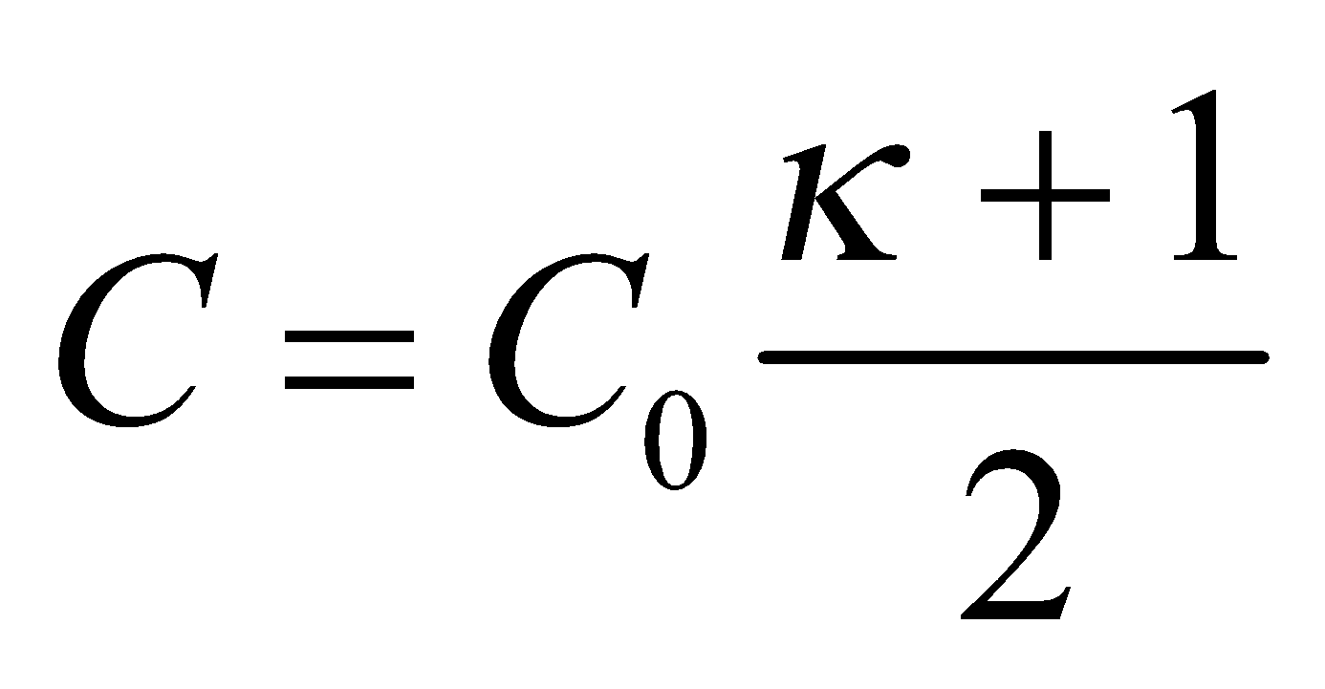

**(b)** The stored energy is

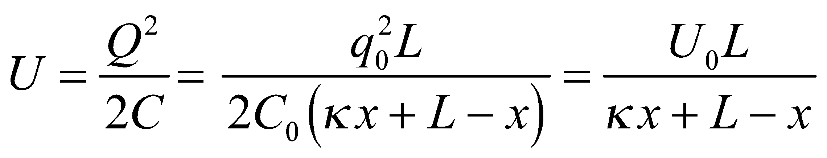

where 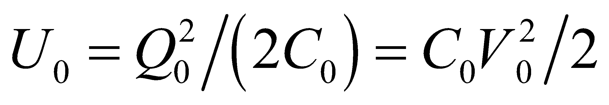. For *x* = *L*/2, the energy is 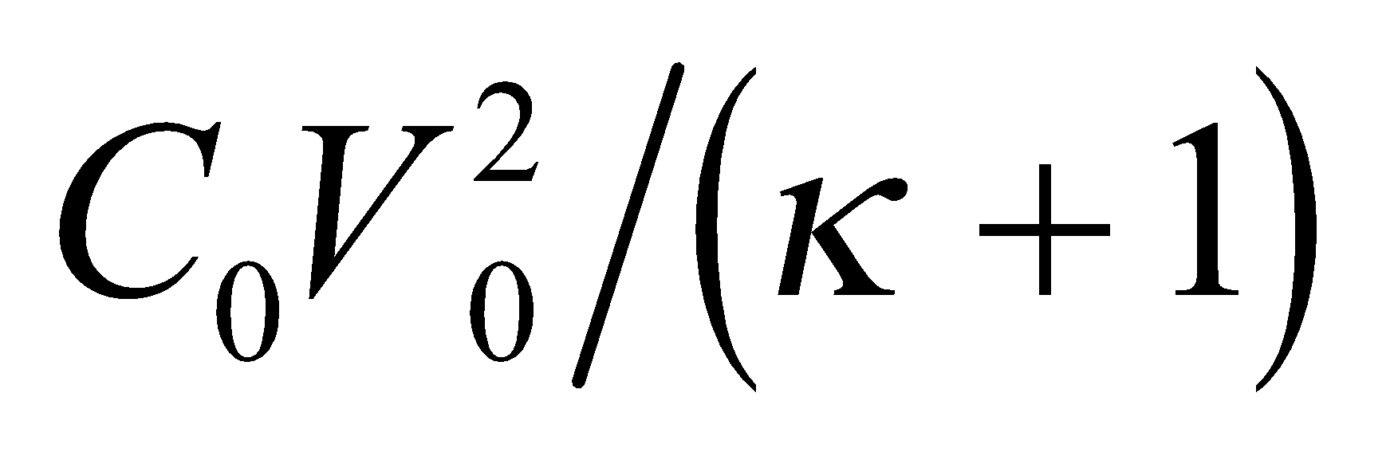.

**(c)** For *x* = *L*/2, the magnitude of the force is

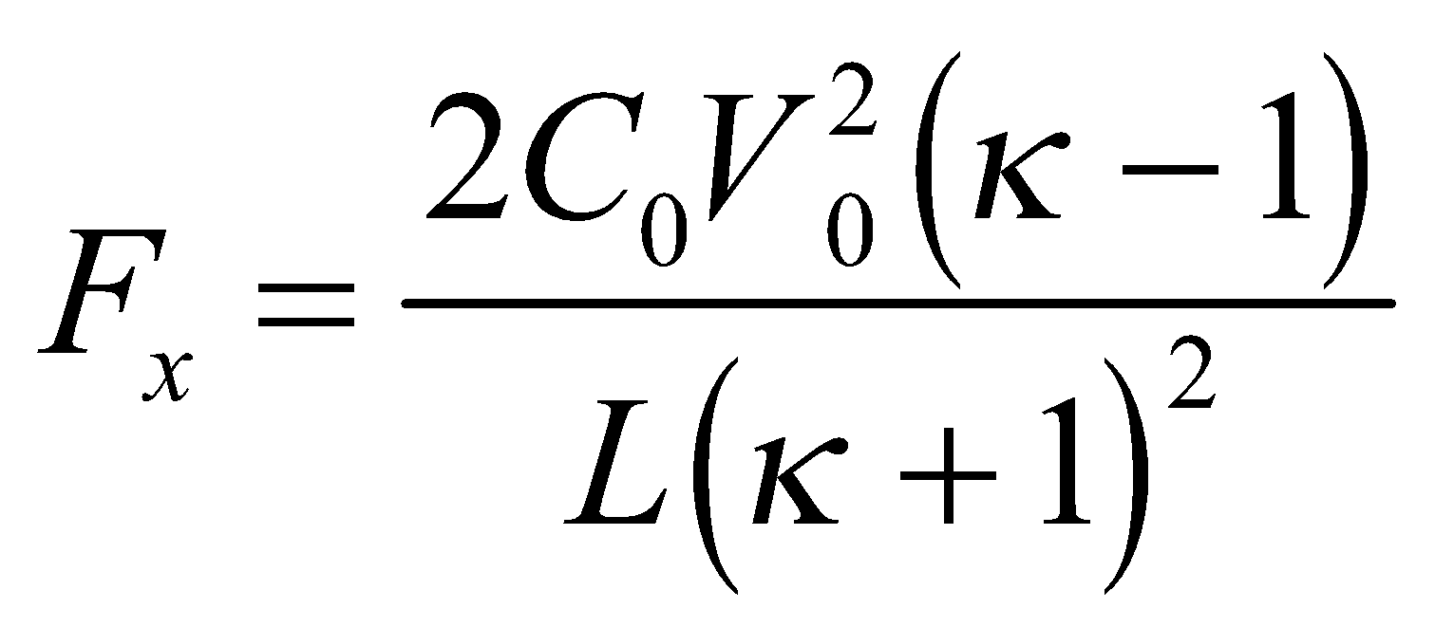

**Assess** Notice that the results depend only on geometrical factors and the dielectric strength of the material.

It turns out that if we rewrite the force, for any value of *x*, in terms of the voltage for that *x*,

using 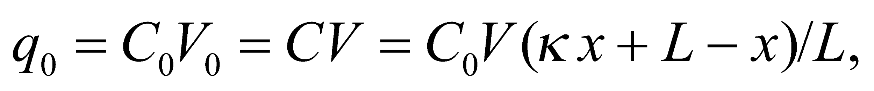 the expression can be used in the succeeding problem. Thus,

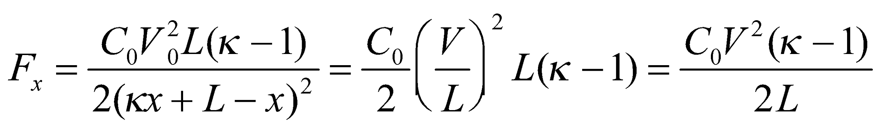

**70. Interpret** This problem is about the effect of inserting a dielectric material into a parallel-plate capacitor, which is connected to a battery and so remains at a constant voltage.

**Develop** We first note that the capacitance depends on the configuration and electrical properties of the plates and insulating materials, not on the external connections. Thus, we can use the result from the previous problem:

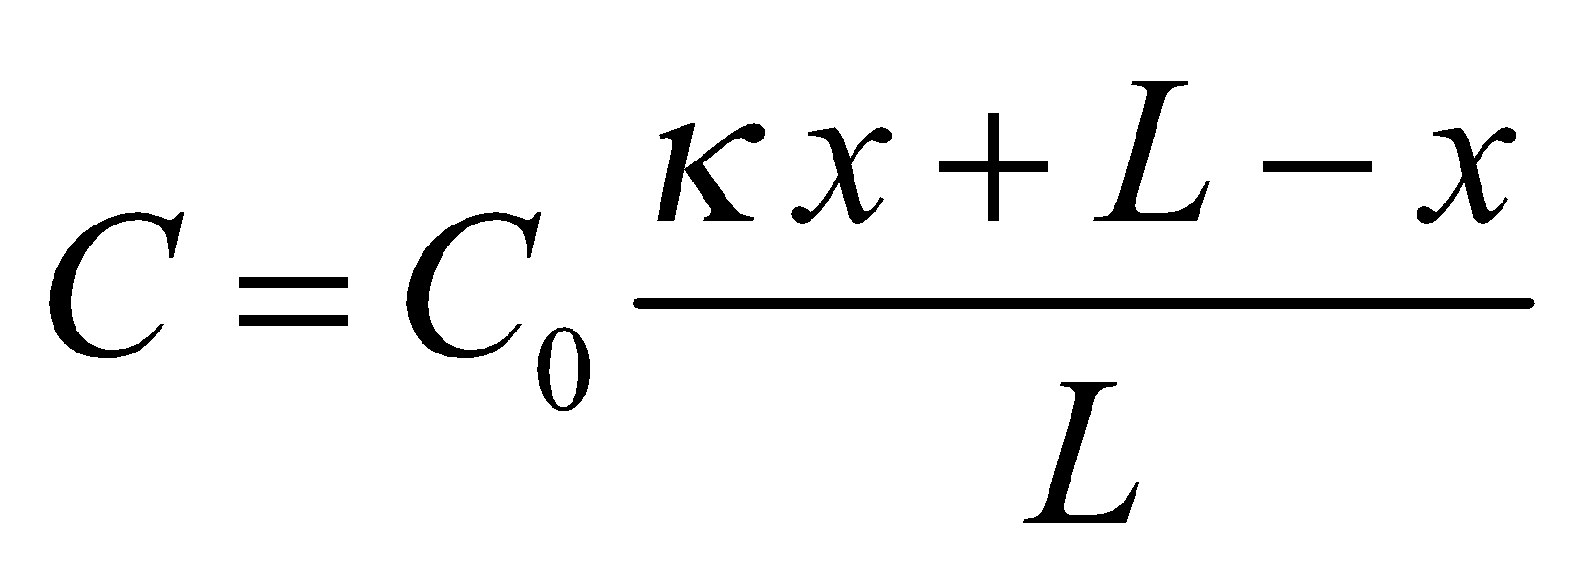

If the capacitor remains connected to a battery, the voltage is constant, 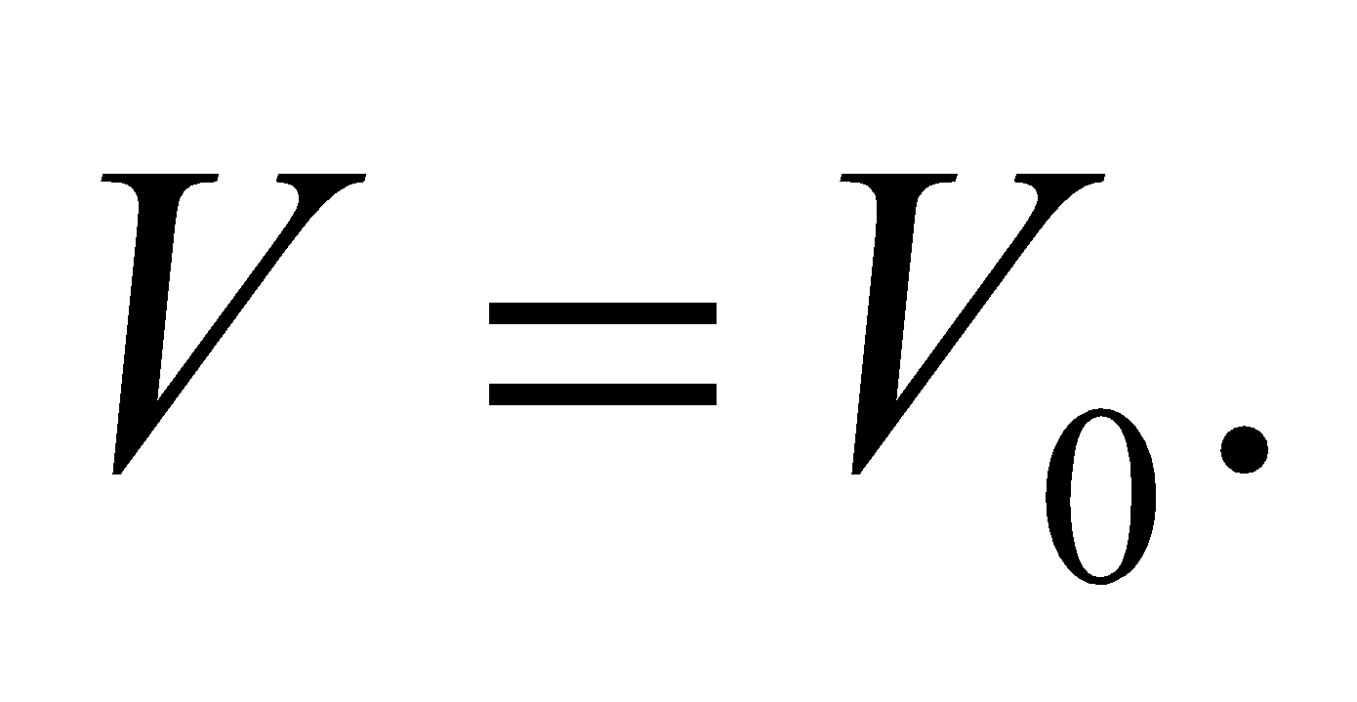

**Evaluate** **(b)** The energy is

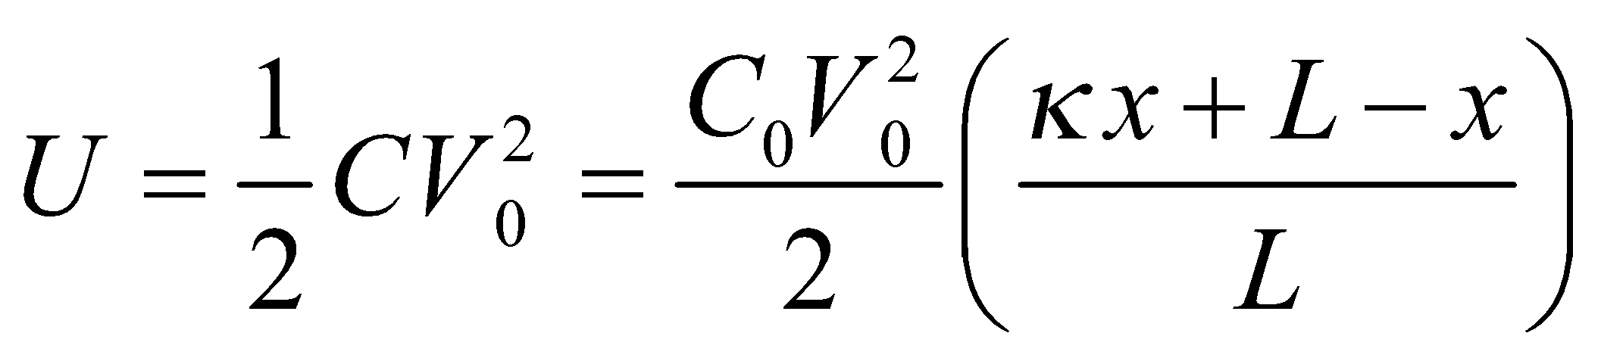

For *x* = *L*/2, we get 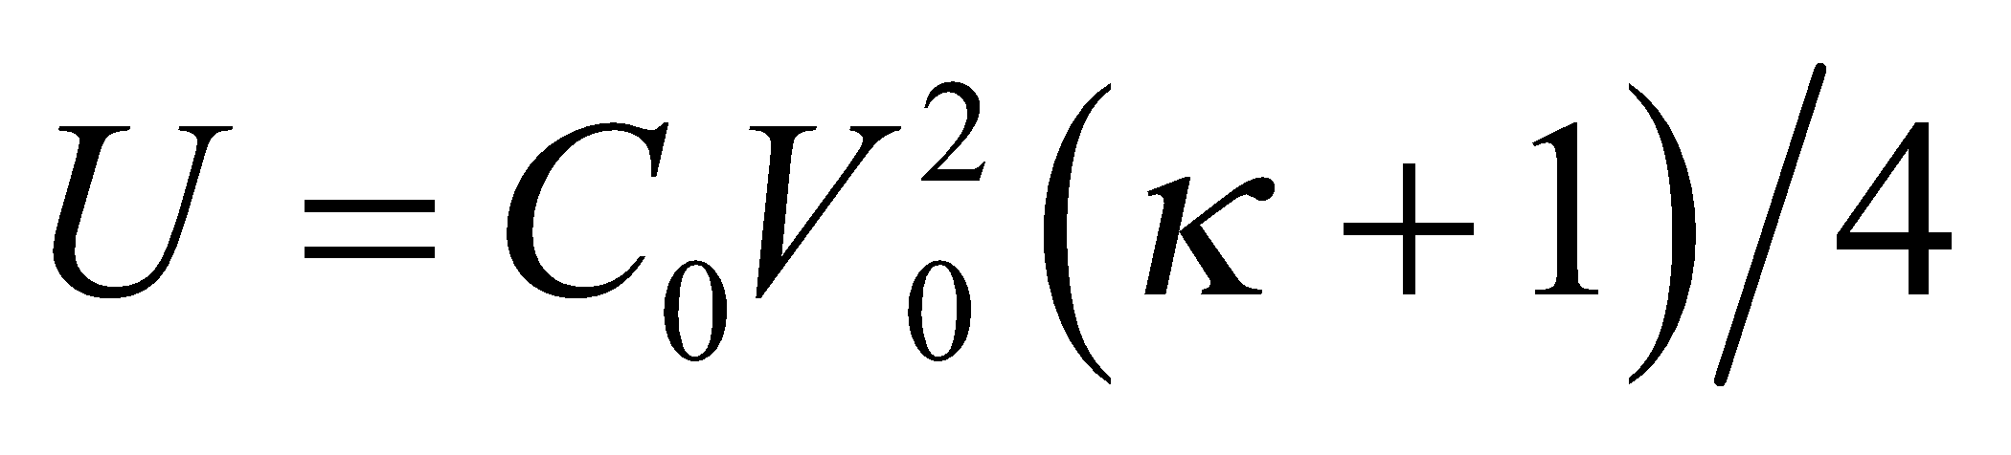.

**(c)** When the capacitor is connected to a battery, Equation 6.8 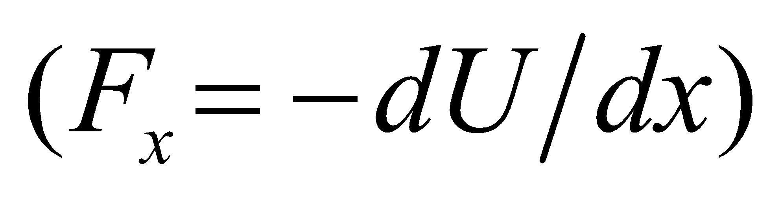 for the force does not apply because the battery does work, which changes the energy of the system. However, for particular values of charge and voltage on the capacitor, the force on the slab considered here is the same, regardless of the external connections. In the preceding problem we found that 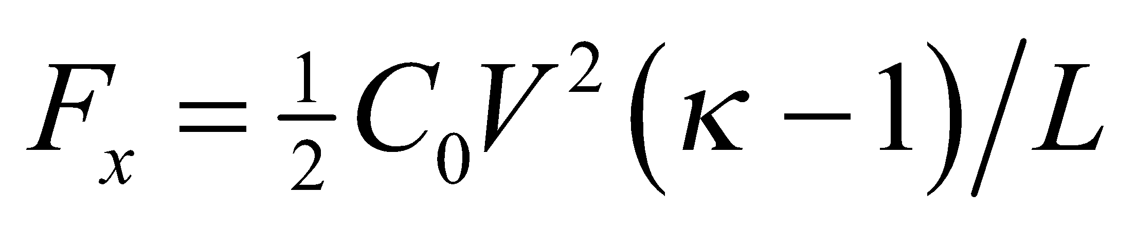 where *V* is the particular voltage (and, because of the special form *C*(*x*) of the capacitance, the particular charge *q* does not appear). Since *V* = *V*0 in this problem,

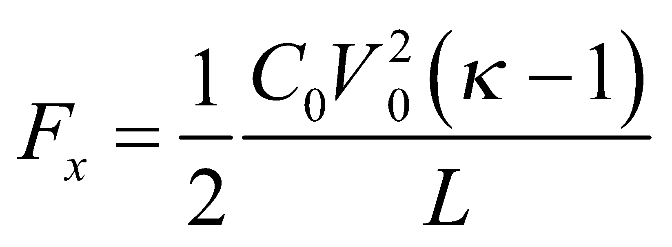

**Assess**  Note that the results are different from the preceding problem, because the battery does work. The force on the slab is to the right, drawing the dielectric between the plates.

**71.** **Interpret** We are to find the capacitance per unit length of two parallel wires whose separation is much, much greater than their radii, so we can assume line symmetry (i.e., infinite wires). The wires carry opposite charge density.

**Develop** Use the coordinate system shown in the figure below. Apply Equation 22.1a:

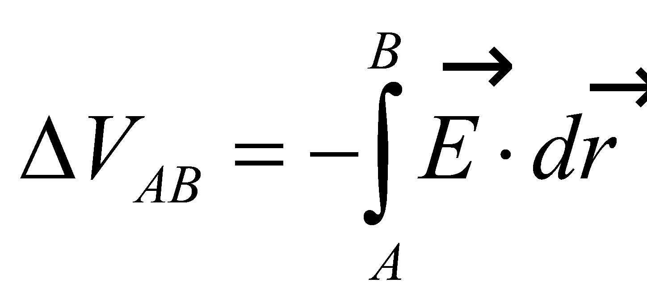

The total electric field is the superposition of the electric fields due to the two wires, each of which is given by Equation 21.6. Summing the two contributions gives

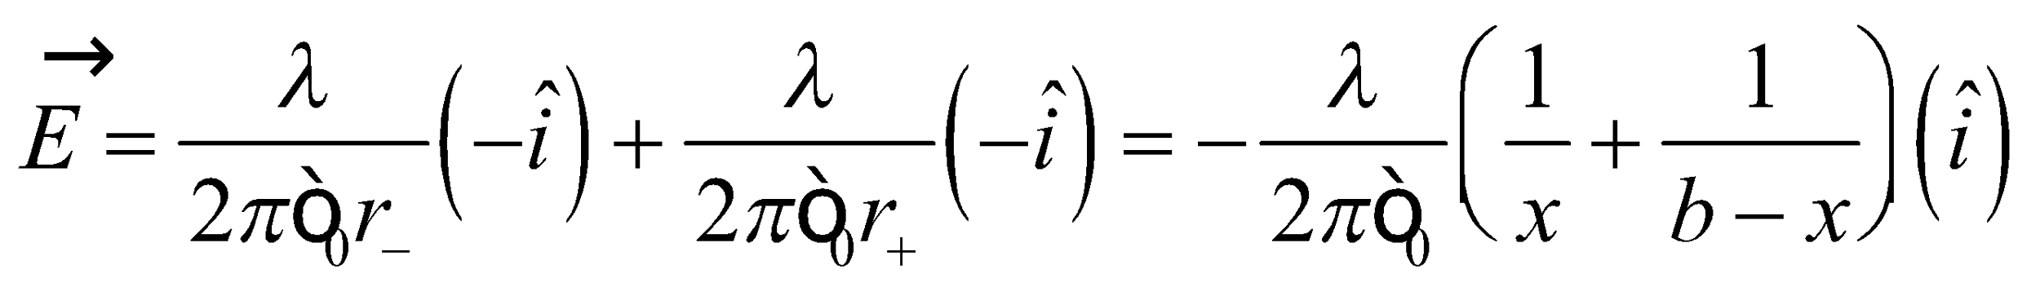

Insert this into the integral and perform the integration to find the voltage difference between the wires. The wire capacitance per unit length can then be found using Equation 23.1, *Q* = *CV*, which we can transform into per unit length by dividing each side by an arbitrary length *L*:

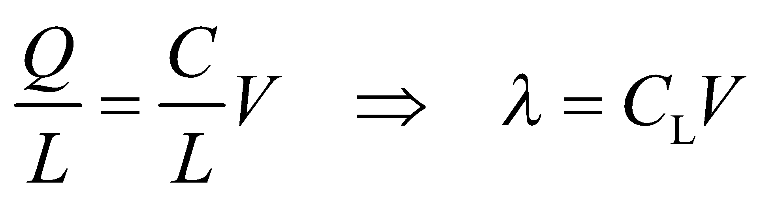

where *C*L is the capacitance per unit length.



**Evaluate** Evaluating the integral gives



Inserting this into the expression for capacitance gives

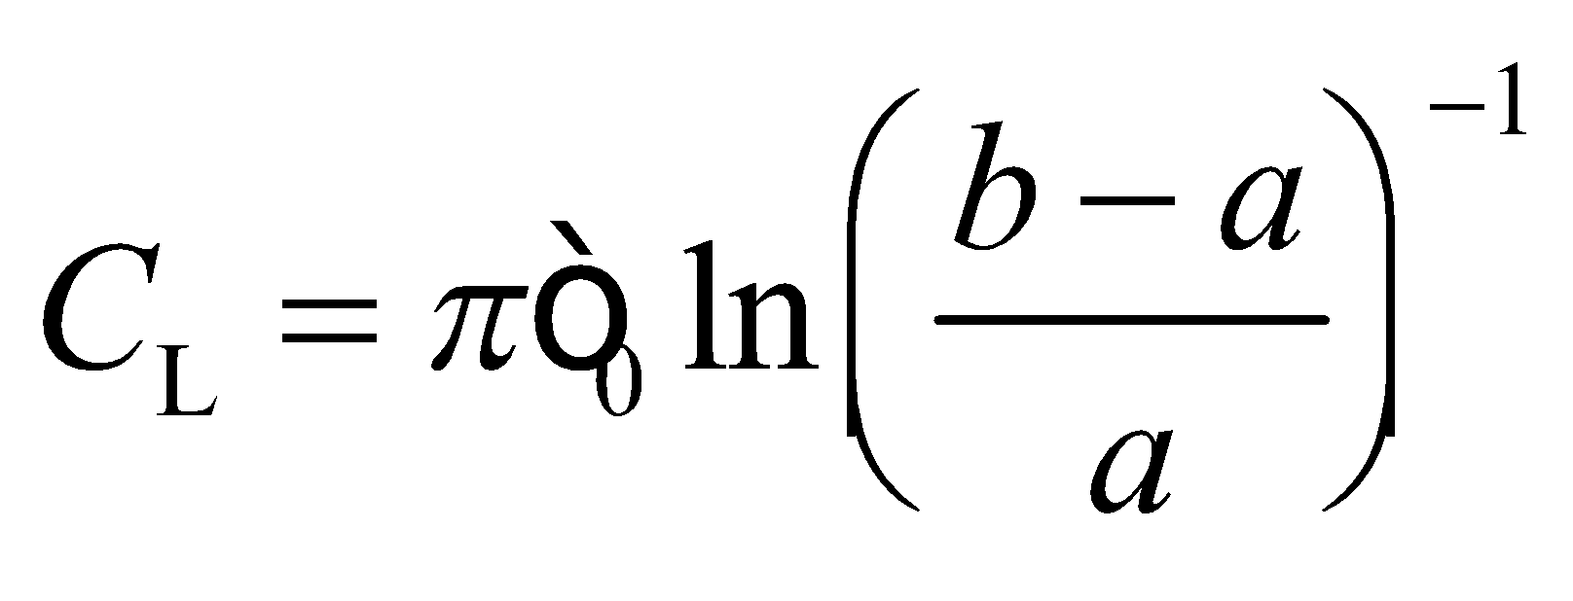

**Assess** The capacitance per unit length depends only on geometrical parameters, and is positive.

**72. Interpret** We are to find the energy per unit length stored in the electric field within a uniformly charged rod. We will use Gauss’s law to determine the electric field within the rod, and then integrate the energy density to find the total energy.

**Develop** We use Gauss’s law (Equation 21.3)

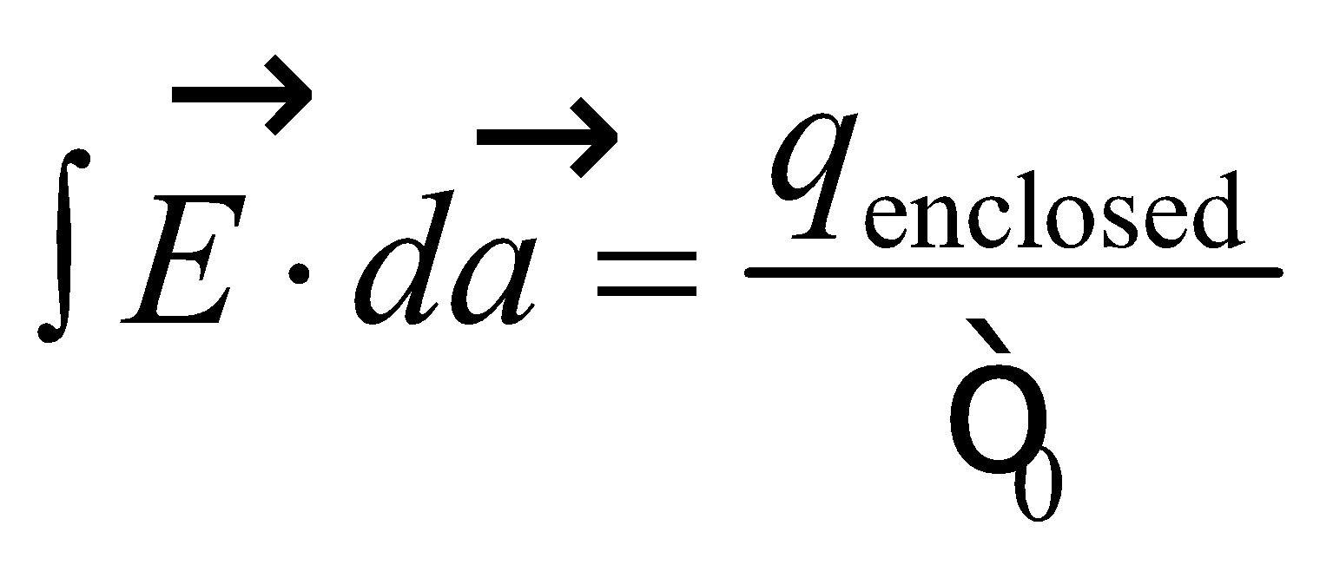

exploiting the cylindrical symmetry, to find the electric field. Once we have this field, we integrate the energy density 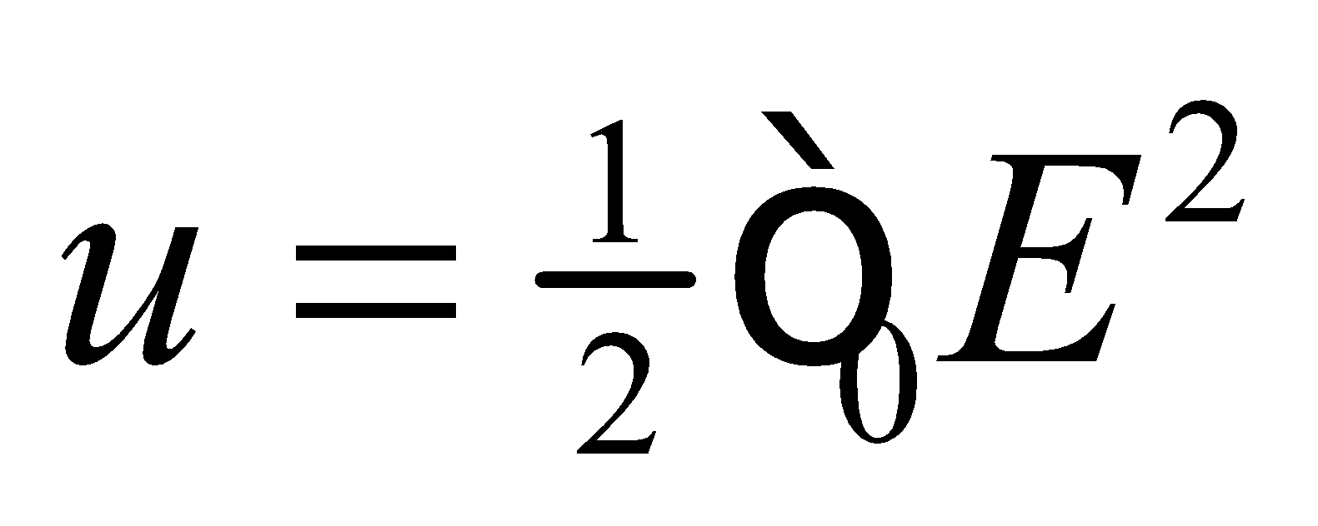 over the cylinder to find the total energy 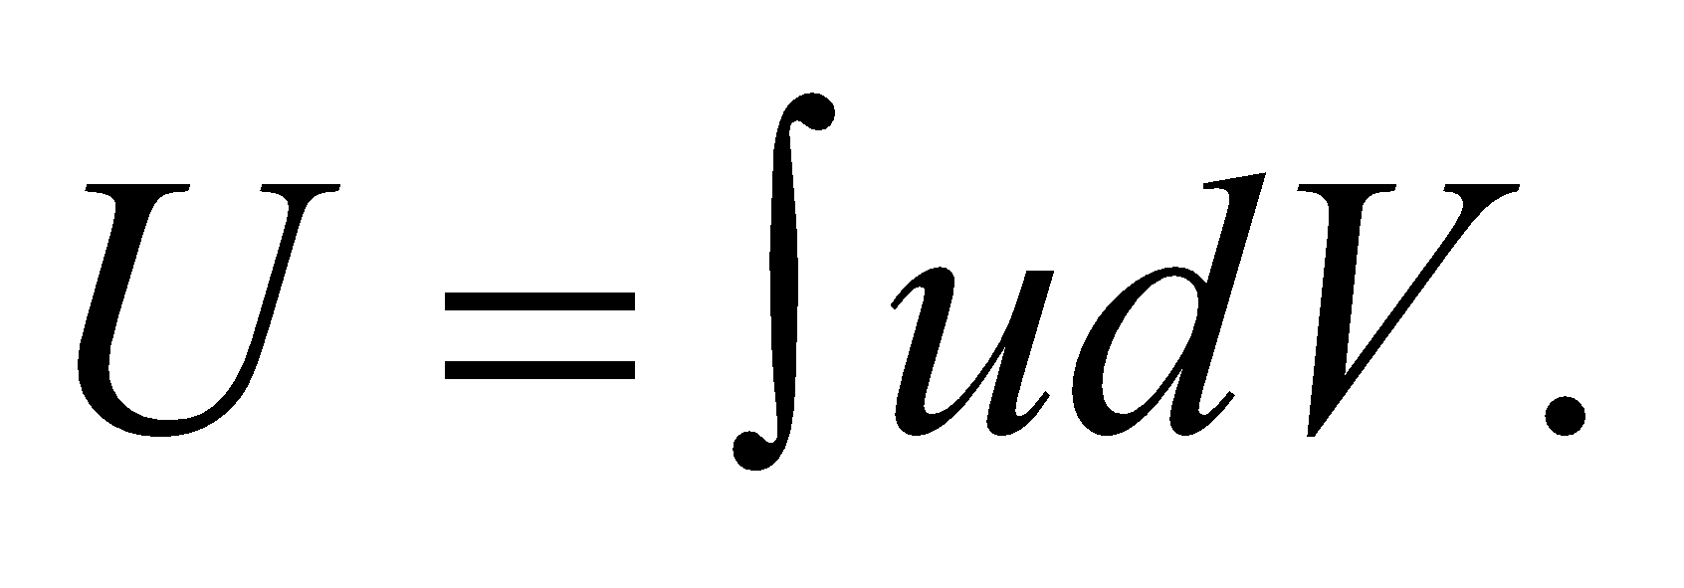

**Evaluate**

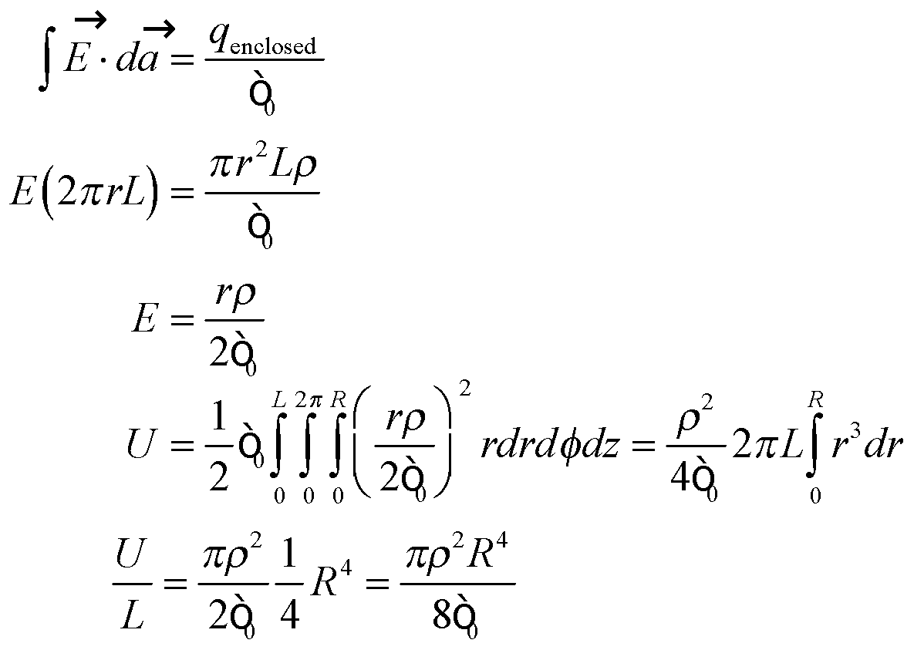

**Assess** Increasing the radius increases the energy per length dramatically.

**73. Interpret** We are to find the electrostatic energy stored between two parallel plates of a parallel-plate capacitor, and then differentiate to find the force between the plates.

**Develop**  Using Equation 21.8, find the electric field between the plates:

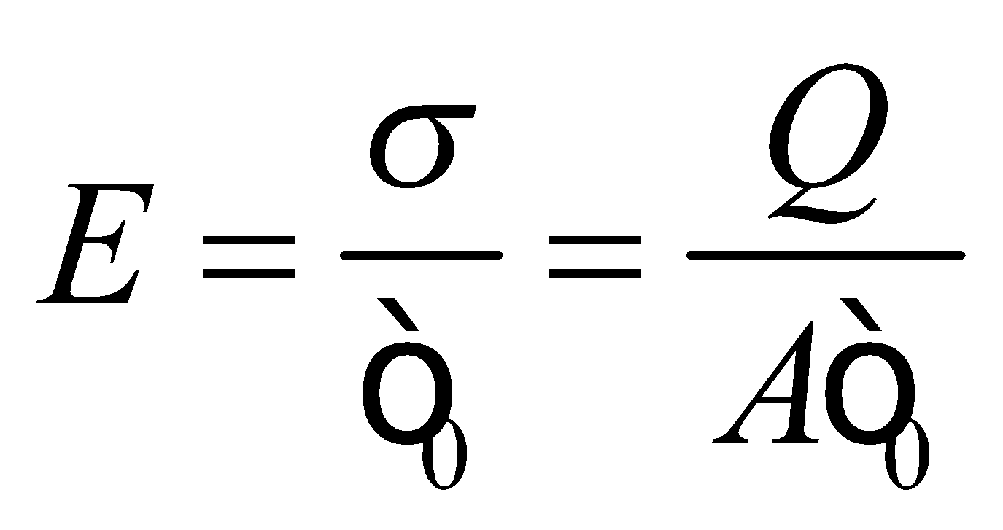

This is constant, so total energy stored in this field is then 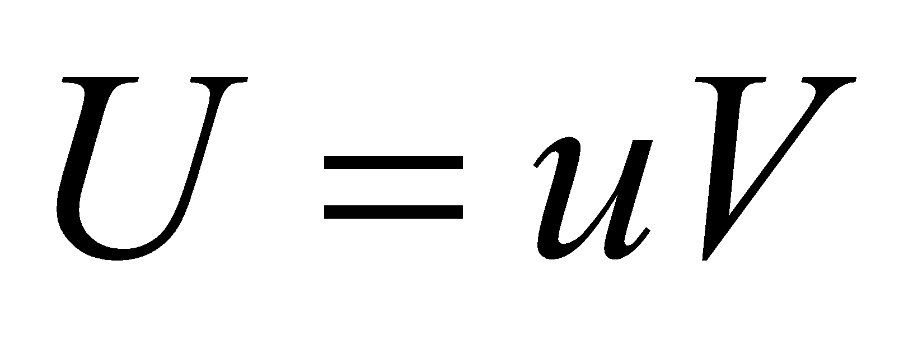, where *u* is the energy density (energy per unit volume). We can find the force by using 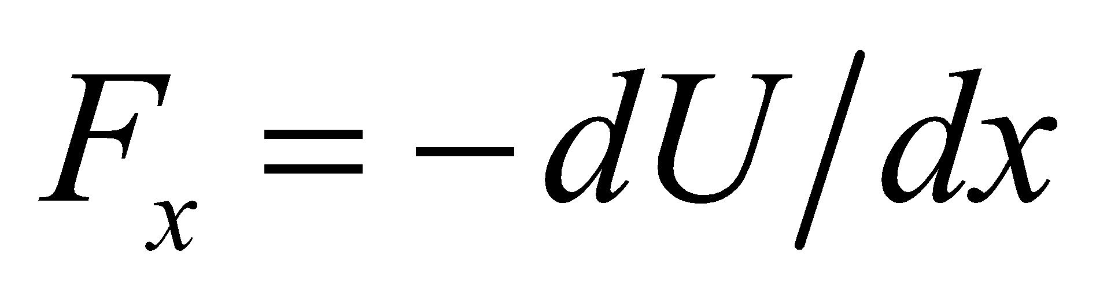.

**Evaluate** **(a)** The electrostatic potential energy is

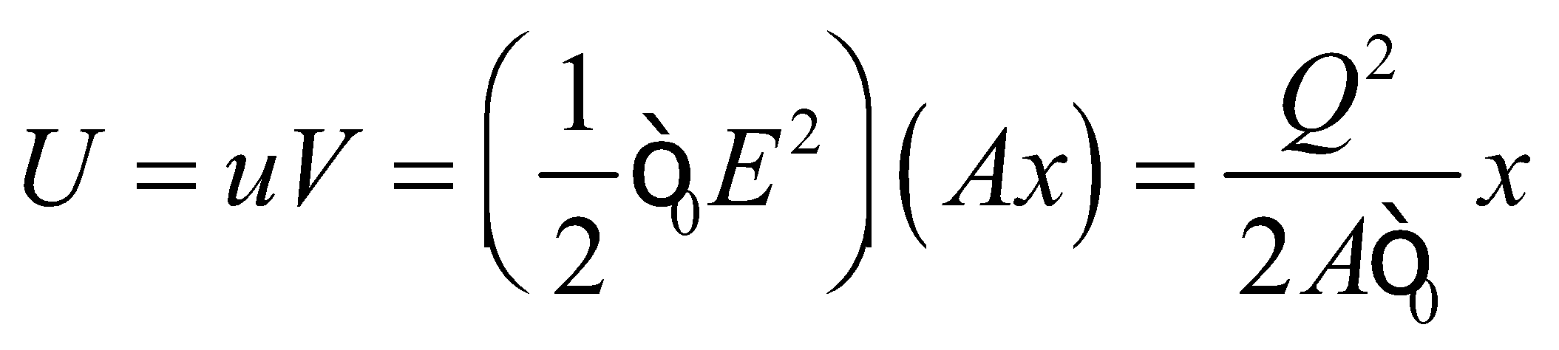

**(b)** The force between the plates is

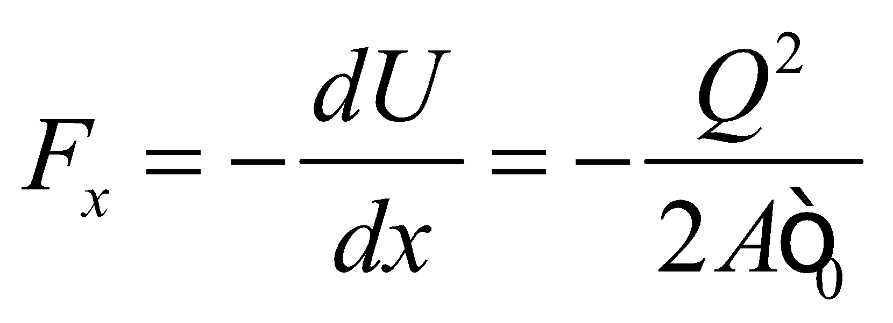

This is half the value you would obtain by multiplying the charge on one plate by the field between the plates.

**Assess** The answer we get for **(b)** is half the field times the charge on one plate: but we must remember that the field between the plates is created by *both* charged plates. A charge is not affected by the field it creates. Only the field created by the *other* plate causes a force on each plate, and the other plate creates half the field.

**74. Interpret** We are to use the energy stored in a capacitor network at a given voltage to find the capacitance of an unknown capacitor in the network. We shall use the equation for the energy stored in a capacitor, and the rules for adding capacitors in series and in parallel.

**Develop** We first find the capacitance  of the entire network in terms of the given values and the unknown capacitance *C*. Next, we use Equation 23.3, 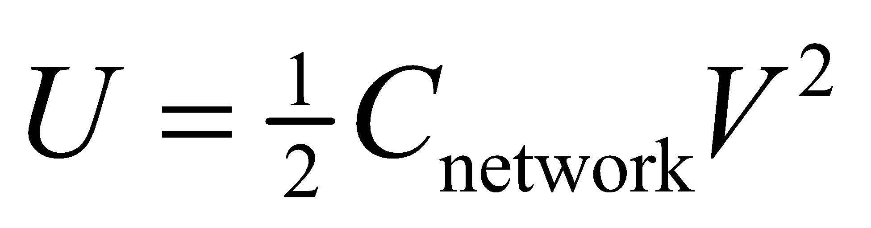 with *U* = 5.8 mJ and *V* = 100 V and work backward through the network to solve for *C*.

**Evaluate**

**(a)** See the circuit diagram in the circuit below.

**(b)**

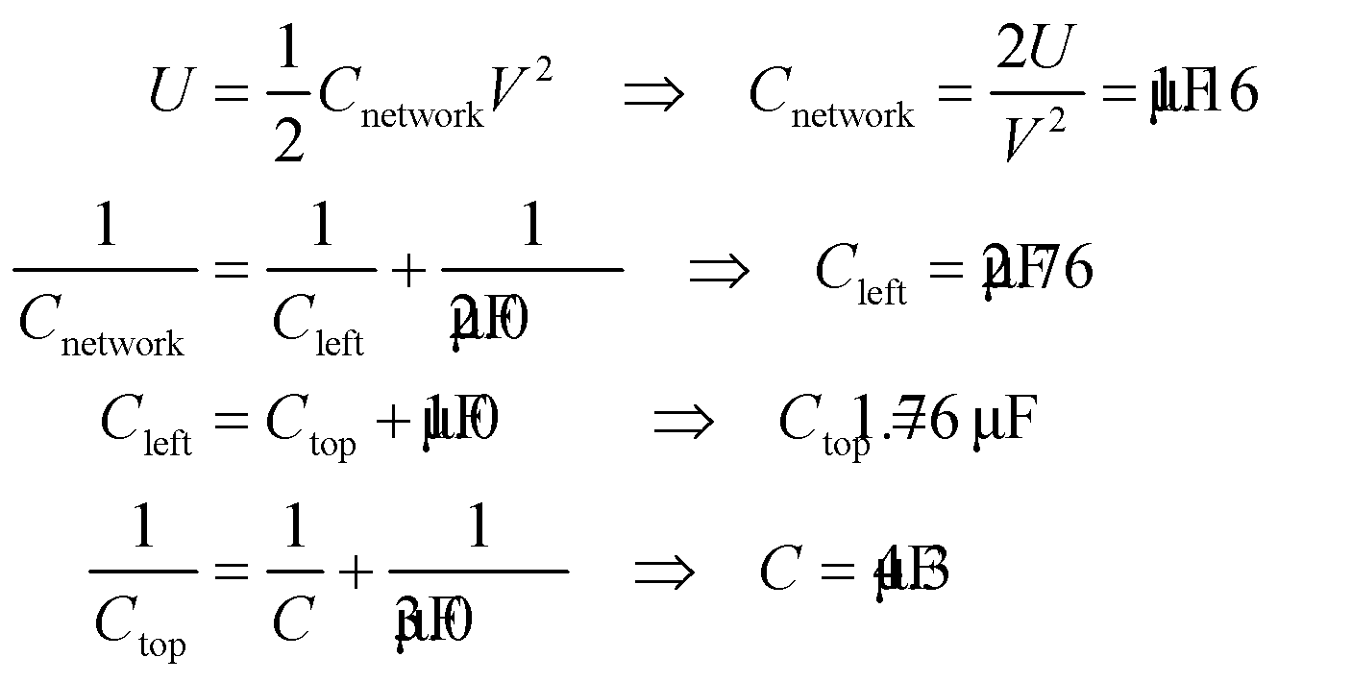



**Assess** This trick of “unraveling” the network is often useful. We will use the same trick in dealing with resistor networks later. Note also that three significant figures were retained for the intermediate results, whereas only two significant figures were retained for the final result, as warranted by the data.

**75.** **Interpret** We're considering the energy used by the National Ignition Facility.

**Develop** The energy stored in a capacitor is given by 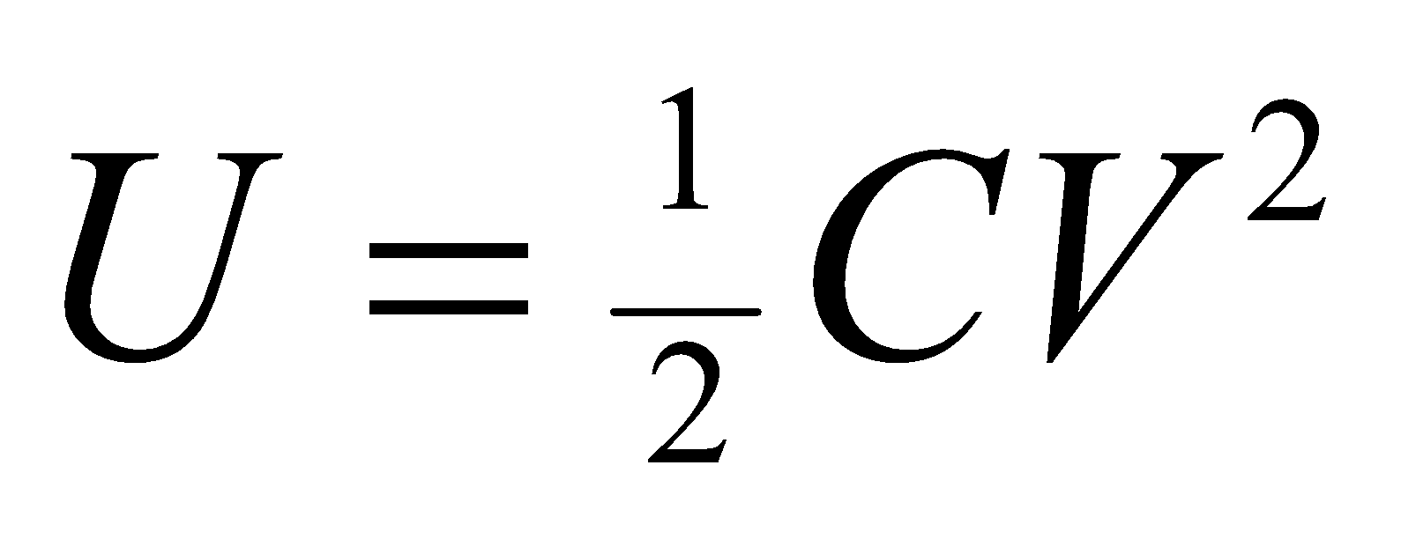 (Equation 23.3).

**Evaluate** We're told that the NIF capacitor system stores 400 MJ at 20 kV, so the capacitance is

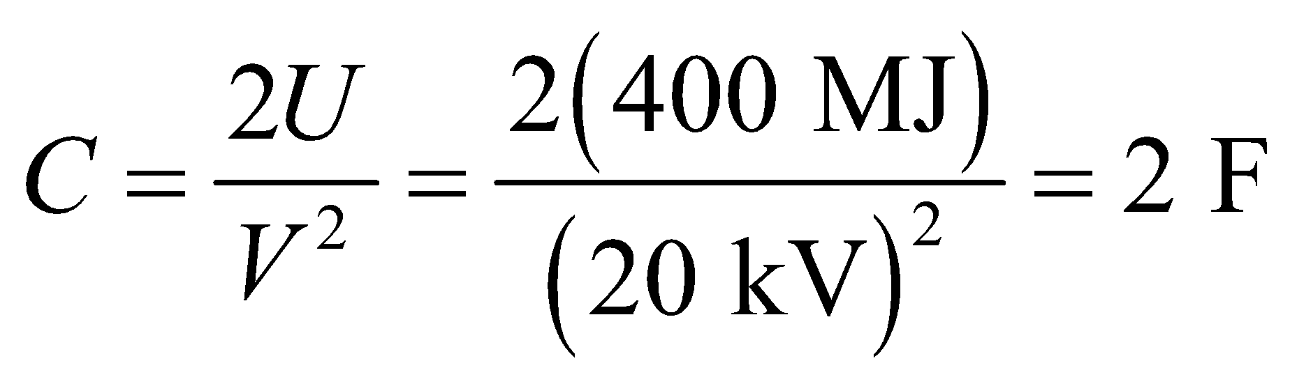

The answer is (d).

**Assess** This is an impressively large capacitance. The advantage of using capacitors in this application is that they can discharge rapidly and thus supply a large amount of power over a short time.

**76.** **Interpret** We're considering the energy used by the National Ignition Facility.

**Develop** If the voltage is changed, the capacitor system still needs to store the same energy, so the capacitance will change by a factor of 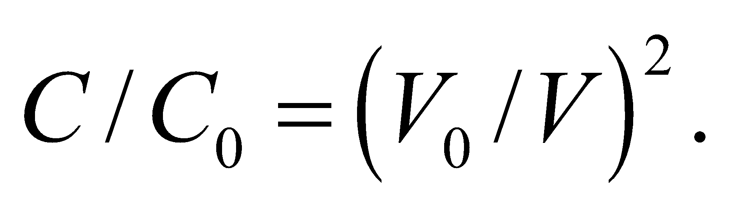

**Evaluate** Doubling the voltage means the capacitance could drop by ¼ and still store the same 400 MJ.

The answer is (a).

**Assess** There's a tradeoff between capacitance and voltage. One can think of the capacitor system as the equivalent of a spring storing mechanical energy 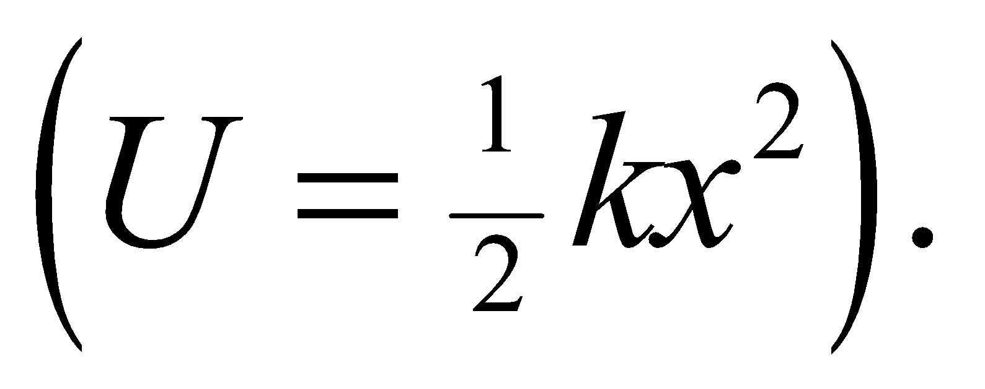 The capacitance is like the spring constant, *k*, and the voltage is like the displacement, *x*. The same energy can be stored with a weaker spring constant if the spring is compressed or stretched further.

**77.** **Interpret** We're considering the energy used by the National Ignition Facility.

**Develop** The power is energy divided by time.

**Evaluate** We're told that the lasers deliver 2 MJ of energy in 1 ns. So the power is

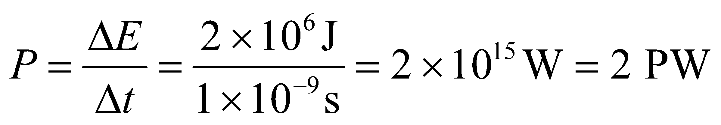

The answer is (d).

**Assess** This is over 100 times the world's average power consumption, but it only lasts for a fraction of a second.

**78.** **Interpret** We're considering the energy used by the National Ignition Facility.

**Develop** The energy stored in a capacitor is given by  (Equation 23.3).

**Evaluate** One of the capacitors at NIF stores

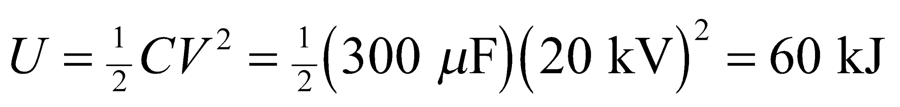

The answer is (c).

**Assess** If there are 1200 of these capacitors in parallel, they can store 72 MJ. To reach 400 MJ with these type of capacitors would require more than 5 times this number.